Extra Log In
1 >> Open Excel
2 >> Connect (print screen 1)
3 >> LogIn / Continue (print screen 2)
4 >> Extra Log in popup where you need to enter username and password (print screen 3)

Print screen 1
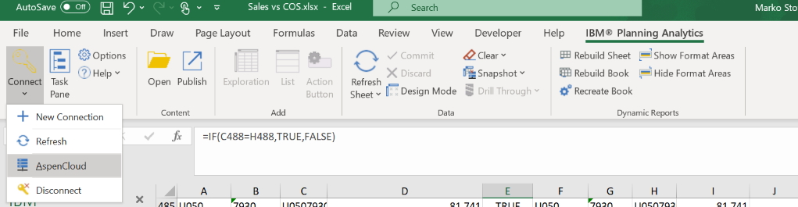

Print screen 2
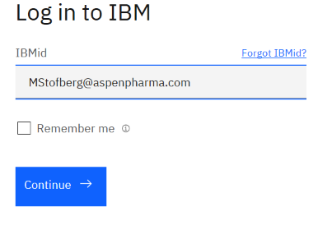
Print screen 3
