For distributed installations, install the QRadar® Console on an appliance and the IBM® QRadar Incident Forensics managed host on another appliance.
Restriction Software versions for all appliances in a deployment must be the same version and fix level. Deployments that use different versions of software are not supported.
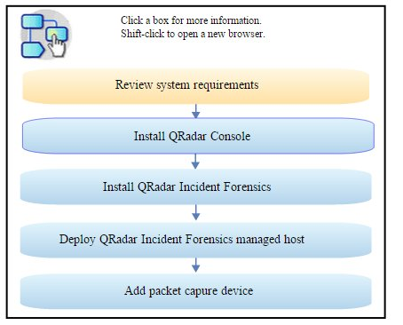

Before you begin
Ensure that the following requirements are met:
- The required hardware is installed.
- You have the required license key for your appliance.
- A keyboard and monitor are connected by using the VGA connection.
- If you want to configure bonded network interfaces, see the topic titled Configuring bonded management interfaces in the IBM QRadar Installation Guide.

Procedure
- For installations on your own hardware or on virtual machines, add the QRadar Console ISO image in the root directory.
  - Create the /media/dvd directory by typing the following command:
mkdir /media/dvd
  - Mount the QRadar Console ISO image by typing the following command:
mount -o loop <QRadar_ISO> /media/dvd
- Use the setup script to start the installation.
  - Change the working directory by typing the command:
cd /media/dvd
  - Start the setup script by typing the command:
setup.sh
- Follow the instructions in the installation wizard.
  - In the Enter your activation key below, when you are prompted for the activation key, enter the 24-digit, 4-part, alphanumeric string that you received from IBM.
The letter I and the number 1 (one) are treated the same. The letter O and the number 0 (zero) are also treated the same.
  - In the Enter the network information to use page, if you do not have an email server, enter localhost in the Email server name field.
  - In the Root password field, create a password that meets the following criteria:
    - Contains at least 5 characters
    - Contains no spaces
    - Can include the following special characters: @, #, ^, and *.
The installation process might take several minutes.
- If you are installing a Console, apply your license key.
  - Log in to QRadar as the admin user:
https://<IP_Address_QRadar>
  - Click Login.
  - On the navigation menu ( ), click Admin.
  - In the navigation pane, click System Configuration.
  - Click the System and License Management icon.
  - From the Display list box, select Licenses, and upload your license key.
  - Select the unallocated license and click Allocate System to License.
  - From the list of systems, select a system, and click Allocate System to License.

What to do next
You can now install QRadar Incident Forensics.

