Centers for Advanced Studies group in IBM Community
https://ibm.biz/advancedstudies

How to Join?
1. Click the person icon in top right corner to Log in
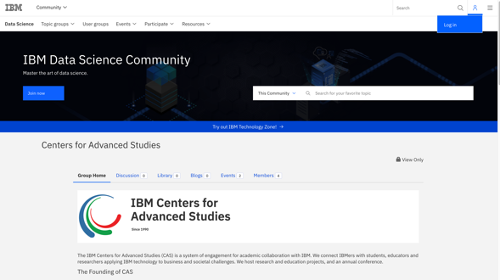

2. Log in using your IBMid.
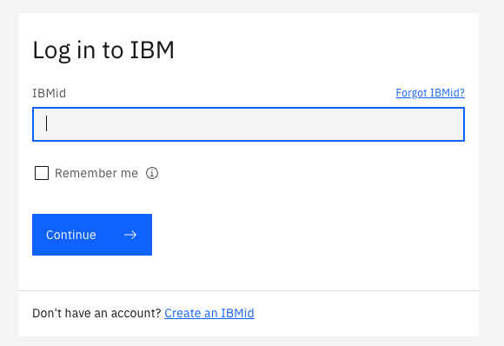

If you do not have an IBMid yet, click “Create an IBMid”. You do not need to be an IBMer nor having an IBM email to have an account. You can use your institution email or simply link it to your LinkedIn account.

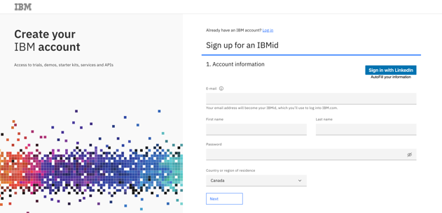

3. After logging in, click “Join Group” to join us!

