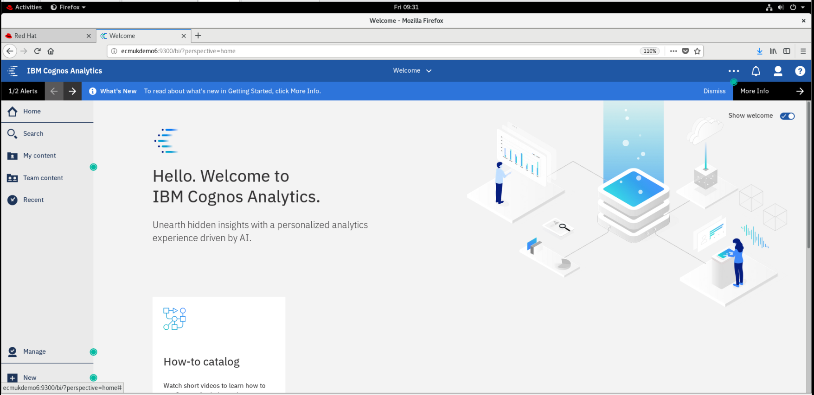

|  |  |
| --- | --- |
|  | Abstract  This Document is an Appendix for the published Cognos Document : IBM Cognos Analytics 11.1.4 Installation and Configuration On Windows 10 and RHEL 8.0 REF: https://doi.org/10.13140/RG.2.2.11774.13129   1. Alan S Bluck |

IBM Installations - ASB Software Development Limited Publications 3

Appendix - Issue with zlib - fix required for build of /usr/local/lib/libz.so.1.2.9 4

Initial cogconfig.sh Cognos Configuration failure 4

zlib – fix 5

Create a Symbolic Link for the ZLIB 1.2.9 library 5

Create the Cognos cm Content Store DB2 jdbc connections 7

Create the cm database DDL sql script 9

Create the Cognos cm database on db2 10

Start the Cognos Configuration using the cogconfig.sh shell script 12

Cognos Start Console Log Output 14

Full log for the ZLIB fix recompilation for libz.so.1.2.9 18

Cognos 11.1.4 Linux Log file locations 26

# IBM Installations - ASB Software Development Limited Publications

<https://doi.org/10.13140/RG.2.2.11682.38089>

IBM Case Analyzer 5.5 Installation and Configuration On RHEL 8.0 for Case Monitor Dashboard 5.3.3 plugin

<https://doi.org/10.13140/RG.2.2.35304.83208>

IBM Content Search Services 5.5.3 Installation on CENTOS 8.0 and Configuration on RHEL 8.0

<https://doi.org/10.13140/RG.2.2.16987.52008>

Importing Case Manager solution Auto Claims example into Case Manager 5.3.3 on RHEL 8.0

[https://doi.org/10.13140/RG.2.2.27057.94561](https://doi.org/10.13140/RG.2.2.27057.94561%0d)

IBM CEBI Content Engine Bulk Import Document Batch Tool Example on Linux Centos 8

<https://doi.org/10.13140/RG.2.2.26048.69128>

Installation of LibreOffice 6.3.3.1 on Linux Centos 8.0

<https://doi.org/10.13140/RG.2.2.12361.49767>

IBM Case Manager Preparation of a new Target Object Store in a FileNet P8 Docker Container on CENTOS 8

<https://doi.org/10.13140/RG.2.2.11327.66721>

IBM Watson Explorer Foundational Components 12.0.3 Installation and Configuration on CentOS Linux 8.0

<https://doi.org/10.13140/RG.2.2.12248.44803>

Watson Explorer 12.0.3 oneWEX Installation on IBM Cloud CENTOS 8.0 Linux with Docker Containers

<https://doi.org/10.13140/RG.2.2.20256.94729>

IBM Cloud Private P8 Container CPIT Installation on CENTOS Linux 8.0

<https://doi.org/10.13140/RG.2.2.36842.88007>

Installation of Eclipse Codewind and Docker Compose on RHEL 8 Linux with IBM Cloud Private CE (Community Edition)<https://doi.org/10.13140/RG.2.2.20160.69129>

IBM FileNet P8 Java Development on ECM Cloud Private Container P8 Examples

<https://doi.org/10.13140/RG.2.2.27358.18246>

IBM Cloud Private P8 Container CPIT Installation on RedHat Enterprise Linux 8.0

<https://doi.org/10.13140/RG.2.2.22030.92486>

Problem Resolution Procedures For fixing Software Installation Issues

<https://doi.org/10.13140/RG.2.2.27345.89440>

IBM BAW 18.0 Installation phase1 preprint with install of IBM Workflow Center 8.6.1.19002

<https://doi.org/10.13140/RG.2.2.10491.67369>

DB2 10.5 Installation on CENTOS 8.0 V1

<https://doi.org/10.13140/RG.2.2.33527.57761>

IBM Security Directory Services 6.4- Installation on RHEL 8.0

<https://doi.org/10.13140/RG.2.2.15007.10408>

WebSphere 8.5.5.15 Installation 29-06-2019 on VMWare Workstation Pro 15.1

<https://doi.org/10.13140/RG.2.2.15737.83048>

IBM BAW 18.0 Installation 18 07 2019 - Install of IBM Security Directory Suite 8.0.1.1 on CENTOS 8 using VMWare Workstation Pro 15.1

<https://doi.org/10.13140/RG.2.2.21708.16001>

Case Manager 5.3.3 Installation on RHEL 8.0 with Content Navigator 3.0.6

**(NB Above describes the installation of the base RHEL 8.0 Linux Content Platform Engine 5.5.3 system for this document)**

<https://doi.org/10.13140/RG.2.2.31489.10082>

Installation of Oracle 12C on the Linux operating system

<https://doi.org/10.13140/RG.2.2.14590.95049>

Content Navigator 3.0.6 Installation on RHEL 8.0_V1.docx

<https://doi.org/10.13140/RG.2.2.21170.76480>

Content Foundation 5.5.3 Installation on RHEL 8.0_V2.docx

<https://doi.org/10.13140/RG.2.2.30401.51048>

 Case Manager Installation on RHEL 8.0_Preparation.docx

## Appendix - Issue with zlib - fix required for build of /usr/local/lib/libz.so.1.2.9

### Initial cogconfig.sh Cognos Configuration failure

initially starting the cognos configuration on RHEL 8.0 Linux gave:

**[root@ECMUKDEMO6 bin64]# cd /opt/ibm/cognos/analytics114/bin64**

**[root@ECMUKDEMO6 bin64]# export JAVA_HOME=/opt/ibm/cognos/analytics114/jre**

**[root@ECMUKDEMO6 bin64]# export JRE_HOME=/opt/ibm/cognos/analytics114/jre**

**[root@ECMUKDEMO6 bin64]# export LD_LIBRARY_PATH=/opt/ibm/cognos/analytics114/bin64:.:/usr/bin/:/opt/ibm/cognos/analytics114/bin64**

**[root@ECMUKDEMO6 bin64]#./cogconfig.sh**

**Came back immediately with no screen load of the GUI interface.**

**In the log file:**

**vi /opt/ibm/cognos/analytics114/logs/cogconfig.log**

**12/11/2019,02:10:03,Info,========== Cognos Configuration =========**

**12/11/2019,02:10:04,Err,java.lang.UnsatisfiedLinkError**: **/opt/ibm/cognos/analytics114/jre/lib/amd64/libawt_xawt.so (/lib64/libpng16.so.16: symbol inflateValidate version ZLIB_1.2.9 not defined in file libz.so.1 with link time reference),**

Exception in thread "main" java.lang.NoClassDefFoundError: java.awt.Toolkit (initialization failure)

at java.lang.J9VMInternals.initializationAlreadyFailed(J9VMInternals.java:98)

at java.awt.Component.<clinit>(Component.java:604)

at CRConfig.doGraphicMode(CRConfig.java:496)

at CRConfig.main(CRConfig.java:237)

Caused by: java.lang.UnsatisfiedLinkError: /opt/ibm/cognos/analytics114/jre/lib/amd64/libawt_xawt.so (/lib64/libpng16.so.16**: symbol inflateValidate version ZLIB_1.2.9 not defined in file libz.so.1 with link time reference**)

at java.lang.ClassLoader.loadLibraryWithPath(ClassLoader.java:1437)

at java.lang.System.load(System.java:571)

at java.lang.ClassLoader.loadLibraryWithPath(Native Method)

at java.lang.ClassLoader.loadLibraryWithPath(ClassLoader.java:1429)

at java.lang.ClassLoader.loadLibraryWithClassLoader(ClassLoader.java:1402)

at java.lang.System.loadLibrary(System.java:584)

at java.awt.Toolkit$3.run(Toolkit.java:1647)

at java.awt.Toolkit$3.run(Toolkit.java:1645)

at java.security.AccessController.doPrivileged(AccessController.java:647)

at java.awt.Toolkit.loadLibraries(Toolkit.java:1644)

at java.awt.Toolkit.<clinit>(Toolkit.java:1681)

at javax.swing.UIManager.getSystemLookAndFeelClassName(UIManager.java:622)

at CRConfig.doGraphicMode(CRConfig.java:441)

## zlib – fix

The source of the ZLIB_1.2.9 **libz.so.1.2.9** missing shared object library was recompiled and a symbolic link set up in the cognos bin64 directory, source was downloaded from URL as follows on a windows server and copied to the VMware RHEL 8.0 Linux machine:

**https://sourceforge.net/projects/libpng/files/zlib/1.2.9/zlib-1.2.9.tar.gz/download**

[root@ECMUKDEMO6 analytics114]# **mkdir ZLIB129**

[root@ECMUKDEMO6 analytics114]# **cd ZLIB129/**

[root@ECMUKDEMO6 ZLIB129]# **cp /mnt/hgfs/Installs/Cognos11/zlib-1.2.9.tar.gz .**

[root@ECMUKDEMO6 ZLIB129]# ls

zlib-1.2.9.tar.gz

[root@ECMUKDEMO6 ZLIB129]# **tar -zxvf zlib-1.2.9.tar.gz**

zlib-1.2.9/

zlib-1.2.9/adler32.c

zlib-1.2.9/amiga/

**etc … etc … (full log in** Full log for the ZLIB fix recompilation for libz.so.1.2.9 **)**

zlib-1.2.9/contrib/ada/zlib.ads

zlib-1.2.9/contrib/ada/zlib.gpr

zlib-1.2.9/amiga/Makefile.pup

zlib-1.2.9/amiga/Makefile.sas

[root@ECMUKDEMO6 ZLIB129]# **ls**

**zlib-1.2.9** **zlib-1.2.9.tar.gz**

[root@ECMUKDEMO6 ZLIB129]# **cd zlib-1.2.9/**

[root@ECMUKDEMO6 zlib-1.2.9]# **./configure; make; make install**

Checking for gcc...

Checking for shared library support...

Building shared library libz.so.1.2.9 with gcc.

**etc … etc … (full log in** Full log for the ZLIB fix recompilation for libz.so.1.2.9 **)**

cp libz.so.1.2.9 /usr/local/lib

chmod 755 /usr/local/lib/libz.so.1.2.9

cp zlib.3 /usr/local/share/man/man3

chmod 644 /usr/local/share/man/man3/zlib.3

cp zlib.pc /usr/local/lib/pkgconfig

chmod 644 /usr/local/lib/pkgconfig/zlib.pc

cp zlib.h zconf.h /usr/local/include

chmod 644 /usr/local/include/zlib.h /usr/local/include/zconf.h

[root@ECMUKDEMO6 zlib-1.2.9]#

## Create a Symbolic Link for the ZLIB 1.2.9 library

**cd /opt/ibm/cognos/analytics114/bin64**

**ln -s -f /usr/local/lib/libz.so.1.2.9 libz.so.1**

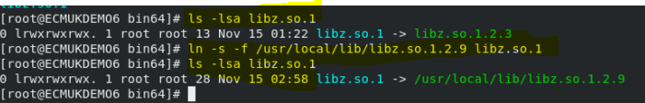

REF: <https://www.ibm.com/support/knowledgecenter/en/SS5R93_5.2.17/com.ibm.spectrum.sc.doc/cfg_cognos_content_store_Linux_Aix.html>

Copy the DB2 jdbc jar files from the WebSphere referenced path (for FileNet datasources) to the

**cd /opt/ibm/cognos/analytics114/drivers**

[root@ECMUKDEMO6 drivers]# **cp /opt/jars/*.* .**

[root@ECMUKDEMO6 drivers]# **ls**

**db2cc.jar db2jcc4.jar db2jcc.jar** **drivers.txt**

[root@ECMUKDEMO6 drivers]# cd ..

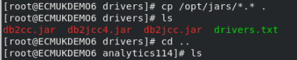

**cd /opt/ibm/cognos/analytics114/bin64**

**export JAVA_HOME=/opt/ibm/cognos/analytics114/jre**

**export JRE_HOME=/opt/ibm/cognos/analytics114/jre**

**export LD_LIBRARY_PATH=/opt/ibm/cognos/analytics114/bin64:.:/usr/bin/:/opt/ibm/cognos/analytics114/bin64**

**./cogconfig.sh**

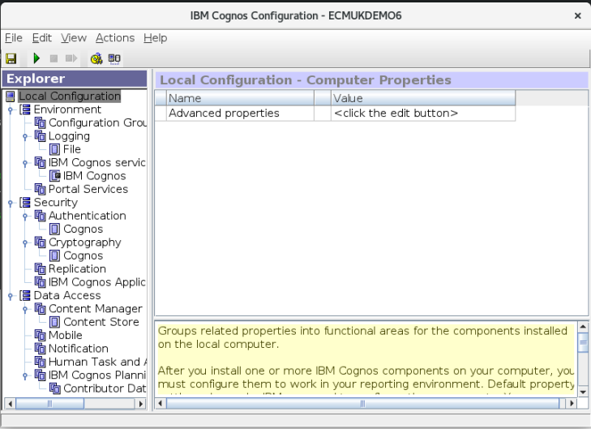

## Create the Cognos cm Content Store DB2 jdbc connections

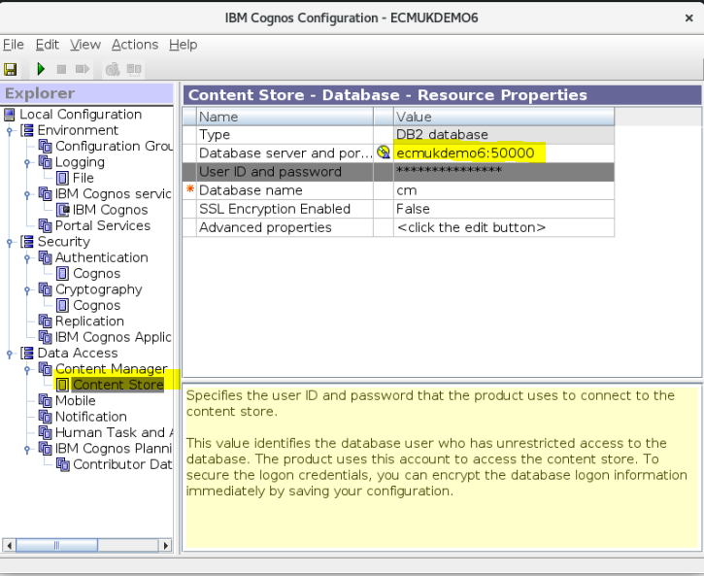

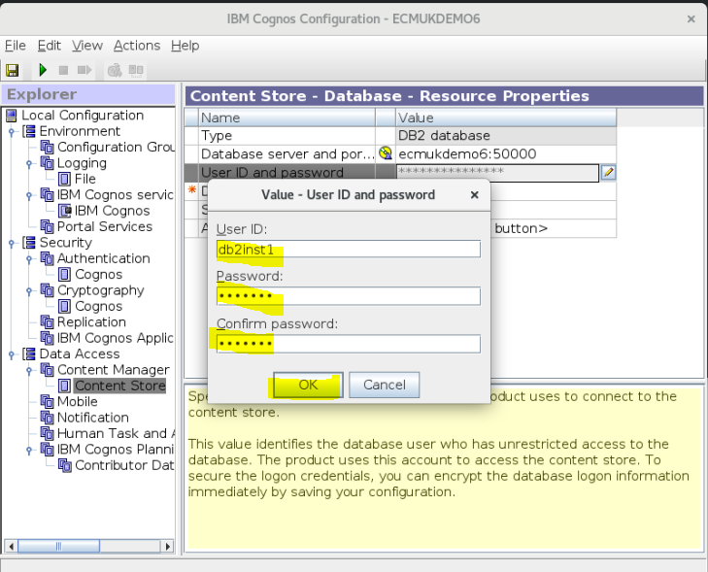

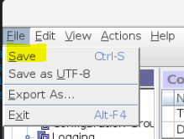

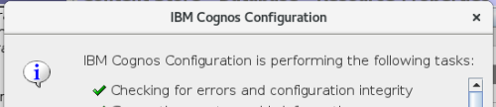

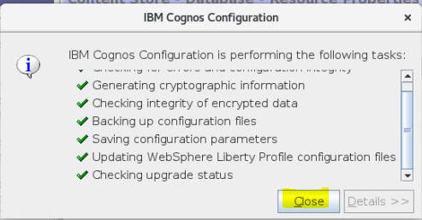

## Create the cm database DDL sql script

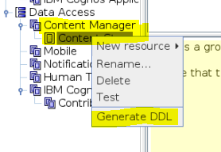

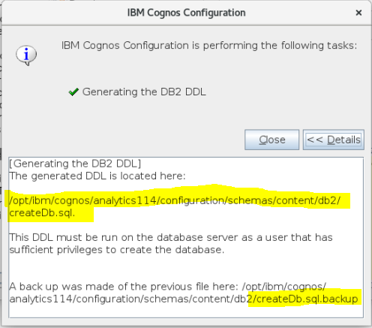

Click Close

## Create the Cognos cm database on db2

**su - db2inst1**

**pwd**

**db2 -tvf /opt/ibm/cognos/analytics114/configuration/schemas/content/db2/createDb.sql**

Commands run successfully as follows:

[root@ECMUKDEMO6 bin64]# **su - db2inst1**

Last login: Sat Nov 9 01:37:44 PST 2019 on pts/1

[db2inst1@ECMUKDEMO6 ~]$ **pwd**

/home/db2inst1

[db2inst1@ECMUKDEMO6 ~]$ **db2 -tvf /opt/ibm/cognos/analytics114/configuration/schemas/content/db2/createDb.sql**

CREATE DATABASE cm AUTOMATIC STORAGE YES ALIAS cm USING CODESET UTF-8 TERRITORY US COLLATE USING SYSTEM PAGESIZE 8192

DB20000I The CREATE DATABASE command completed successfully.

CHANGE DATABASE cm COMMENT WITH 'IBM Cognos Content Store'

DB20000I The CHANGE DATABASE COMMENT command completed successfully.

CONNECT TO cm

Database Connection Information

Database server = DB2/LINUXX8664 10.5.10

SQL authorization ID = DB2INST1

Local database alias = CM

UPDATE DATABASE CONFIGURATION USING APPLHEAPSZ 1024 DEFERRED

DB20000I The UPDATE DATABASE CONFIGURATION command completed successfully.

UPDATE DATABASE CONFIGURATION USING LOCKTIMEOUT 240 DEFERRED

DB20000I The UPDATE DATABASE CONFIGURATION command completed successfully.

CONNECT RESET

DB20000I The SQL command completed successfully.

CONNECT TO cm

Database Connection Information

Database server = DB2/LINUXX8664 10.5.10

SQL authorization ID = DB2INST1

Local database alias = CM

CREATE BUFFERPOOL cm_08KBP IMMEDIATE SIZE 1000 PAGESIZE 8K

DB20000I The SQL command completed successfully.

CREATE BUFFERPOOL cm_32KBP IMMEDIATE SIZE 1000 PAGESIZE 32K

DB20000I The SQL command completed successfully.

CONNECT RESET

DB20000I The SQL command completed successfully.

CONNECT TO cm

Database Connection Information

Database server = DB2/LINUXX8664 10.5.10

SQL authorization ID = DB2INST1

Local database alias = CM

CREATE SYSTEM TEMPORARY TABLESPACE TSN_SYS_cm IN DATABASE PARTITION GROUP IBMTEMPGROUP PAGESIZE 32K BUFFERPOOL cm_32KBP

DB20000I The SQL command completed successfully.

CREATE USER TEMPORARY TABLESPACE TSN_USR_cm IN DATABASE PARTITION GROUP IBMDEFAULTGROUP PAGESIZE 8K BUFFERPOOL IBMDEFAULTBP

DB20000I The SQL command completed successfully.

CREATE REGULAR TABLESPACE TSN_REG_cm IN DATABASE PARTITION GROUP IBMDEFAULTGROUP PAGESIZE 8K BUFFERPOOL cm_08KBP

DB20000I The SQL command completed successfully.

DROP TABLESPACE USERSPACE1

DB20000I The SQL command completed successfully.

CONNECT RESET

DB20000I The SQL command completed successfully.

CONNECT TO cm

Database Connection Information

Database server = DB2/LINUXX8664 10.5.10

SQL authorization ID = DB2INST1

Local database alias = CM

CREATE SCHEMA db2COGNOS AUTHORIZATION db2inst1

DB20000I The SQL command completed successfully.

COMMENT ON SCHEMA db2COGNOS IS 'IBM Cognos Content Store'

DB20000I The SQL command completed successfully.

GRANT CREATETAB,BINDADD,CONNECT,IMPLICIT_SCHEMA ON DATABASE TO USER db2inst1

DB21034E The command was processed as an SQL statement because it was not a

valid Command Line Processor command. During SQL processing it returned:

SQL0554N An authorization ID cannot grant a privilege or authority to itself.

SQLSTATE=42502

GRANT CREATEIN,DROPIN,ALTERIN ON SCHEMA DB2COGNOS TO USER db2inst1

DB21034E The command was processed as an SQL statement because it was not a

valid Command Line Processor command. During SQL processing it returned:

SQL0554N An authorization ID cannot grant a privilege or authority to itself.

SQLSTATE=42502

GRANT USE OF TABLESPACE TSN_USR_cm TO USER db2inst1

DB21034E The command was processed as an SQL statement because it was not a

valid Command Line Processor command. During SQL processing it returned:

SQL0554N An authorization ID cannot grant a privilege or authority to itself.

SQLSTATE=42502

GRANT USE OF TABLESPACE TSN_REG_cm TO USER db2inst1

DB21034E The command was processed as an SQL statement because it was not a

valid Command Line Processor command. During SQL processing it returned:

SQL0554N An authorization ID cannot grant a privilege or authority to itself.

SQLSTATE=42502

CONNECT RESET

**DB20000I The SQL command completed successfully.**

[db2inst1@ECMUKDEMO6 ~]$

**NOTE: REF : from the referenced IBM notes:**

“If the results of this command contain the following similar messages, **you can safely ignore those messages** because the Db2 instance owner already has the necessary privileges:

GRANT CREATETAB,BINDADD,CONNECT,IMPLICIT_SCHEMA ON DATABASE TO USER db2inst1

DB21034E The command was processed as an SQL statement because it was not a

valid Command Line Processor command. During SQL processing it returned:

SQL0554N An authorization ID cannot grant a privilege or authority to itself.

SQLSTATE=42502

GRANT CREATEIN,DROPIN,ALTERIN ON SCHEMA DB2COGNOS TO USER db2inst1

DB21034E The command was processed as an SQL statement because it was not a

valid Command Line Processor command. During SQL processing it returned:

SQL0554N An authorization ID cannot grant a privilege or authority to itself.

SQLSTATE=42502

GRANT USE OF TABLESPACE TSN_USR_cm TO USER db2inst1

DB21034E The command was processed as an SQL statement because it was not a

valid Command Line Processor command. During SQL processing it returned:

SQL0554N An authorization ID cannot grant a privilege or authority to itself.

SQLSTATE=42502

GRANT USE OF TABLESPACE TSN_REG_cm TO USER db2inst1

DB21034E The command was processed as an SQL statement because it was not a

valid Command Line Processor command. During SQL processing it returned:

SQL0554N An authorization ID cannot grant a privilege or authority to itself.

SQLSTATE=42502:

## Start the Cognos Configuration using the cogconfig.sh shell script

[root@ECMUKDEMO6 bin64]# **pwd**

/opt/ibm/cognos/analytics114/bin64

[root@ECMUKDEMO6 bin64]# **cd /opt/ibm/cognos/analytics114/bin64**

[root@ECMUKDEMO6 bin64]# **export JAVA_HOME=/opt/ibm/cognos/analytics114/jre**

[root@ECMUKDEMO6 bin64]# **export JRE_HOME=/opt/ibm/cognos/analytics114/jre**

[root@ECMUKDEMO6 bin64]# **export LD_LIBRARY_PATH=/opt/ibm/cognos/analytics114/bin64:.:/usr/bin/:/opt/ibm/cognos/analytics114/bin64**

[root@ECMUKDEMO6 bin64]# **./cogconfig.sh**

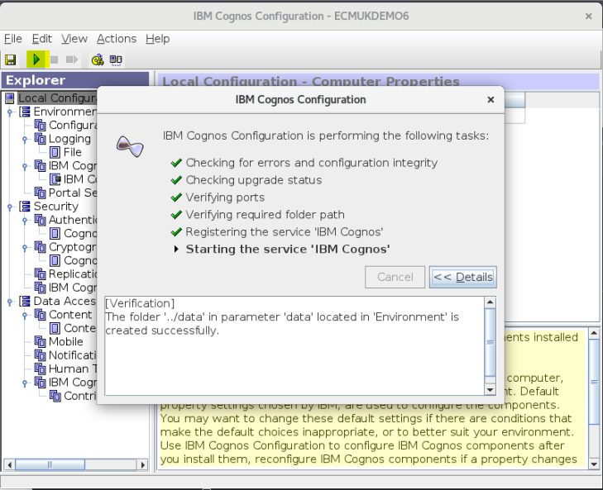

Start the Cognos system, click the 

## Cognos Start Console Log Output

[Verification]

The folder '../data' in parameter 'data' located in 'Environment' is created successfully.

[Start Service]

07:58:18, 'LogService', 'StartService', 'Success'.

07:58:21, CAF-WRN-0010 CAF input validation enabled.

07:58:21, CAF-WRN-0021 CAF Third Party XSS checking disabled.

07:59:48, CM-SYS-2057 Creating content store tables (schema version 7.00641).

08:00:22, CM-SYS-2215 A Content Manager internal PRECACHEINITACTIONS task started.

08:00:23, CM-SYS-2216 A Content Manager internal PRECACHEINITACTIONS task is complete.

08:00:24, CM-SYS-2216 A Content Manager internal POSTINITACTIONS task is complete.

08:00:24, CM-SYS-2215 A Content Manager internal POSTINITACTIONS task started.

08:00:24, CM-SYS-2093 The Content Manager cache initialization is complete. 1 objects loaded in 0.49 seconds.

08:00:58, 'ContentManagerService', 'StartService', 'Success'.

08:00:58, CM-SYS-5159 Content Manager is running in active mode.

08:00:57, CM-SYS-2215 A Content Manager internal CMUPGRADESCRIPT task started.

08:00:59, DPR-DPR-1002 Successfully registered the dispatcher http://ecmukdemo6:9300/p2pd in Content Manager.

08:01:45, 'SACamService', 'StartService', 'Success'.

08:01:45, 'camAsyncService', 'StartService', 'Success'.

08:01:55, 'AnnotationService', 'StartService', 'ANN DB Validation successful.'.

08:01:57, 'EventService', 'StartService', 'NC DB Validation successful.'.

08:02:05, 'HumanTaskService', 'StartService', 'HTS DB Validation successful.'.

08:02:21, 'PDC', 'StartService', 'Success'.

08:02:21, 'zipiService', 'StartService', 'Success'.

08:02:23, 'PresentationService', 'StartService', 'Success'.

08:02:23, 'BUX Service', 'StartService', 'Success'.

08:02:23, Start a cgsServer.sh because the start count 1 is larger than 0.

08:02:55, 'GraphicsService', 'StartService', 'Success'.

08:02:55, 'RepositoryService', 'StartService', 'Success'.

08:02:55, 'burstDistributionService', 'StartService', 'Success'.

08:04:54, 'QueryService', 'StartService', 'Success'.

08:06:02, 'QueryService', 'StartService', 'Success'.

08:06:02, 'visualisationGalleryService', 'StartService', 'Success'.

08:06:24, 'ReportService', 'StartService', 'Success'.

08:07:37, 'MobileService', 'StartService', 'Success'.

08:07:37, 'CacheService', 'StartService', 'Success'.

08:07:37, 'camAsyncAA', 'StartService', 'Success'.

08:07:37, 'Fragment Server Service', 'StartService', 'Success'.

08:07:37, 'SystemService', 'StartService', 'Success'.

08:07:37, 'ContentManagerCacheService', 'StartService', 'Success'.

08:07:37, 'relationalMetadataService', 'StartService', 'Success'.

08:07:37, 'BatchReportService', 'StartService', 'Success'.

08:07:37, 'SACamSrvc', 'StartService', 'Success'.

08:07:37, 'RestBridgeService', 'StartService', 'Success'.

08:07:37, 'SACamSrvcInternal', 'StartService', 'Success'.

08:07:37, 'ReportDataService', 'StartService', 'Success'.

08:07:37, 'DeliveryService', 'StartService', 'Success'.

08:07:41, 'MetadataService', 'StartService', 'Success'.

08:07:41, 'HumanTaskService', 'StartService', 'Success'.

08:07:41, 'JobService', 'StartService', 'Success'.

08:07:41, 'MonitorService', 'StartService', 'Success'.

08:07:41, 'EventService', 'StartService', 'Success'.

08:07:41, 'AgentService', 'StartService', 'Success'.

08:07:41, 'AnnotationService', 'StartService', 'Success'.

08:07:53, 'CPS Producer Registration Service', 'StartService', 'Success'.

08:07:54, 'Dispatcher', 'Start', 'Success'.

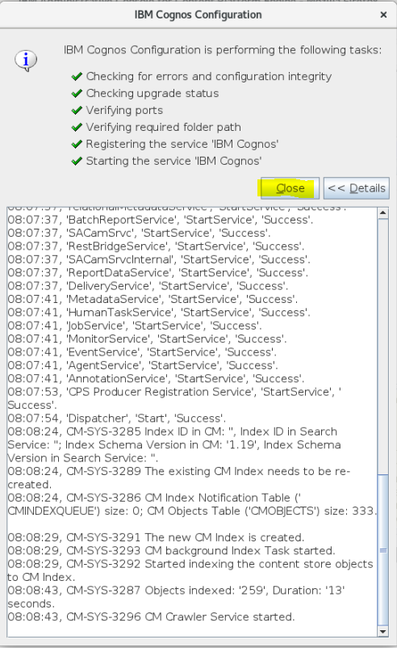

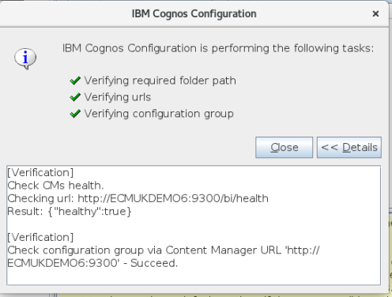

**http://ecmukdemo6:9300/bi/?perspective=home**



Screen now loading in RHEL 8.0 Linux

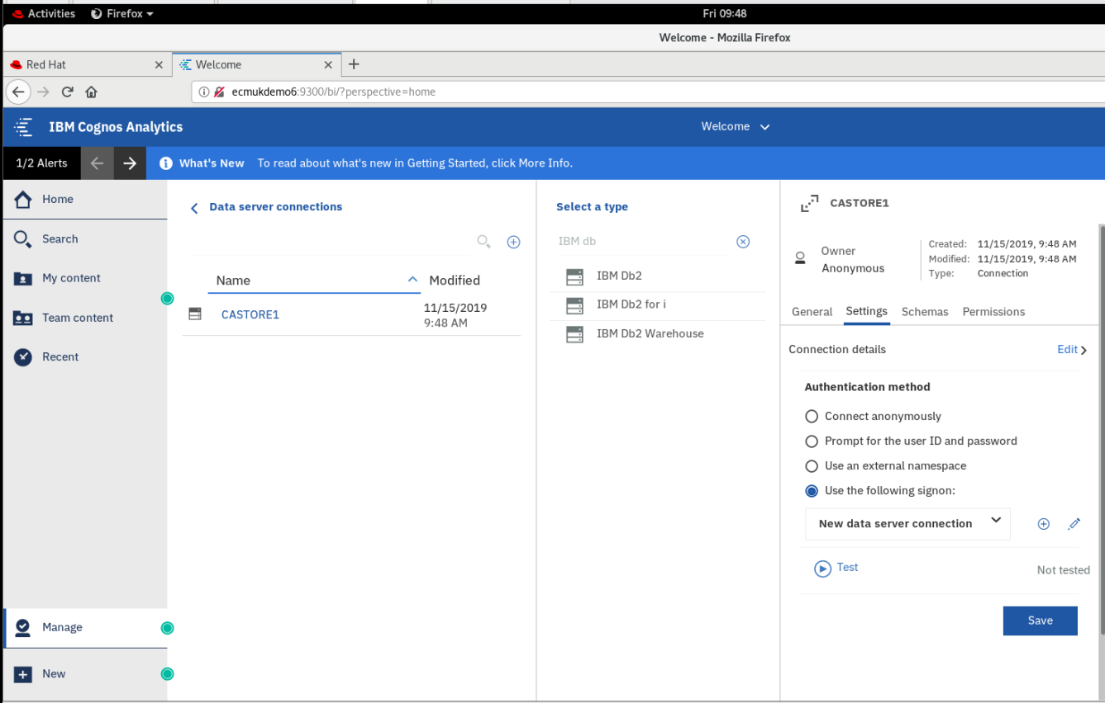

Datasource Connection created for CASTORE1

## Full log for the ZLIB fix recompilation for libz.so.1.2.9

The source of the ZLIB_1.2.9 **libz.so.1.2.9** missing shared object library was recompiled and a symbolic link set up in the cognos bin64 directory, source was downloaded from URL as follows on a windows server and copied to the VMware RHEL 8.0 Linux machine:

**https://sourceforge.net/projects/libpng/files/zlib/1.2.9/zlib-1.2.9.tar.gz/download**

[root@ECMUKDEMO6 analytics114]# **mkdir ZLIB129**

[root@ECMUKDEMO6 analytics114]# **cd ZLIB129/**

[root@ECMUKDEMO6 ZLIB129]# **cp /mnt/hgfs/Installs/Cognos11/zlib-1.2.9.tar.gz .**

[root@ECMUKDEMO6 ZLIB129]# ls

zlib-1.2.9.tar.gz

[root@ECMUKDEMO6 ZLIB129]# **tar -zxvf zlib-1.2.9.tar.gz**

zlib-1.2.9/

zlib-1.2.9/adler32.c

zlib-1.2.9/amiga/

zlib-1.2.9/ChangeLog

zlib-1.2.9/CMakeLists.txt

zlib-1.2.9/compress.c

zlib-1.2.9/configure

zlib-1.2.9/contrib/

zlib-1.2.9/crc32.c

zlib-1.2.9/crc32.h

zlib-1.2.9/deflate.c

zlib-1.2.9/deflate.h

zlib-1.2.9/doc/

zlib-1.2.9/examples/

zlib-1.2.9/FAQ

zlib-1.2.9/gzclose.c

zlib-1.2.9/gzguts.h

zlib-1.2.9/gzlib.c

zlib-1.2.9/gzread.c

zlib-1.2.9/gzwrite.c

zlib-1.2.9/INDEX

zlib-1.2.9/infback.c

zlib-1.2.9/inffast.c

zlib-1.2.9/inffast.h

zlib-1.2.9/inffixed.h

zlib-1.2.9/inflate.c

zlib-1.2.9/inflate.h

zlib-1.2.9/inftrees.c

zlib-1.2.9/inftrees.h

zlib-1.2.9/make_vms.com

zlib-1.2.9/Makefile

zlib-1.2.9/Makefile.in

zlib-1.2.9/msdos/

zlib-1.2.9/nintendods/

zlib-1.2.9/old/

zlib-1.2.9/os400/

zlib-1.2.9/qnx/

zlib-1.2.9/README

zlib-1.2.9/test/

zlib-1.2.9/treebuild.xml

zlib-1.2.9/trees.c

zlib-1.2.9/trees.h

zlib-1.2.9/uncompr.c

zlib-1.2.9/watcom/

zlib-1.2.9/win32/

zlib-1.2.9/zconf.h

zlib-1.2.9/zconf.h.cmakein

zlib-1.2.9/zconf.h.in

zlib-1.2.9/zlib.3

zlib-1.2.9/zlib.3.pdf

zlib-1.2.9/zlib.h

zlib-1.2.9/zlib.map

zlib-1.2.9/zlib.pc.cmakein

zlib-1.2.9/zlib.pc.in

zlib-1.2.9/zlib2ansi

zlib-1.2.9/zutil.c

zlib-1.2.9/zutil.h

zlib-1.2.9/win32/DLL_FAQ.txt

zlib-1.2.9/win32/Makefile.bor

zlib-1.2.9/win32/Makefile.gcc

zlib-1.2.9/win32/Makefile.msc

zlib-1.2.9/win32/README-WIN32.txt

zlib-1.2.9/win32/VisualC.txt

zlib-1.2.9/win32/zlib.def

zlib-1.2.9/win32/zlib1.rc

zlib-1.2.9/watcom/watcom_f.mak

zlib-1.2.9/watcom/watcom_l.mak

zlib-1.2.9/test/example.c

zlib-1.2.9/test/infcover.c

zlib-1.2.9/test/minigzip.c

zlib-1.2.9/qnx/package.qpg

zlib-1.2.9/os400/bndsrc

zlib-1.2.9/os400/make.sh

zlib-1.2.9/os400/README400

zlib-1.2.9/os400/zlib.inc

zlib-1.2.9/old/descrip.mms

zlib-1.2.9/old/Makefile.emx

zlib-1.2.9/old/Makefile.riscos

zlib-1.2.9/old/os2/

zlib-1.2.9/old/README

zlib-1.2.9/old/visual-basic.txt

zlib-1.2.9/old/os2/Makefile.os2

zlib-1.2.9/old/os2/zlib.def

zlib-1.2.9/nintendods/Makefile

zlib-1.2.9/nintendods/README

zlib-1.2.9/msdos/Makefile.bor

zlib-1.2.9/msdos/Makefile.dj2

zlib-1.2.9/msdos/Makefile.emx

zlib-1.2.9/msdos/Makefile.msc

zlib-1.2.9/msdos/Makefile.tc

zlib-1.2.9/examples/enough.c

zlib-1.2.9/examples/fitblk.c

zlib-1.2.9/examples/gun.c

zlib-1.2.9/examples/gzappend.c

zlib-1.2.9/examples/gzjoin.c

zlib-1.2.9/examples/gzlog.c

zlib-1.2.9/examples/gzlog.h

zlib-1.2.9/examples/README.examples

zlib-1.2.9/examples/zlib_how.html

zlib-1.2.9/examples/zpipe.c

zlib-1.2.9/examples/zran.c

zlib-1.2.9/doc/algorithm.txt

zlib-1.2.9/doc/rfc1950.txt

zlib-1.2.9/doc/rfc1951.txt

zlib-1.2.9/doc/rfc1952.txt

zlib-1.2.9/doc/txtvsbin.txt

zlib-1.2.9/contrib/ada/

zlib-1.2.9/contrib/amd64/

zlib-1.2.9/contrib/asm686/

zlib-1.2.9/contrib/blast/

zlib-1.2.9/contrib/delphi/

zlib-1.2.9/contrib/dotzlib/

zlib-1.2.9/contrib/gcc_gvmat64/

zlib-1.2.9/contrib/infback9/

zlib-1.2.9/contrib/inflate86/

zlib-1.2.9/contrib/iostream/

zlib-1.2.9/contrib/iostream2/

zlib-1.2.9/contrib/iostream3/

zlib-1.2.9/contrib/masmx64/

zlib-1.2.9/contrib/masmx86/

zlib-1.2.9/contrib/minizip/

zlib-1.2.9/contrib/pascal/

zlib-1.2.9/contrib/puff/

zlib-1.2.9/contrib/README.contrib

zlib-1.2.9/contrib/testzlib/

zlib-1.2.9/contrib/untgz/

zlib-1.2.9/contrib/vstudio/

zlib-1.2.9/contrib/vstudio/readme.txt

zlib-1.2.9/contrib/vstudio/vc10/

zlib-1.2.9/contrib/vstudio/vc11/

zlib-1.2.9/contrib/vstudio/vc12/

zlib-1.2.9/contrib/vstudio/vc14/

zlib-1.2.9/contrib/vstudio/vc9/

zlib-1.2.9/contrib/vstudio/vc9/miniunz.vcproj

zlib-1.2.9/contrib/vstudio/vc9/minizip.vcproj

zlib-1.2.9/contrib/vstudio/vc9/testzlib.vcproj

zlib-1.2.9/contrib/vstudio/vc9/testzlibdll.vcproj

zlib-1.2.9/contrib/vstudio/vc9/zlib.rc

zlib-1.2.9/contrib/vstudio/vc9/zlibstat.vcproj

zlib-1.2.9/contrib/vstudio/vc9/zlibvc.def

zlib-1.2.9/contrib/vstudio/vc9/zlibvc.sln

zlib-1.2.9/contrib/vstudio/vc9/zlibvc.vcproj

zlib-1.2.9/contrib/vstudio/vc14/miniunz.vcxproj

zlib-1.2.9/contrib/vstudio/vc14/miniunz.vcxproj.user

zlib-1.2.9/contrib/vstudio/vc14/minizip.vcxproj

zlib-1.2.9/contrib/vstudio/vc14/minizip.vcxproj.user

zlib-1.2.9/contrib/vstudio/vc14/testzlib.vcxproj

zlib-1.2.9/contrib/vstudio/vc14/testzlib.vcxproj.user

zlib-1.2.9/contrib/vstudio/vc14/testzlibdll.vcxproj

zlib-1.2.9/contrib/vstudio/vc14/testzlibdll.vcxproj.user

zlib-1.2.9/contrib/vstudio/vc14/zlib.rc

zlib-1.2.9/contrib/vstudio/vc14/zlibstat.vcxproj

zlib-1.2.9/contrib/vstudio/vc14/zlibstat.vcxproj.user

zlib-1.2.9/contrib/vstudio/vc14/zlibvc.def

zlib-1.2.9/contrib/vstudio/vc14/zlibvc.sln

zlib-1.2.9/contrib/vstudio/vc14/zlibvc.vcxproj

zlib-1.2.9/contrib/vstudio/vc14/zlibvc.vcxproj.user

zlib-1.2.9/contrib/vstudio/vc12/miniunz.vcxproj

zlib-1.2.9/contrib/vstudio/vc12/minizip.vcxproj

zlib-1.2.9/contrib/vstudio/vc12/testzlib.vcxproj

zlib-1.2.9/contrib/vstudio/vc12/testzlibdll.vcxproj

zlib-1.2.9/contrib/vstudio/vc12/zlib.rc

zlib-1.2.9/contrib/vstudio/vc12/zlibstat.vcxproj

zlib-1.2.9/contrib/vstudio/vc12/zlibvc.def

zlib-1.2.9/contrib/vstudio/vc12/zlibvc.sln

zlib-1.2.9/contrib/vstudio/vc12/zlibvc.vcxproj

zlib-1.2.9/contrib/vstudio/vc11/miniunz.vcxproj

zlib-1.2.9/contrib/vstudio/vc11/minizip.vcxproj

zlib-1.2.9/contrib/vstudio/vc11/testzlib.vcxproj

zlib-1.2.9/contrib/vstudio/vc11/testzlibdll.vcxproj

zlib-1.2.9/contrib/vstudio/vc11/zlib.rc

zlib-1.2.9/contrib/vstudio/vc11/zlibstat.vcxproj

zlib-1.2.9/contrib/vstudio/vc11/zlibvc.def

zlib-1.2.9/contrib/vstudio/vc11/zlibvc.sln

zlib-1.2.9/contrib/vstudio/vc11/zlibvc.vcxproj

zlib-1.2.9/contrib/vstudio/vc10/miniunz.vcxproj

zlib-1.2.9/contrib/vstudio/vc10/miniunz.vcxproj.filters

zlib-1.2.9/contrib/vstudio/vc10/minizip.vcxproj

zlib-1.2.9/contrib/vstudio/vc10/minizip.vcxproj.filters

zlib-1.2.9/contrib/vstudio/vc10/testzlib.vcxproj

zlib-1.2.9/contrib/vstudio/vc10/testzlib.vcxproj.filters

zlib-1.2.9/contrib/vstudio/vc10/testzlibdll.vcxproj

zlib-1.2.9/contrib/vstudio/vc10/testzlibdll.vcxproj.filters

zlib-1.2.9/contrib/vstudio/vc10/zlib.rc

zlib-1.2.9/contrib/vstudio/vc10/zlibstat.vcxproj

zlib-1.2.9/contrib/vstudio/vc10/zlibstat.vcxproj.filters

zlib-1.2.9/contrib/vstudio/vc10/zlibvc.def

zlib-1.2.9/contrib/vstudio/vc10/zlibvc.sln

zlib-1.2.9/contrib/vstudio/vc10/zlibvc.vcxproj

zlib-1.2.9/contrib/vstudio/vc10/zlibvc.vcxproj.filters

zlib-1.2.9/contrib/untgz/Makefile

zlib-1.2.9/contrib/untgz/Makefile.msc

zlib-1.2.9/contrib/untgz/untgz.c

zlib-1.2.9/contrib/testzlib/testzlib.c

zlib-1.2.9/contrib/testzlib/testzlib.txt

zlib-1.2.9/contrib/puff/Makefile

zlib-1.2.9/contrib/puff/puff.c

zlib-1.2.9/contrib/puff/puff.h

zlib-1.2.9/contrib/puff/pufftest.c

zlib-1.2.9/contrib/puff/README

zlib-1.2.9/contrib/puff/zeros.raw

zlib-1.2.9/contrib/pascal/example.pas

zlib-1.2.9/contrib/pascal/readme.txt

zlib-1.2.9/contrib/pascal/zlibd32.mak

zlib-1.2.9/contrib/pascal/zlibpas.pas

zlib-1.2.9/contrib/minizip/configure.ac

zlib-1.2.9/contrib/minizip/crypt.h

zlib-1.2.9/contrib/minizip/ioapi.c

zlib-1.2.9/contrib/minizip/ioapi.h

zlib-1.2.9/contrib/minizip/iowin32.c

zlib-1.2.9/contrib/minizip/iowin32.h

zlib-1.2.9/contrib/minizip/make_vms.com

zlib-1.2.9/contrib/minizip/Makefile

zlib-1.2.9/contrib/minizip/Makefile.am

zlib-1.2.9/contrib/minizip/miniunz.c

zlib-1.2.9/contrib/minizip/miniunzip.1

zlib-1.2.9/contrib/minizip/minizip.1

zlib-1.2.9/contrib/minizip/minizip.c

zlib-1.2.9/contrib/minizip/minizip.pc.in

zlib-1.2.9/contrib/minizip/MiniZip64_Changes.txt

zlib-1.2.9/contrib/minizip/MiniZip64_info.txt

zlib-1.2.9/contrib/minizip/mztools.c

zlib-1.2.9/contrib/minizip/mztools.h

zlib-1.2.9/contrib/minizip/unzip.c

zlib-1.2.9/contrib/minizip/unzip.h

zlib-1.2.9/contrib/minizip/zip.c

zlib-1.2.9/contrib/minizip/zip.h

zlib-1.2.9/contrib/masmx86/bld_ml32.bat

zlib-1.2.9/contrib/masmx86/inffas32.asm

zlib-1.2.9/contrib/masmx86/match686.asm

zlib-1.2.9/contrib/masmx86/readme.txt

zlib-1.2.9/contrib/masmx64/bld_ml64.bat

zlib-1.2.9/contrib/masmx64/gvmat64.asm

zlib-1.2.9/contrib/masmx64/inffas8664.c

zlib-1.2.9/contrib/masmx64/inffasx64.asm

zlib-1.2.9/contrib/masmx64/readme.txt

zlib-1.2.9/contrib/iostream3/README

zlib-1.2.9/contrib/iostream3/test.cc

zlib-1.2.9/contrib/iostream3/TODO

zlib-1.2.9/contrib/iostream3/zfstream.cc

zlib-1.2.9/contrib/iostream3/zfstream.h

zlib-1.2.9/contrib/iostream2/zstream.h

zlib-1.2.9/contrib/iostream2/zstream_test.cpp

zlib-1.2.9/contrib/iostream/test.cpp

zlib-1.2.9/contrib/iostream/zfstream.cpp

zlib-1.2.9/contrib/iostream/zfstream.h

zlib-1.2.9/contrib/inflate86/inffas86.c

zlib-1.2.9/contrib/inflate86/inffast.S

zlib-1.2.9/contrib/infback9/infback9.c

zlib-1.2.9/contrib/infback9/infback9.h

zlib-1.2.9/contrib/infback9/inffix9.h

zlib-1.2.9/contrib/infback9/inflate9.h

zlib-1.2.9/contrib/infback9/inftree9.c

zlib-1.2.9/contrib/infback9/inftree9.h

zlib-1.2.9/contrib/infback9/README

zlib-1.2.9/contrib/gcc_gvmat64/gvmat64.S

zlib-1.2.9/contrib/dotzlib/DotZLib/

zlib-1.2.9/contrib/dotzlib/DotZLib.build

zlib-1.2.9/contrib/dotzlib/DotZLib.chm

zlib-1.2.9/contrib/dotzlib/DotZLib.sln

zlib-1.2.9/contrib/dotzlib/LICENSE_1_0.txt

zlib-1.2.9/contrib/dotzlib/readme.txt

zlib-1.2.9/contrib/dotzlib/DotZLib/AssemblyInfo.cs

zlib-1.2.9/contrib/dotzlib/DotZLib/ChecksumImpl.cs

zlib-1.2.9/contrib/dotzlib/DotZLib/CircularBuffer.cs

zlib-1.2.9/contrib/dotzlib/DotZLib/CodecBase.cs

zlib-1.2.9/contrib/dotzlib/DotZLib/Deflater.cs

zlib-1.2.9/contrib/dotzlib/DotZLib/DotZLib.cs

zlib-1.2.9/contrib/dotzlib/DotZLib/DotZLib.csproj

zlib-1.2.9/contrib/dotzlib/DotZLib/GZipStream.cs

zlib-1.2.9/contrib/dotzlib/DotZLib/Inflater.cs

zlib-1.2.9/contrib/dotzlib/DotZLib/UnitTests.cs

zlib-1.2.9/contrib/delphi/readme.txt

zlib-1.2.9/contrib/delphi/ZLib.pas

zlib-1.2.9/contrib/delphi/ZLibConst.pas

zlib-1.2.9/contrib/delphi/zlibd32.mak

zlib-1.2.9/contrib/blast/blast.c

zlib-1.2.9/contrib/blast/blast.h

zlib-1.2.9/contrib/blast/Makefile

zlib-1.2.9/contrib/blast/README

zlib-1.2.9/contrib/blast/test.pk

zlib-1.2.9/contrib/blast/test.txt

zlib-1.2.9/contrib/asm686/match.S

zlib-1.2.9/contrib/asm686/README.686

zlib-1.2.9/contrib/amd64/amd64-match.S

zlib-1.2.9/contrib/ada/buffer_demo.adb

zlib-1.2.9/contrib/ada/mtest.adb

zlib-1.2.9/contrib/ada/read.adb

zlib-1.2.9/contrib/ada/readme.txt

zlib-1.2.9/contrib/ada/test.adb

zlib-1.2.9/contrib/ada/zlib-streams.adb

zlib-1.2.9/contrib/ada/zlib-streams.ads

zlib-1.2.9/contrib/ada/zlib-thin.adb

zlib-1.2.9/contrib/ada/zlib-thin.ads

zlib-1.2.9/contrib/ada/zlib.adb

zlib-1.2.9/contrib/ada/zlib.ads

zlib-1.2.9/contrib/ada/zlib.gpr

zlib-1.2.9/amiga/Makefile.pup

zlib-1.2.9/amiga/Makefile.sas

Rebuild of the zlib

[root@ECMUKDEMO6 ZLIB129]# **ls**

**zlib-1.2.9** **zlib-1.2.9.tar.gz**

[root@ECMUKDEMO6 ZLIB129]# **cd zlib-1.2.9/**

[root@ECMUKDEMO6 zlib-1.2.9]# **ls**

adler32.c configure deflate.h gzguts.h infback.c inflate.h make_vms.com qnx trees.h zconf.h.cmakein zlib.h zutil.h

amiga contrib doc gzlib.c inffast.c inftrees.c msdos README uncompr.c zconf.h.in zlib.map

ChangeLog crc32.c examples gzread.c inffast.h inftrees.h nintendods test watcom zlib2ansi zlib.pc.cmakein

CMakeLists.txt crc32.h FAQ gzwrite.c inffixed.h Makefile old treebuild.xml win32 zlib.3 zlib.pc.in

compress.c deflate.c gzclose.c INDEX inflate.c Makefile.in os400 trees.c zconf.h zlib.3.pdf zutil.c

[root@ECMUKDEMO6 zlib-1.2.9]# **./configure; make; make install**

Checking for gcc...

Checking for shared library support...

Building shared library libz.so.1.2.9 with gcc.

Checking for size_t... Yes.

Checking for off64_t... Yes.

Checking for fseeko... Yes.

Checking for strerror... Yes.

Checking for unistd.h... Yes.

Checking for stdarg.h... Yes.

Checking whether to use vs[n]printf() or s[n]printf()... using vs[n]printf().

Checking for vsnprintf() in stdio.h... Yes.

Checking for return value of vsnprintf()... Yes.

Checking for attribute(visibility) support... Yes.

gcc -O3 -D_LARGEFILE64_SOURCE=1 -DHAVE_HIDDEN -I. -c -o example.o test/example.c

gcc -O3 -D_LARGEFILE64_SOURCE=1 -DHAVE_HIDDEN -c -o adler32.o adler32.c

gcc -O3 -D_LARGEFILE64_SOURCE=1 -DHAVE_HIDDEN -c -o crc32.o crc32.c

gcc -O3 -D_LARGEFILE64_SOURCE=1 -DHAVE_HIDDEN -c -o deflate.o deflate.c

gcc -O3 -D_LARGEFILE64_SOURCE=1 -DHAVE_HIDDEN -c -o infback.o infback.c

gcc -O3 -D_LARGEFILE64_SOURCE=1 -DHAVE_HIDDEN -c -o inffast.o inffast.c

gcc -O3 -D_LARGEFILE64_SOURCE=1 -DHAVE_HIDDEN -c -o inflate.o inflate.c

gcc -O3 -D_LARGEFILE64_SOURCE=1 -DHAVE_HIDDEN -c -o inftrees.o inftrees.c

gcc -O3 -D_LARGEFILE64_SOURCE=1 -DHAVE_HIDDEN -c -o trees.o trees.c

gcc -O3 -D_LARGEFILE64_SOURCE=1 -DHAVE_HIDDEN -c -o zutil.o zutil.c

gcc -O3 -D_LARGEFILE64_SOURCE=1 -DHAVE_HIDDEN -c -o compress.o compress.c

gcc -O3 -D_LARGEFILE64_SOURCE=1 -DHAVE_HIDDEN -c -o uncompr.o uncompr.c

gcc -O3 -D_LARGEFILE64_SOURCE=1 -DHAVE_HIDDEN -c -o gzclose.o gzclose.c

gcc -O3 -D_LARGEFILE64_SOURCE=1 -DHAVE_HIDDEN -c -o gzlib.o gzlib.c

gcc -O3 -D_LARGEFILE64_SOURCE=1 -DHAVE_HIDDEN -c -o gzread.o gzread.c

gcc -O3 -D_LARGEFILE64_SOURCE=1 -DHAVE_HIDDEN -c -o gzwrite.o gzwrite.c

ar rc libz.a adler32.o crc32.o deflate.o infback.o inffast.o inflate.o inftrees.o trees.o zutil.o compress.o uncompr.o gzclose.o gzlib.o gzread.o gzwrite.o

gcc -O3 -D_LARGEFILE64_SOURCE=1 -DHAVE_HIDDEN -o example example.o -L. libz.a

gcc -O3 -D_LARGEFILE64_SOURCE=1 -DHAVE_HIDDEN -I. -c -o minigzip.o test/minigzip.c

gcc -O3 -D_LARGEFILE64_SOURCE=1 -DHAVE_HIDDEN -o minigzip minigzip.o -L. libz.a

gcc -O3 -fPIC -D_LARGEFILE64_SOURCE=1 -DHAVE_HIDDEN -DPIC -c -o objs/adler32.o adler32.c

gcc -O3 -fPIC -D_LARGEFILE64_SOURCE=1 -DHAVE_HIDDEN -DPIC -c -o objs/crc32.o crc32.c

gcc -O3 -fPIC -D_LARGEFILE64_SOURCE=1 -DHAVE_HIDDEN -DPIC -c -o objs/deflate.o deflate.c

gcc -O3 -fPIC -D_LARGEFILE64_SOURCE=1 -DHAVE_HIDDEN -DPIC -c -o objs/infback.o infback.c

gcc -O3 -fPIC -D_LARGEFILE64_SOURCE=1 -DHAVE_HIDDEN -DPIC -c -o objs/inffast.o inffast.c

gcc -O3 -fPIC -D_LARGEFILE64_SOURCE=1 -DHAVE_HIDDEN -DPIC -c -o objs/inflate.o inflate.c

gcc -O3 -fPIC -D_LARGEFILE64_SOURCE=1 -DHAVE_HIDDEN -DPIC -c -o objs/inftrees.o inftrees.c

gcc -O3 -fPIC -D_LARGEFILE64_SOURCE=1 -DHAVE_HIDDEN -DPIC -c -o objs/trees.o trees.c

gcc -O3 -fPIC -D_LARGEFILE64_SOURCE=1 -DHAVE_HIDDEN -DPIC -c -o objs/zutil.o zutil.c

gcc -O3 -fPIC -D_LARGEFILE64_SOURCE=1 -DHAVE_HIDDEN -DPIC -c -o objs/compress.o compress.c

gcc -O3 -fPIC -D_LARGEFILE64_SOURCE=1 -DHAVE_HIDDEN -DPIC -c -o objs/uncompr.o uncompr.c

gcc -O3 -fPIC -D_LARGEFILE64_SOURCE=1 -DHAVE_HIDDEN -DPIC -c -o objs/gzclose.o gzclose.c

gcc -O3 -fPIC -D_LARGEFILE64_SOURCE=1 -DHAVE_HIDDEN -DPIC -c -o objs/gzlib.o gzlib.c

gcc -O3 -fPIC -D_LARGEFILE64_SOURCE=1 -DHAVE_HIDDEN -DPIC -c -o objs/gzread.o gzread.c

gcc -O3 -fPIC -D_LARGEFILE64_SOURCE=1 -DHAVE_HIDDEN -DPIC -c -o objs/gzwrite.o gzwrite.c

gcc -shared -Wl,-soname,libz.so.1,--version-script,zlib.map -O3 -fPIC -D_LARGEFILE64_SOURCE=1 -DHAVE_HIDDEN -o libz.so.1.2.9 adler32.lo crc32.lo deflate.lo infback.lo inffast.lo inflate.lo inftrees.lo trees.lo zutil.lo compress.lo uncompr.lo gzclose.lo gzlib.lo gzread.lo gzwrite.lo -lc

rm -f libz.so libz.so.1

ln -s libz.so.1.2.9 libz.so

ln -s libz.so.1.2.9 libz.so.1

gcc -O3 -D_LARGEFILE64_SOURCE=1 -DHAVE_HIDDEN -o examplesh example.o -L. libz.so.1.2.9

gcc -O3 -D_LARGEFILE64_SOURCE=1 -DHAVE_HIDDEN -o minigzipsh minigzip.o -L. libz.so.1.2.9

gcc -O3 -D_LARGEFILE64_SOURCE=1 -DHAVE_HIDDEN -I. -D_FILE_OFFSET_BITS=64 -c -o example64.o test/example.c

gcc -O3 -D_LARGEFILE64_SOURCE=1 -DHAVE_HIDDEN -o example64 example64.o -L. libz.a

gcc -O3 -D_LARGEFILE64_SOURCE=1 -DHAVE_HIDDEN -I. -D_FILE_OFFSET_BITS=64 -c -o minigzip64.o test/minigzip.c

gcc -O3 -D_LARGEFILE64_SOURCE=1 -DHAVE_HIDDEN -o minigzip64 minigzip64.o -L. libz.a

cp libz.a /usr/local/lib

chmod 644 /usr/local/lib/libz.a

cp libz.so.1.2.9 /usr/local/lib

chmod 755 /usr/local/lib/libz.so.1.2.9

cp zlib.3 /usr/local/share/man/man3

chmod 644 /usr/local/share/man/man3/zlib.3

cp zlib.pc /usr/local/lib/pkgconfig

chmod 644 /usr/local/lib/pkgconfig/zlib.pc

cp zlib.h zconf.h /usr/local/include

chmod 644 /usr/local/include/zlib.h /usr/local/include/zconf.h

[root@ECMUKDEMO6 zlib-1.2.9]#

## Cognos 11.1.4 Linux Log file locations

[root@ECMUKDEMO6 bin64]# **find /opt/ibm/cognos/analytics114 -name *.log**

/opt/ibm/cognos/analytics114/uninstall/logs/install_configuration.log

/opt/ibm/cognos/analytics114/uninstall/logs/IBM_Cognos_Analytics_Install_11_12_2019_01_18_59.log

/opt/ibm/cognos/analytics114/bin64/build/logs/core.log

/opt/ibm/cognos/analytics114/wlp/usr/servers/dataset-service/logs/messages.log

/opt/ibm/cognos/analytics114/wlp/usr/servers/cognosserver/logs/console.log

/opt/ibm/cognos/analytics114/wlp/usr/servers/cognosserver/logs/p2pd_messages.log

/opt/ibm/cognos/analytics114/wlp/usr/servers/cognosserver/logs/messages_19.11.12_07.53.05.0.log

/opt/ibm/cognos/analytics114/wlp/usr/servers/cognosserver/logs/messages.log

/opt/ibm/cognos/analytics114/wlp/lib/fixes/fixinstall.log

/opt/ibm/cognos/analytics114/logs/cogconfig.log

/opt/ibm/cognos/analytics114/logs/ipfInternal_cpp.log

/opt/ibm/cognos/analytics114/logs/ipfInternal_java.log

/opt/ibm/cognos/analytics114/logs/cbsdefault.log

/opt/ibm/cognos/analytics114/logs/cbs_cnfgtest_run_WebSphereLiberty.log

/opt/ibm/cognos/analytics114/logs/cogconfigipf.log

/opt/ibm/cognos/analytics114/logs/cbs_start_WebSphereLiberty.log

/opt/ibm/cognos/analytics114/logs/cbs_run_WebSphereLiberty.log

/opt/ibm/cognos/analytics114/logs/p2pd_messages.log

/opt/ibm/cognos/analytics114/logs/ffdc/ffdc_19.11.12_07.54.39.0.log

/opt/ibm/cognos/analytics114/logs/ffdc/exception_summary_19.11.15_07.54.39.0.log

/opt/ibm/cognos/analytics114/logs/ffdc/ffdc_19.11.12_07.55.08.0.log

/opt/ibm/cognos/analytics114/logs/ffdc/ffdc_19.11.12_07.59.25.0.log

/opt/ibm/cognos/analytics114/logs/cognosserver.log

/opt/ibm/cognos/analytics114/logs/cogaudit_default.log

/opt/ibm/cognos/analytics114/logs/cogaudit.log

/opt/ibm/cognos/analytics114/logs/cmMetrics_2019-11-12.log

/opt/ibm/cognos/analytics114/logs/mobccs.log

/opt/ibm/cognos/analytics114/logs/mob.log

/opt/ibm/cognos/analytics114/logs/visualization.log

/opt/ibm/cognos/analytics114/logs/dq_messages.log

/opt/ibm/cognos/analytics114/logs/dataset-service.log

/opt/ibm/cognos/analytics114/logs/flint-console.log

/opt/ibm/cognos/analytics114/logs/cbs_isrunning_WebSphereLiberty.log

/opt/ibm/cognos/analytics114/ZLIB129/zlib-1.2.9/configure.log