**Upgrade to Fix Pack 7 on Windows 2008 R2**

From <https://www-01.ibm.com/support/docview.wss?uid=swg22015716> , look at the “Use IBM Installation Manager to point to a **local copy** of the fix pack” section and download the following 4 zip files.

**Use the following instructions**:

1. To update Optim Designer, download <http://public.dhe.ibm.com/software/rationalsdp/v75/nex/zips/OPDM-11.03.07-designer_update.zip>
2. To update Optim Runtime Services, download <http://public.dhe.ibm.com/software/rationalsdp/v75/nex/zips/OPDM-11.03.07-runtime_update.zip>
3. To update WAS CE: download <http://public.dhe.ibm.com/software/rationalsdp/v75/nex/zips/OPDM-11.03.07-wasce_update.zip>
4. To update Optim Web Applications, download <http://public.dhe.ibm.com/software/rationalsdp/v75/nex/zips/OPDM-11.03.07-web_update.zip>

Follow the rest steps under the same section for the upgrade.

Below are the major screenshots that I collected during the upgrade.

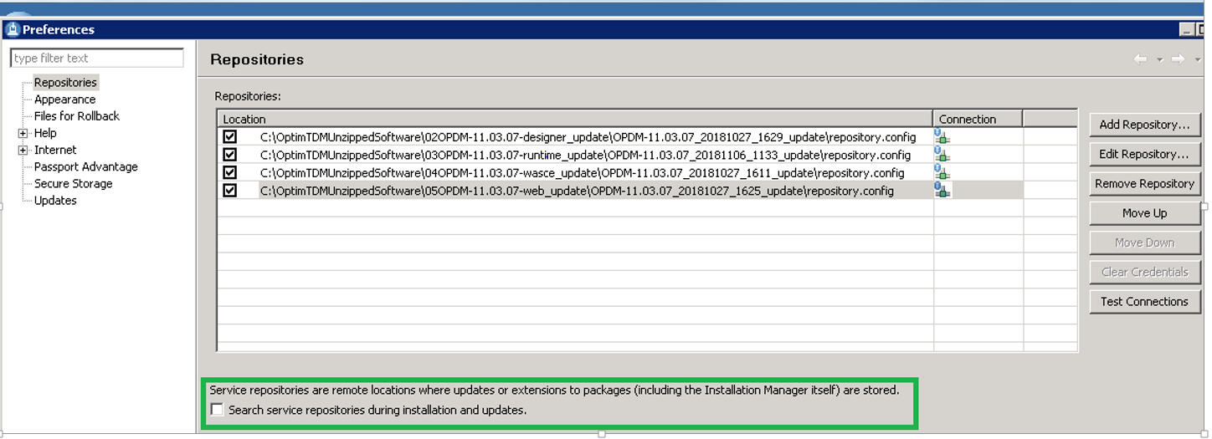

Fig. Add Repository for each Optim component & unmark the check box "Search service repositories during installation and updates."

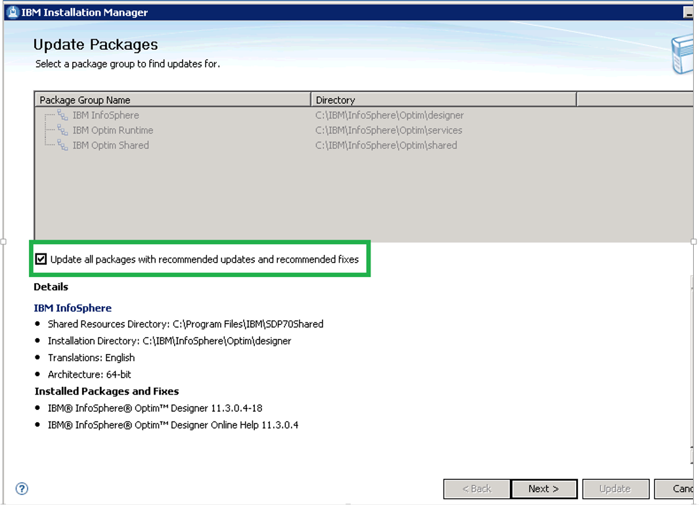

I shouldn’t have marked this checkbox!

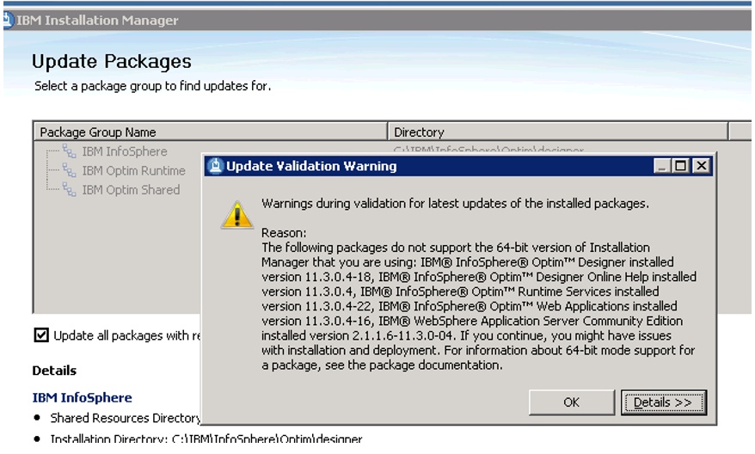

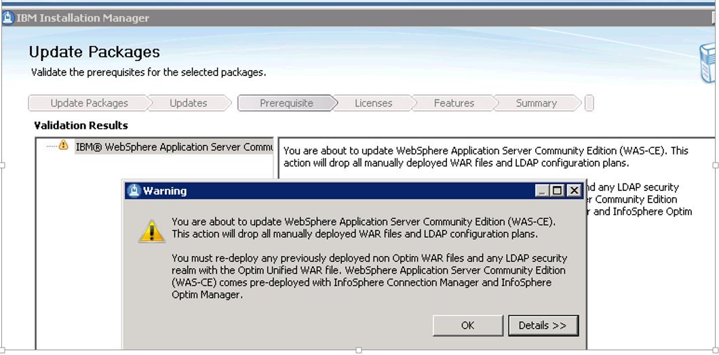

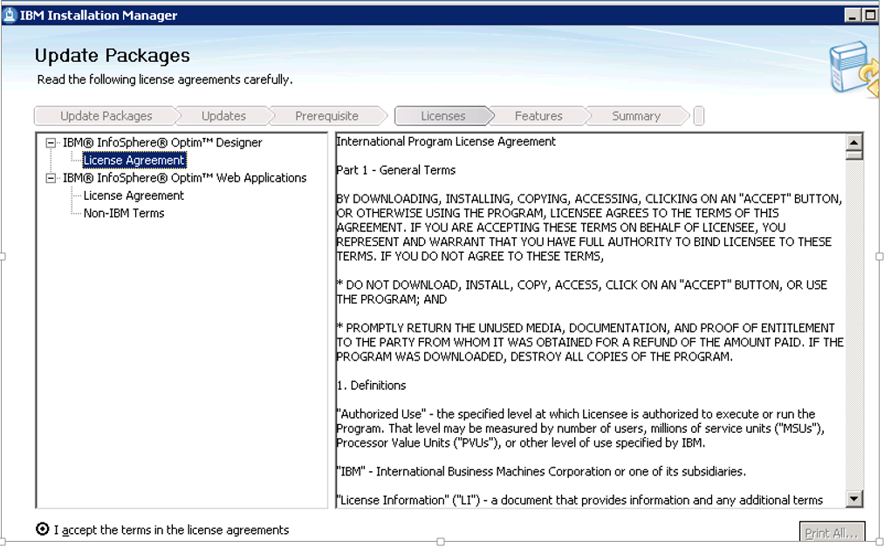

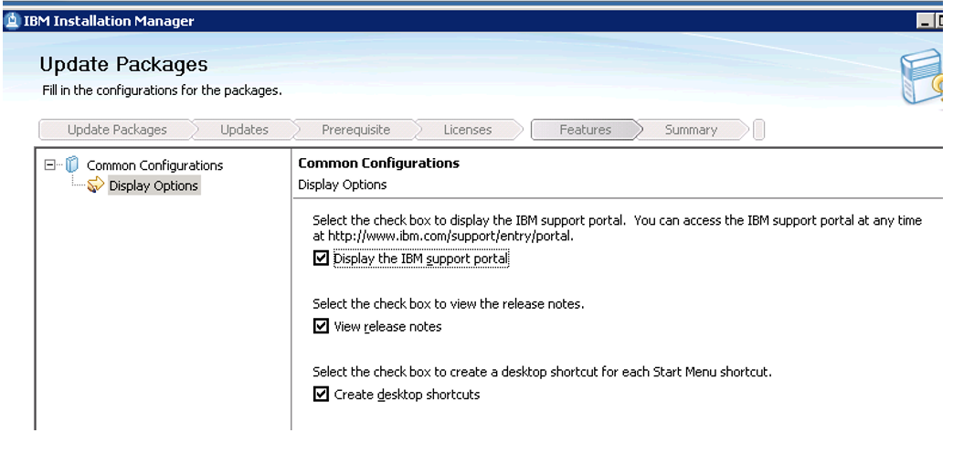

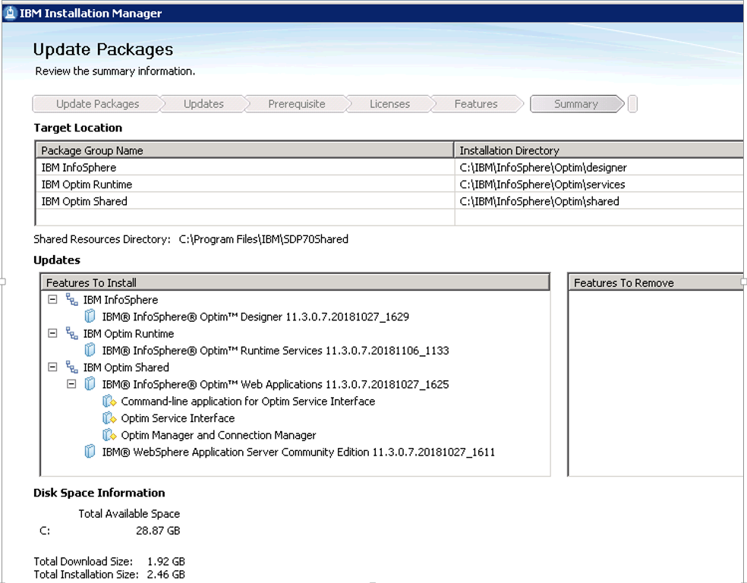

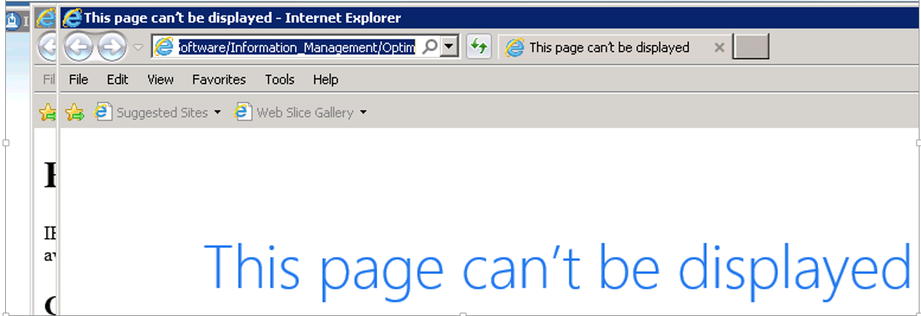

During the upgrade to FP7, the Installation Manager tried to get the Internet connection to

<http://www-947.ibm.com/support/entry/portal/Overview/Software/Information_Management/Optim>

I ignored the “This page can’t be displayed” because of our security policy (no internet access on servers) and continued the upgrade.

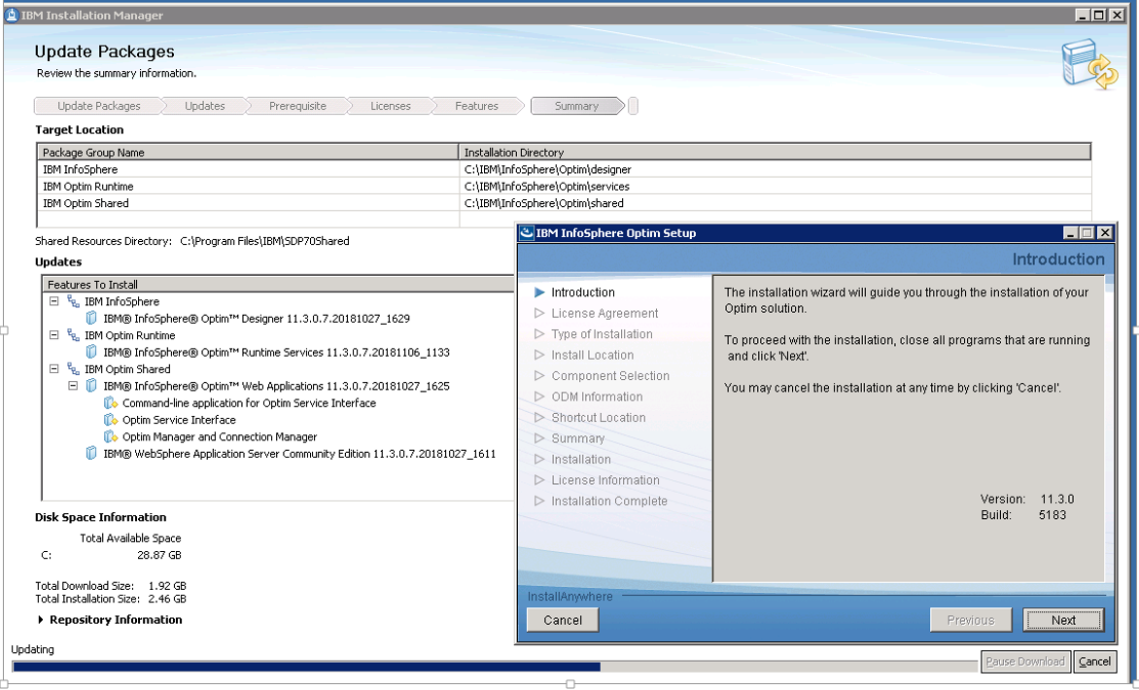

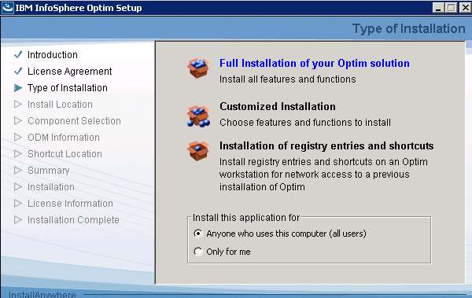

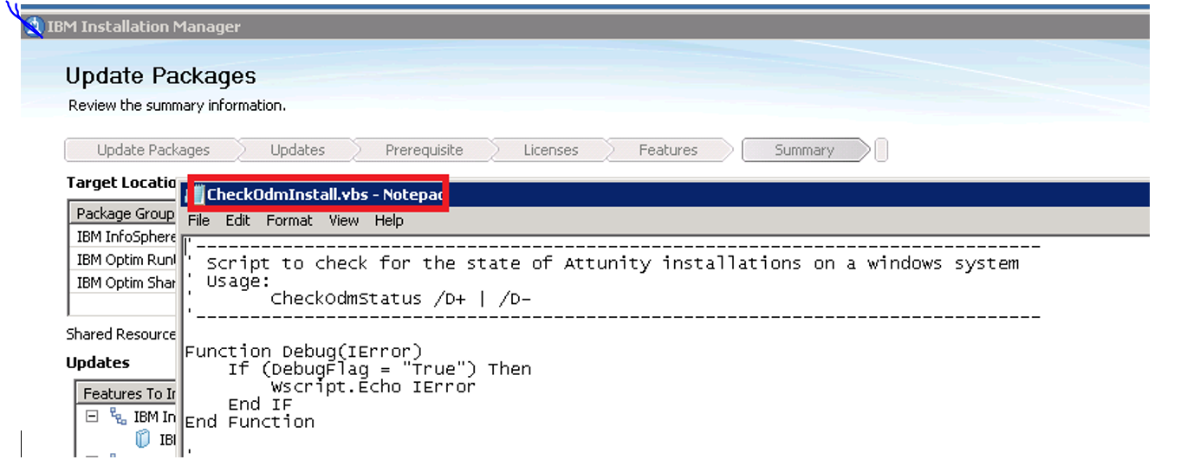

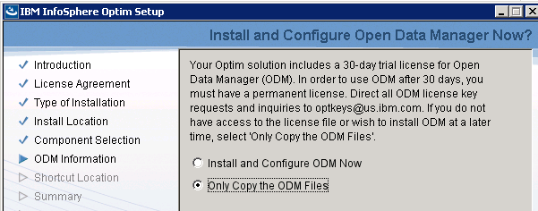

Skipped ODM because we do not have the Optim Archive neither ODM licenses

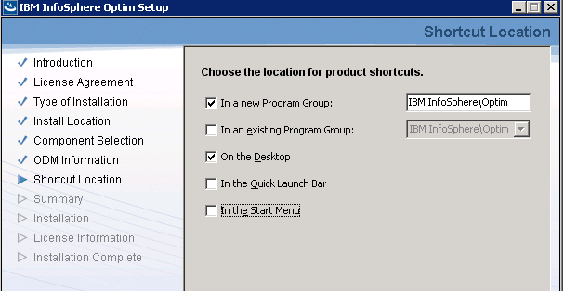

Default selections for the shortcuts

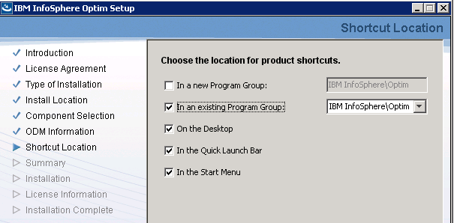

My selection for the shortcuts

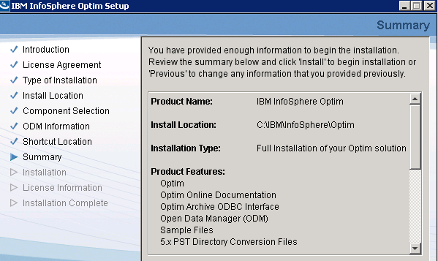 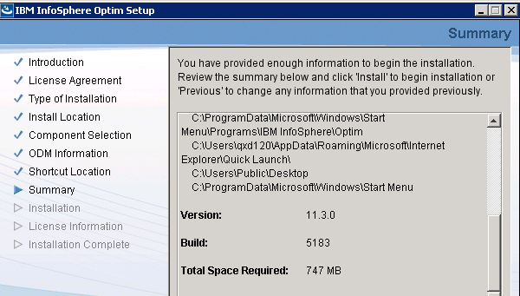

The Summary window

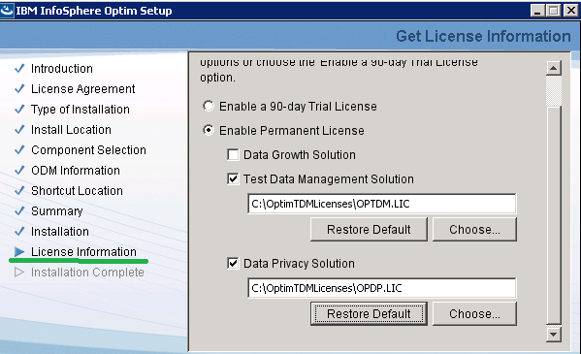

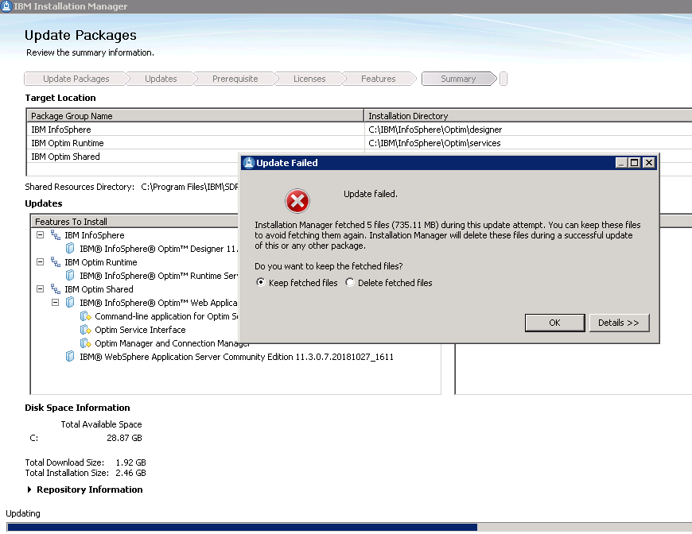

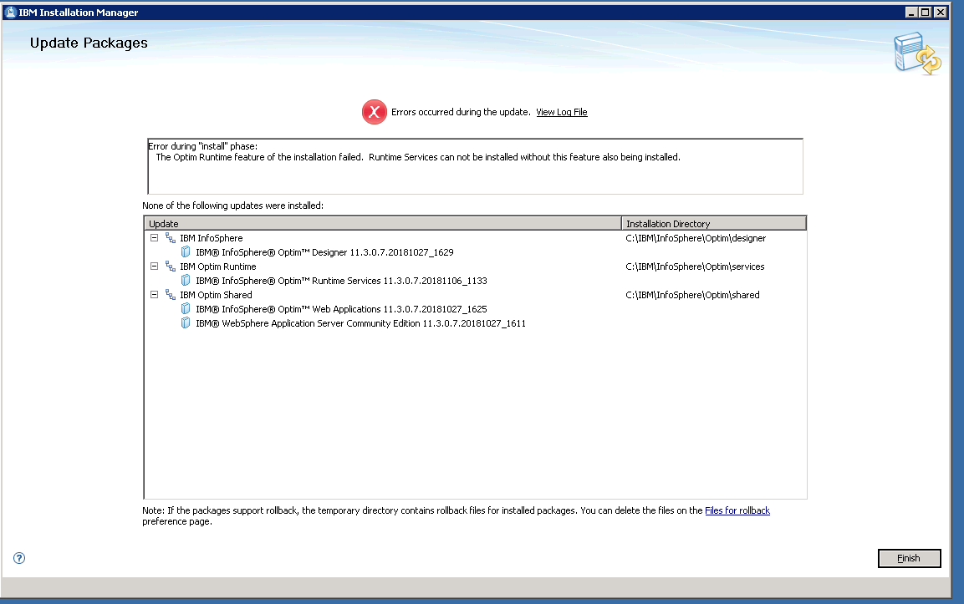

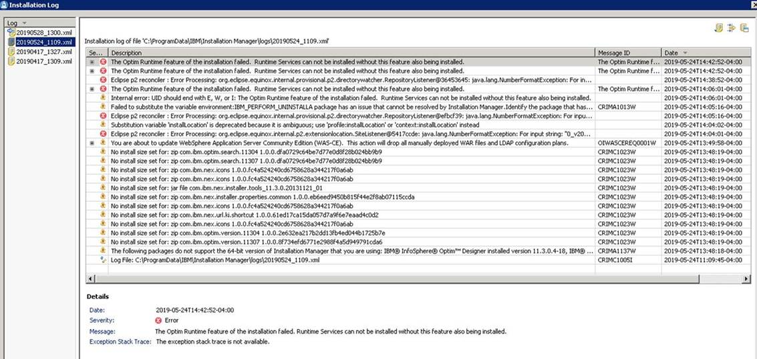

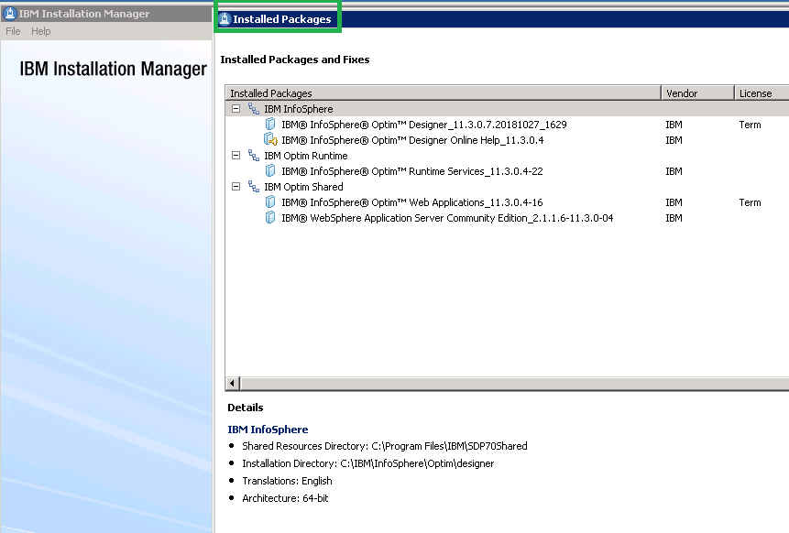

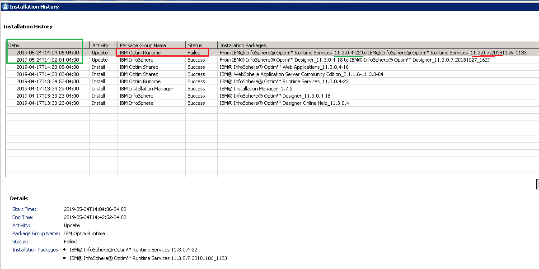

In addition to this mentioned validation that I did after the installation of Optim 11.3.**0.4** on May 17, how could I know that Optim V11.3.04 Runtime is still working after the failure of the upgrade to Fix Pack 7? What I did is the following to make sure the Optim Service can be started.

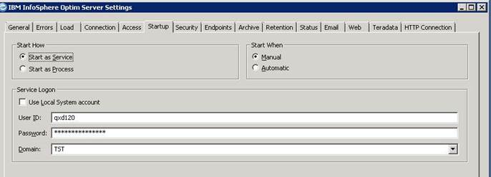

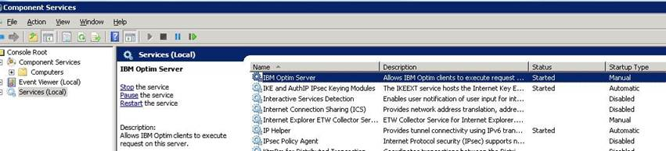

Thank you!