Changing language setting for the PAX Tool Bar
Does anybody know how to change the language for the PA toolbar in PAX/excel?
- Select the tool bar and the language setting

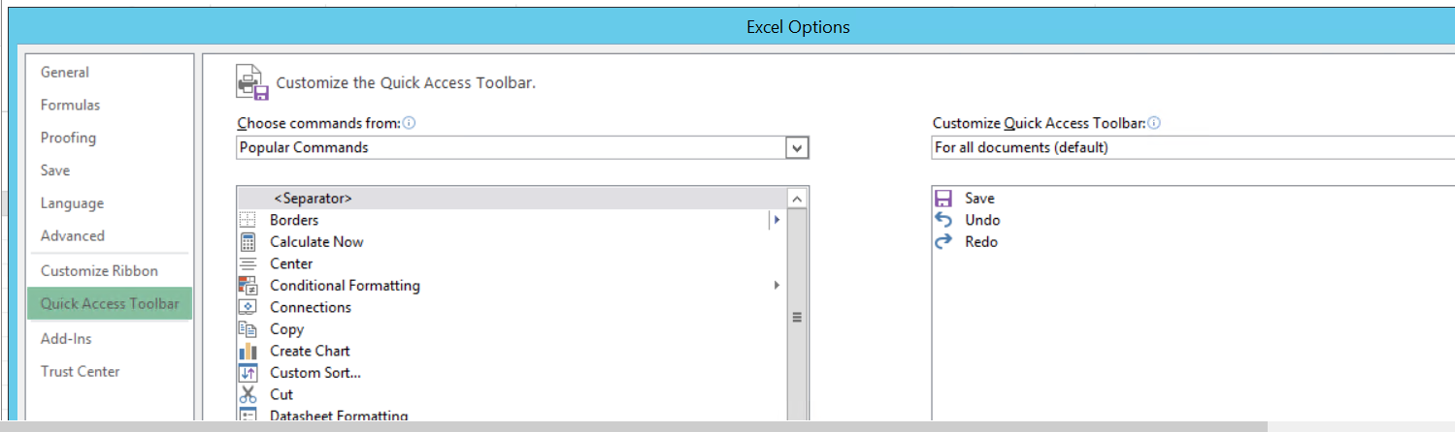

- You will need to add the language

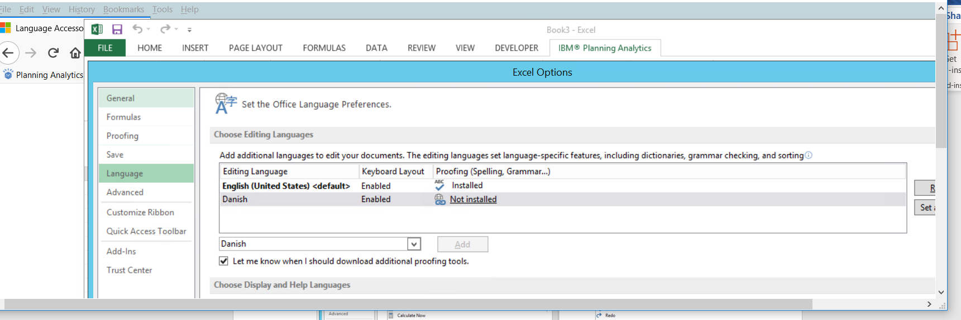

- Install the language pack https://support.office.com/en-us/article/language-accessory-pack-for-office-82ee1236-0f9a-45ee-9c72-05b026ee809f?ui=en-US&rs=en-US&ad=US

User Guide – page Planning Analytics for Microsoft Excel - IBM https://www.ibm.com/support/knowledgecenter/SSD29G_2.0.0/...2.../ug_cxr.pdf

