Can’t open the login page in 11.1.3 version cognos framework manager. Login page begins with a blank page.
I copied the package( BC_Student_geo) from our another cognos framework manager instance ( 11.0.11).
I am getting below response when I was opening from the 11.1.3
I have installed 11.1.3 in my sandbox. The URL is http://sndcognosgw.bc.edu/ibmcognos
I have another instance ( I already mentioned)11.0.11, which is a development box. ( https://devodata.bc.edu/analytics)

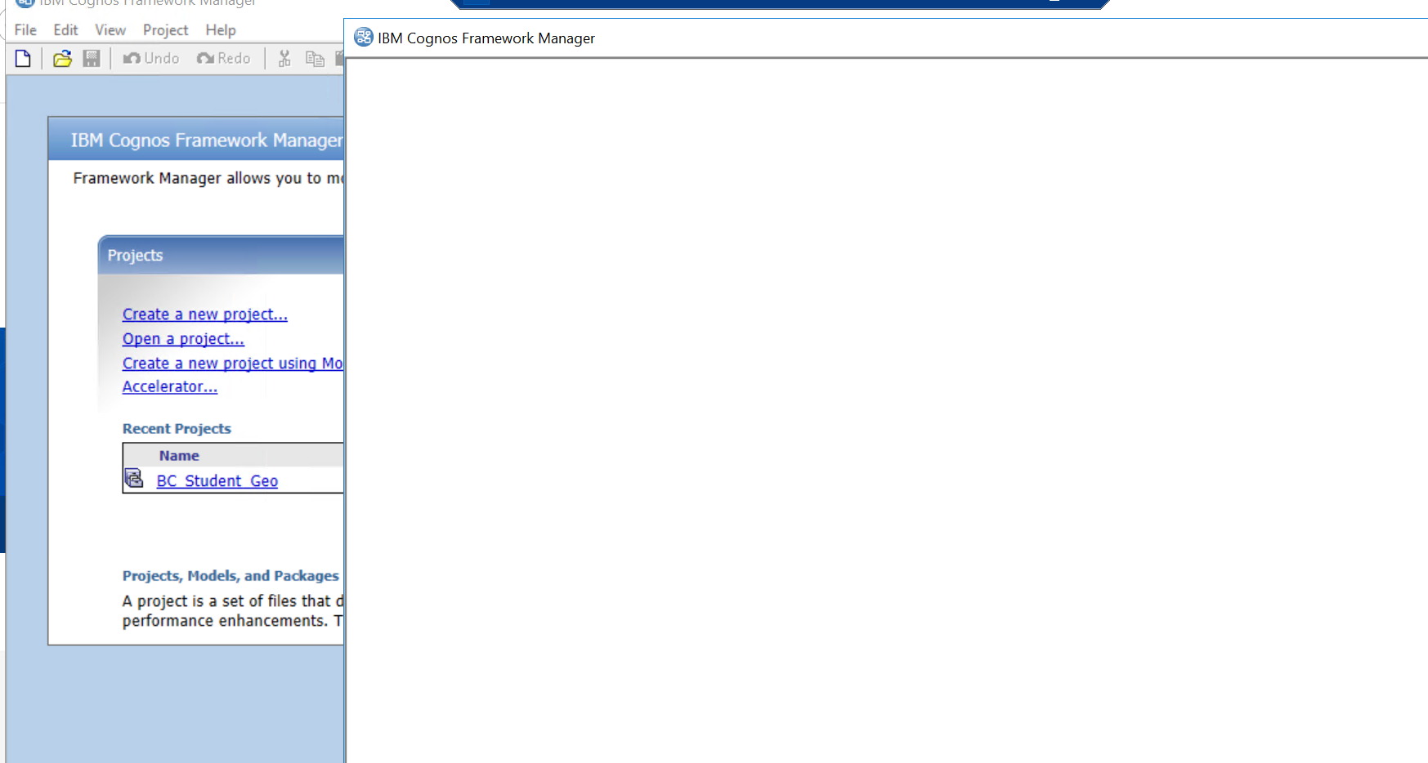

I did following steps in the IE browser
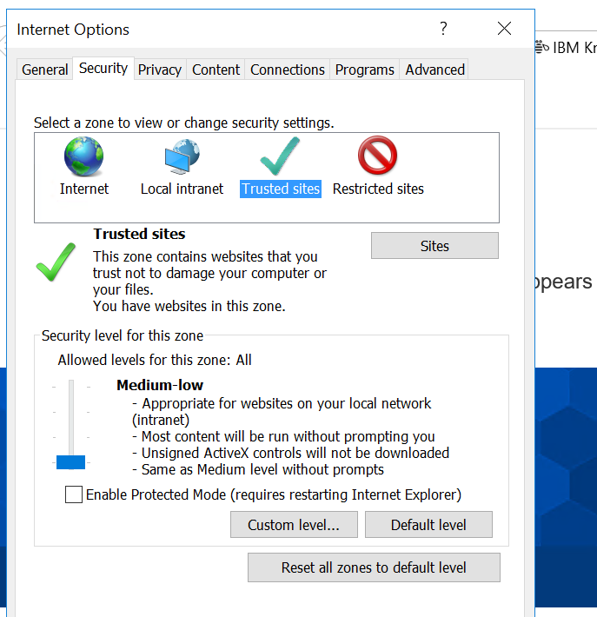

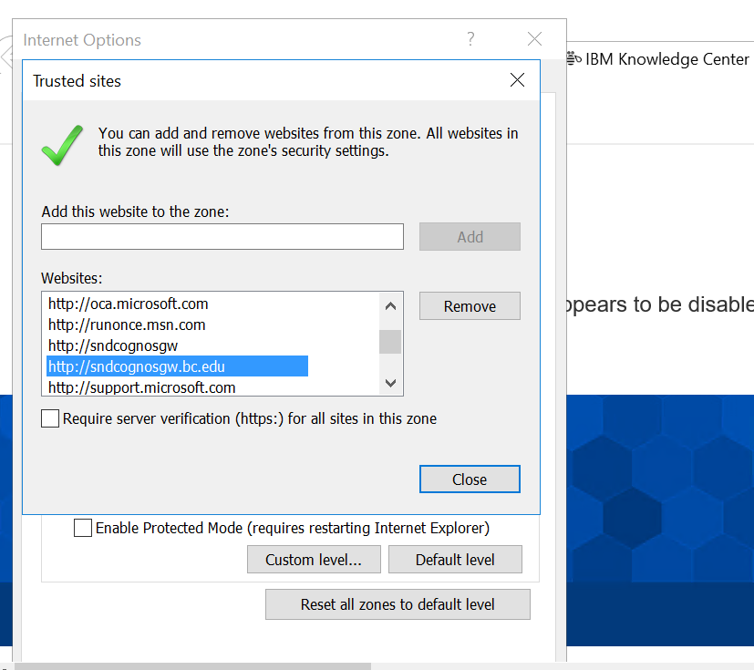

I can open my 11.0.11 framework manager without any issues.

