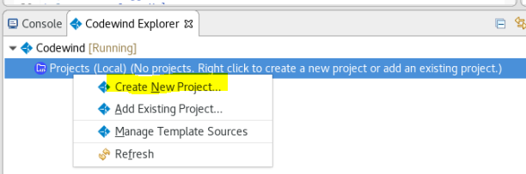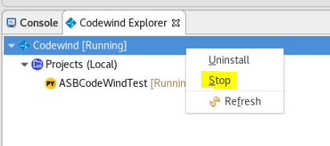
Abstract
This document describes the step by step installation of Eclipse Codewind plugin and Docker Compose Container development, including test examples, using Eclipse Version: 2019-06 (4.12.0), installed on the Linux Master node on the IBM ECM Cloud Private Container on RHEL 8.0 .
- Alan Bluck

© ASB Software Development Limited
Contents
IBM Installations - ASB Software Development Limited Publications 3
Installation of Eclipse Codewind and an Example using Docker Compose on RHEL 8 Linux 4
Create an example Docker Container 15
Create a Dockerfile 17
Define services in a Compose file 18
Build and run your app with Compose 18
Edit the Compose file to add a bind mount 24
Experiment with some other commands 27
Appendix A – Example Test Docker Container 28
Appendix B - Example Eclipse plugin python container log 31

IBM Installations - ASB Software Development Limited Publications

https://doi.org/10.13140/RG.2.2.20160.69129
IBM FileNet P8 Java Development on ECM Cloud Private Container P8 Examples
(NB Above describes the installation of the Eclipse IDE I used for this document)
https://doi.org/10.13140/RG.2.2.27358.18246
IBM Cloud Private P8 Container CPIT Installation on RedHat Enterprise Linux 8.0
(NB Above describes the installation of the base system I used for this document)
https://doi.org/10.13140/RG.2.2.22030.92486
Problem Resolution Procedures For fixing Software Installation Issues

https://doi.org/10.13140/RG.2.2.27345.89440
IBM BAW 18.0 Installation phase1 preprint with install of IBM Workflow Center 8.6.1.19002
https://doi.org/10.13140/RG.2.2.10491.67369
DB2 10.5 Installation on RHEL 8.0 V1
https://doi.org/10.13140/RG.2.2.33527.57761
IBM Security Directory Services 6.4- Installation on RHEL 8.0

https://doi.org/10.13140/RG.2.2.15007.10408
WebSphere 8.5.5.15 Installation 29-06-2019 on VMWare Workstation Pro 15.1

https://doi.org/10.13140/RG.2.2.15737.83048
IBM BAW 18.0 Installation 18 07 2019 - Install of IBM Security Directory Suite 8.0.1.1 on RHEL 8 using VMWare Workstation Pro 15.1

https://doi.org/10.13140/RG.2.2.21708.16001
Case Manager 5.3.3 Installation on RHEL 8.0 with Content Navigator 3.0.6

https://doi.org/10.13140/RG.2.2.31489.10082
Installation of Oracle 12C on the Linux operating system

https://doi.org/10.13140/RG.2.2.14590.95049
Content Navigator 3.0.6 Installation on RHEL 8.0_V1.docx

https://doi.org/10.13140/RG.2.2.21170.76480
Content Foundation 5.5.3 Installation on RHEL 8.0_V2.docx

https://doi.org/10.13140/RG.2.2.30401.51048
Case Manager Installation on RHEL 8.0_Preparation.docx
This document provides step by step Installation steps to install
IBM FileNet Content Engine 5.5.2

Installation of Eclipse Codewind and an Example using Docker Compose on RHEL 8 Linux
REF:
https://www.eclipse.org/codewind/mdteclipsegettingstarted.html

https://docs.docker.com/compose/gettingstarted/

Download and install the latest Eclipse IDE for Java EE Developers or use an existing installation.
- Install Eclipse IDE Version 2019-09 R (4.13.0) or later to avoid Bug 541220.
I used the current installed:
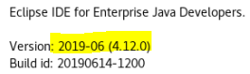

However, the earliest supported version of the Eclipse IDE is Version 2019-03 (4.11).
- Open the Eclipse IDE and navigate to Help > Eclipse Marketplace.
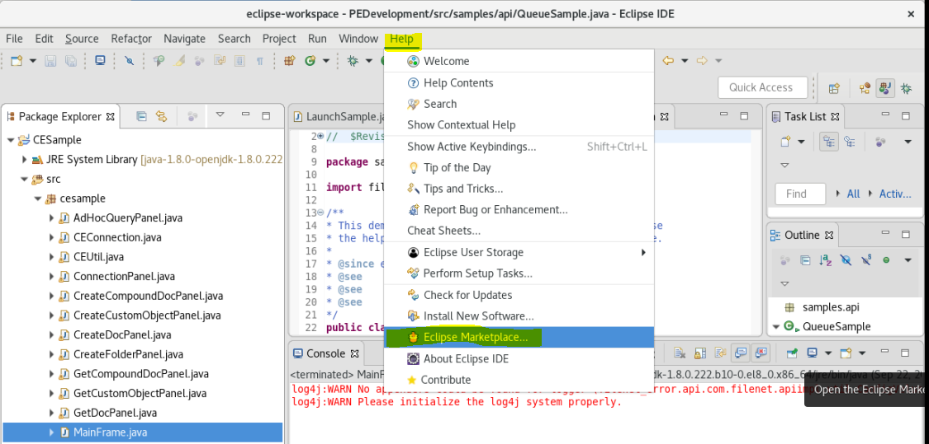
- Search for Codewind.
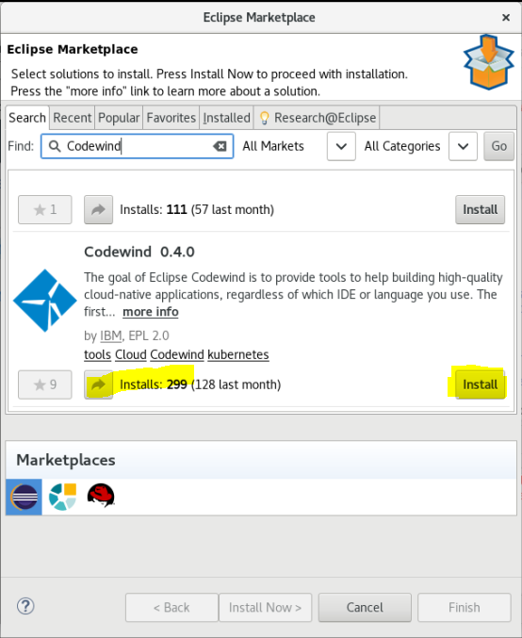
- Click the Install button.
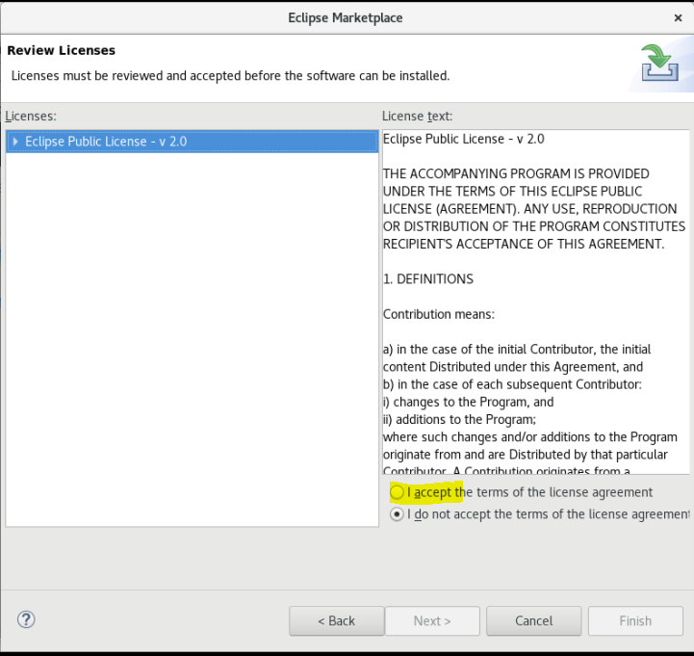
Click Accept
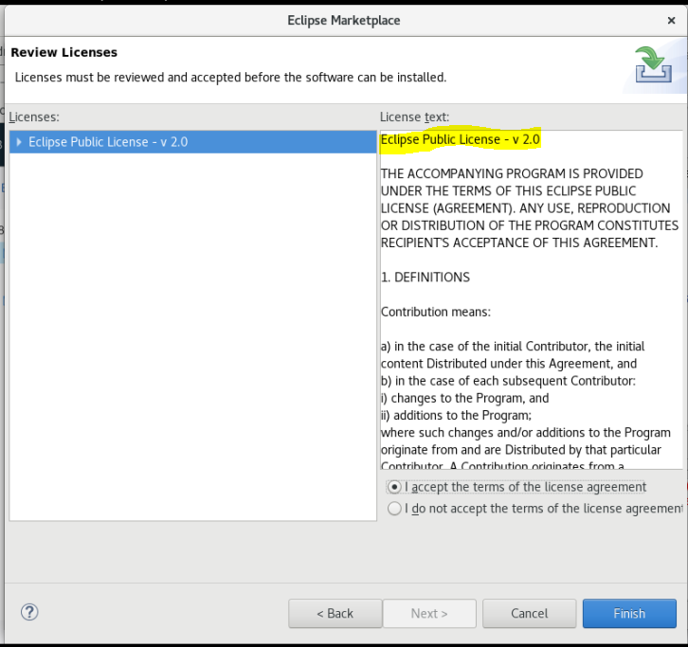
- Finish the wizard and accept licenses as needed.
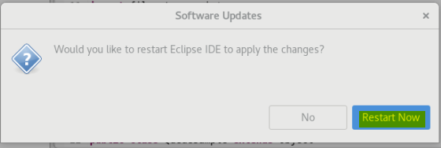
- When the installation is complete, restart Eclipse.
- Open the Codewind view. Navigate to Window > Show View > Other… > Codewind > Codewind Explorer
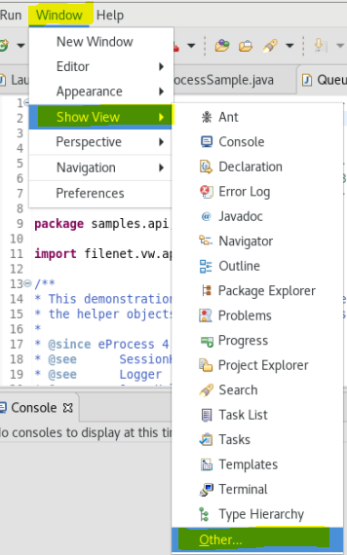
- Codewind requires the installation of additional Docker images to run. Double-click on the Codewind item in the Codewind Explorer view to complete the installation. The installation may take a few minutes to complete.
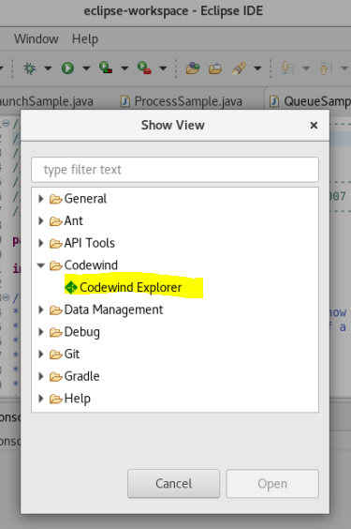
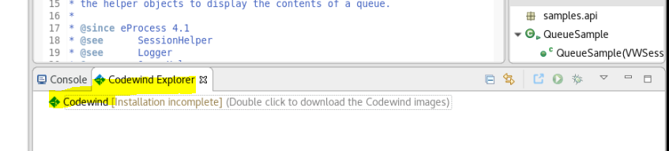
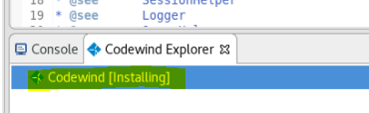
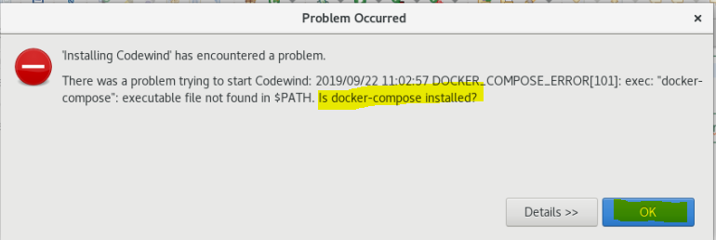
There was a problem trying to start Codewind: 2019/09/22 11:02:57 DOCKER_COMPOSE_ERROR[101]: exec: "docker-compose": executable file not found in $PATH. Is docker-compose installed?
https://docs.docker.com/compose/install/
curl -L "https://github.com/docker/compose/releases/download/1.24.1/docker-compose-$(uname -s)-$(uname -m)" -o /usr/local/bin/docker-compose
chmod +x /usr/local/bin/docker-compose
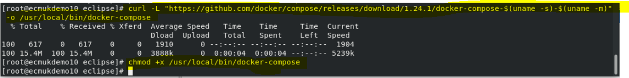
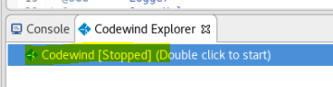
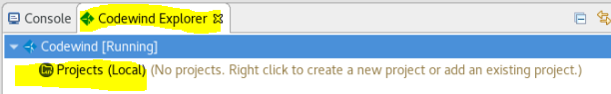

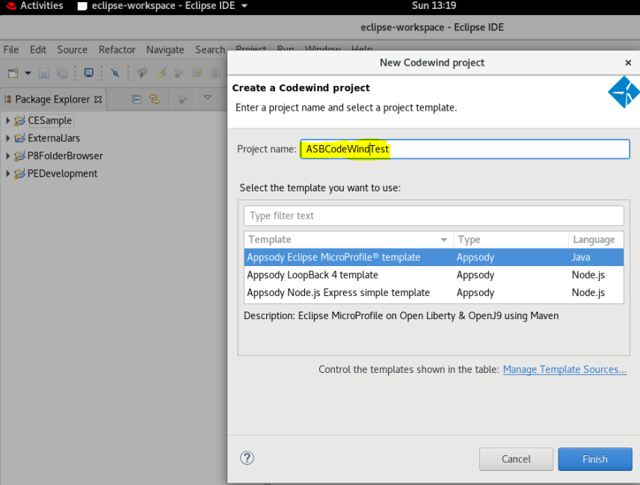
Select the project type required from the scrollable list:

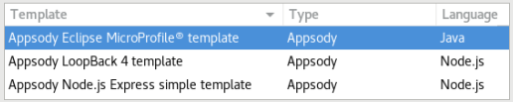

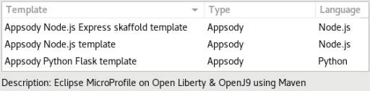
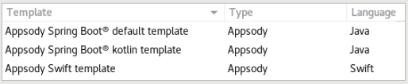
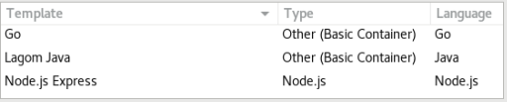
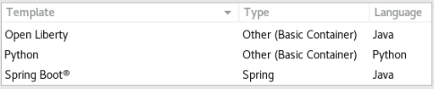
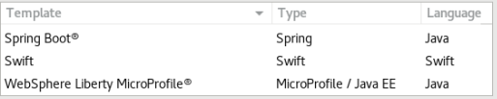

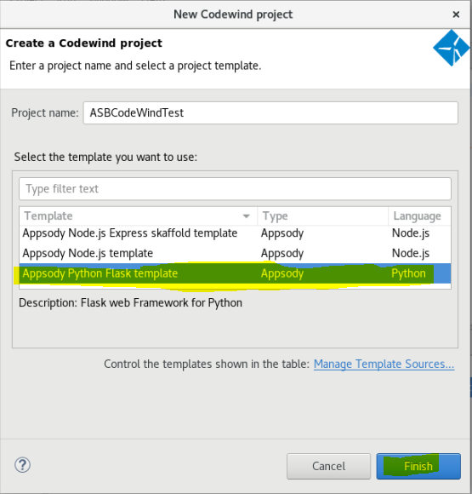

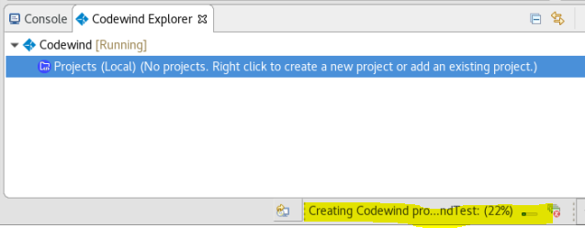
Wait for the template build for the Project name we created
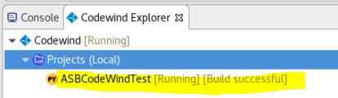

Double-click on __init__.py

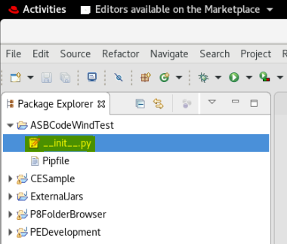

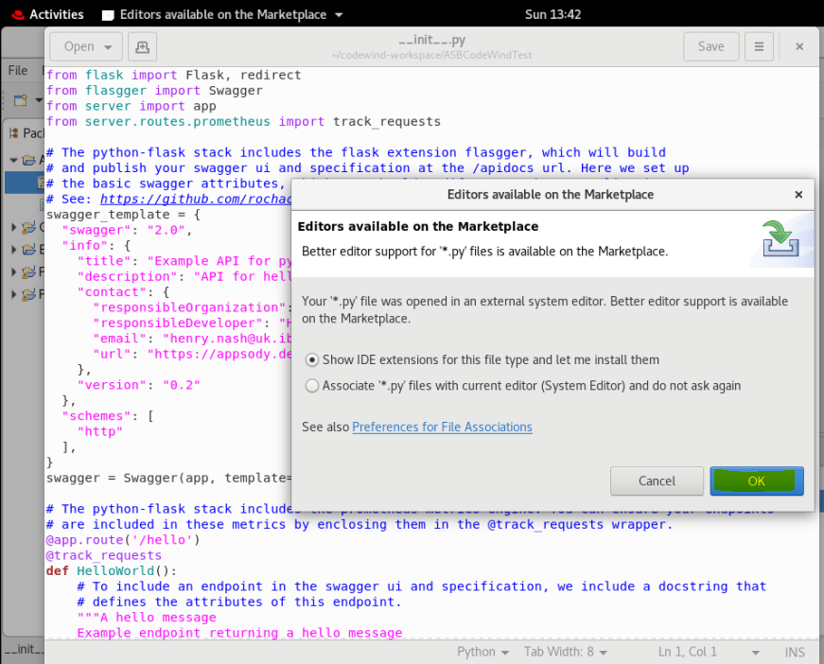
I suggest Cancel as the plugin-editor selected gives a Java Null-pointer exception!

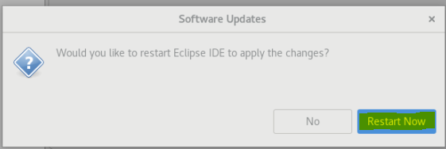
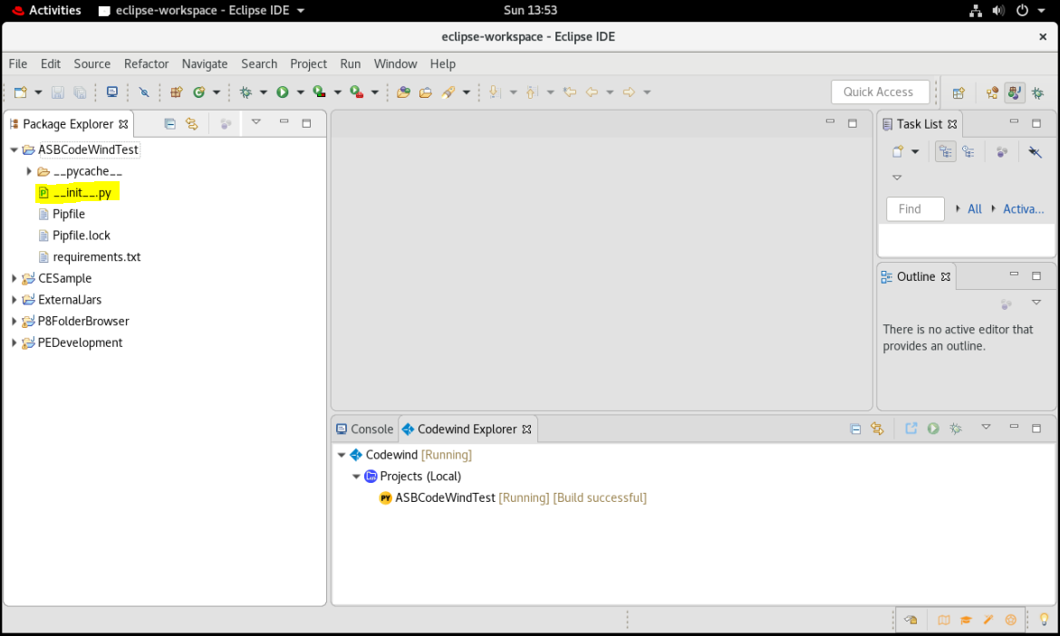

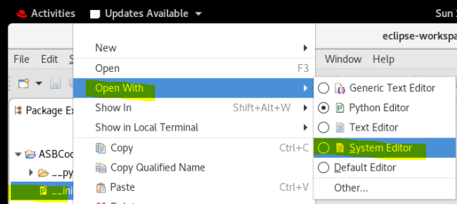

Above Python Editor defaulted, has an issue!
Selected System Editor
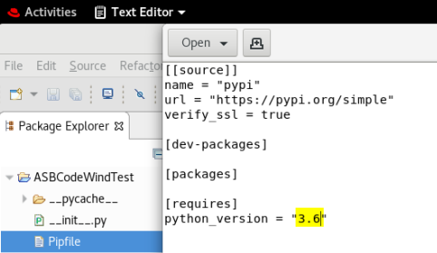
Changed from 3.7 to 3.6
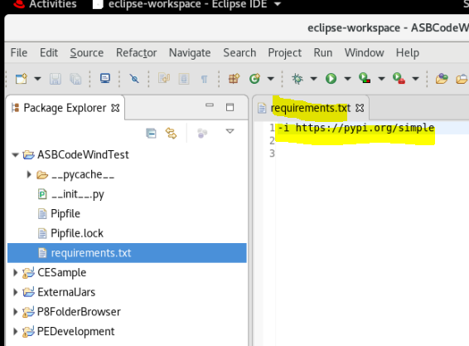

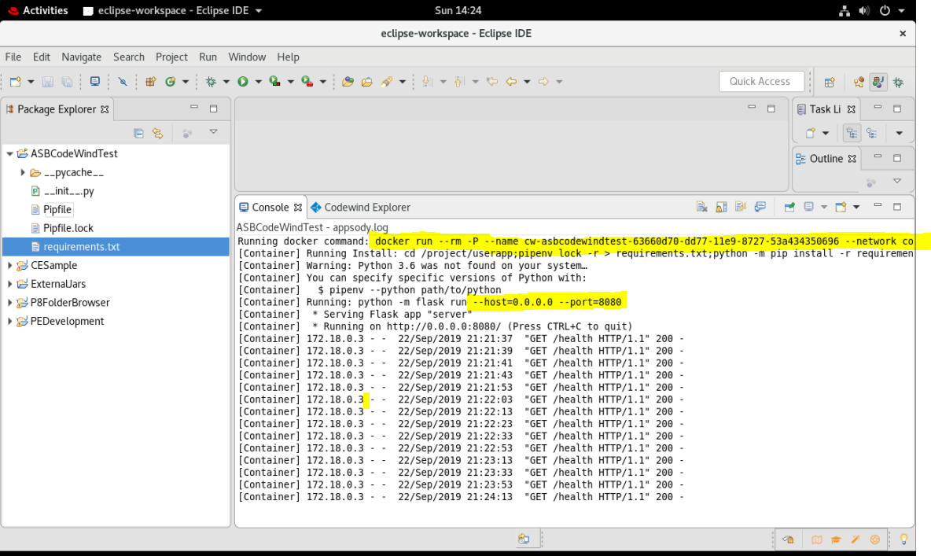
See Appendix B Example Eclipse plugin python container log project log for full list

Right-mouse click on the Codewind [Running] node and select Stop

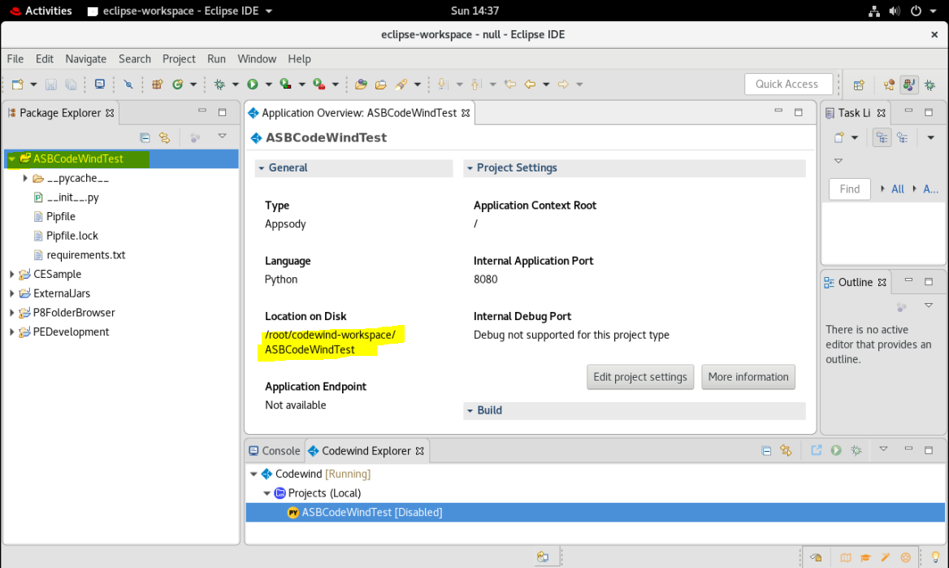

Disable project to stop this running and right click to view the Application details

Create an example Docker Container
REF https://docs.docker.com/compose/gettingstarted/

# mkdir composetest
# cd composetest
vi app.py
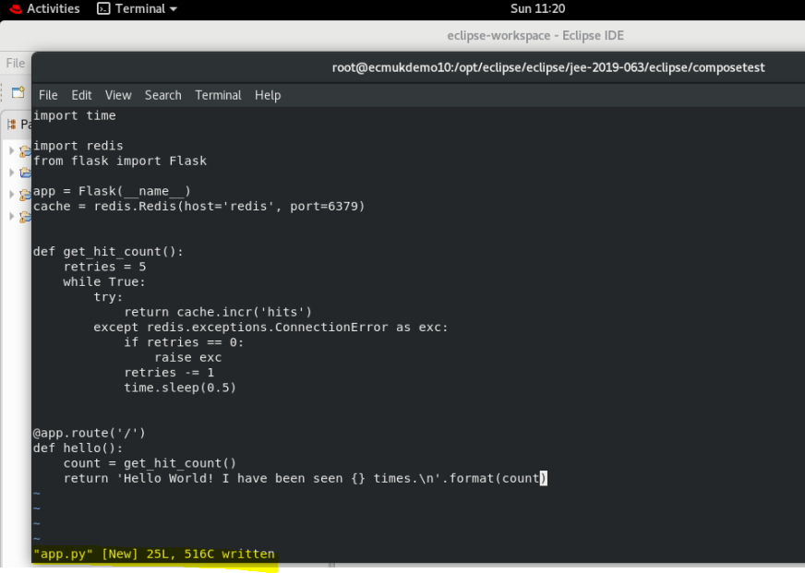
import time
import redis
from flask import Flask
app = Flask(__name__)
cache = redis.Redis(host='redis', port=6379)
def get_hit_count():
retries = 5
while True:
try:
return cache.incr('hits')
except redis.exceptions.ConnectionError as exc:
if retries == 0:
raise exc
retries -= 1
time.sleep(0.5)
@app.route('/')
def hello():
count = get_hit_count()
return 'Hello World! I have been seen {} times.\n'.format(count)

vi requirements.txt
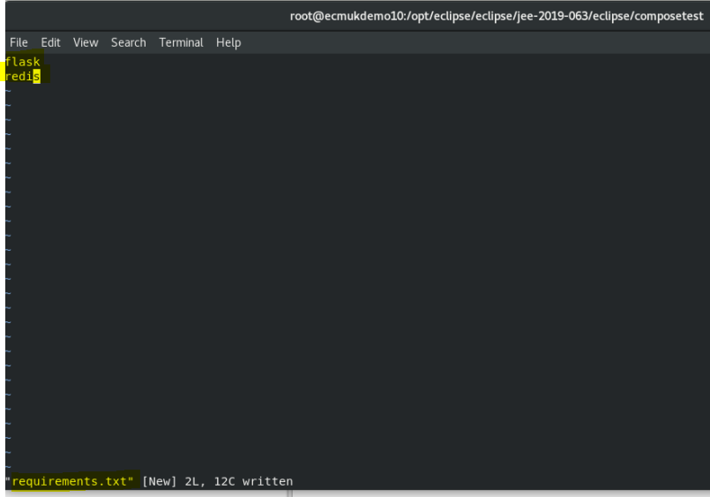
flask
redis
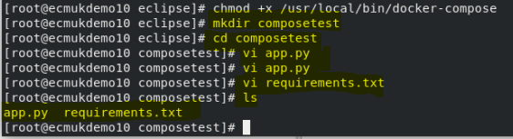
NOTE: yum install python37 - not able to install this, the existing version python36 is the latest for repos I have on RHEL 8.0 !

Create a Dockerfile
In this step, you write a Dockerfile that builds a Docker image. The image contains all the dependencies the Python application requires, including Python itself.
In your project directory, create a file named Dockerfile and paste the following:

FROM python:3.6-alpine
WORKDIR /code
ENV FLASK_APP app.py
ENV FLASK_RUN_HOST 0.0.0.0
RUN apk add --no-cache gcc musl-dev linux-headers
COPY requirements.txt requirements.txt
RUN pip install -r requirements.txt
COPY . .
CMD ["flask", "run"]
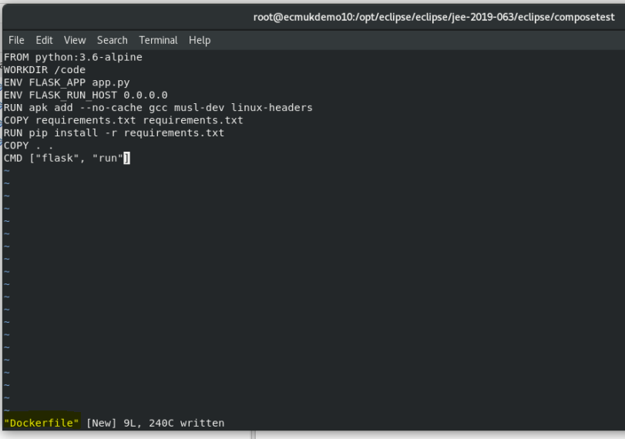
This tells Docker to:
- Build an image starting with the Python 3.6 image.
- Set the working directory to /code.
- Set environment variables used by the flask command.
- Install gcc so Python packages such as MarkupSafe and SQLAlchemy can compile speedups.
- Copy requirements.txt and install the Python dependencies.
- Copy the current directory . in the project to the workdir . in the image.
- Set the default command for the container to flask run.
Define services in a Compose file
Create a file called docker-compose.yml in your project directory and paste the following:

version: '3'
services:
web:
build: .
ports:
- "5000:5000"
redis:
image: "redis:alpine"

This Compose file defines two services: web and redis.

Web service
The web service uses an image that’s built from the Dockerfile in the current directory. It then binds the container and the host machine to the exposed port, 5000. This example service uses the default port for the Flask web server, 5000.

Redis service
The redis service uses a public Redis image pulled from the Docker Hub registry.

Build and run your app with Compose
From your project directory, start up your application by running docker-compose up.
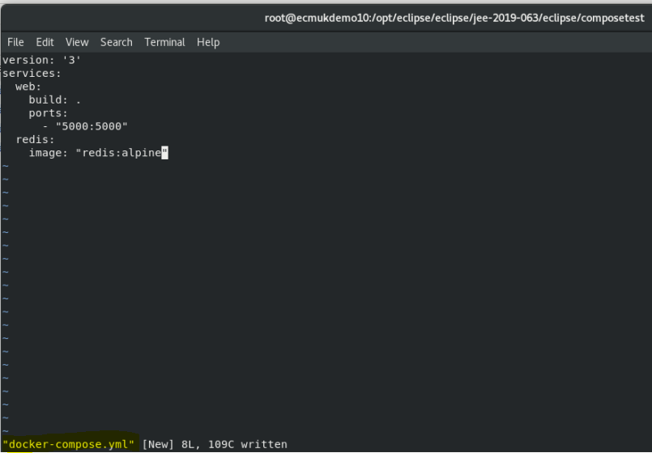

docker-compose up

See Appendix A – Example Test Docker Container for the full compose log
Enter http://localhost:5000/ in a browser to see the application running.
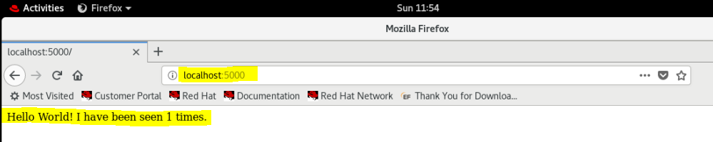

List the installed container images using

docker image ls
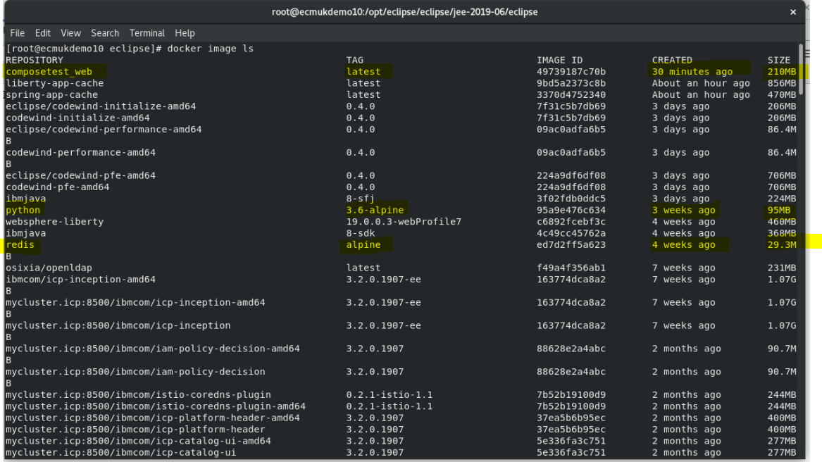
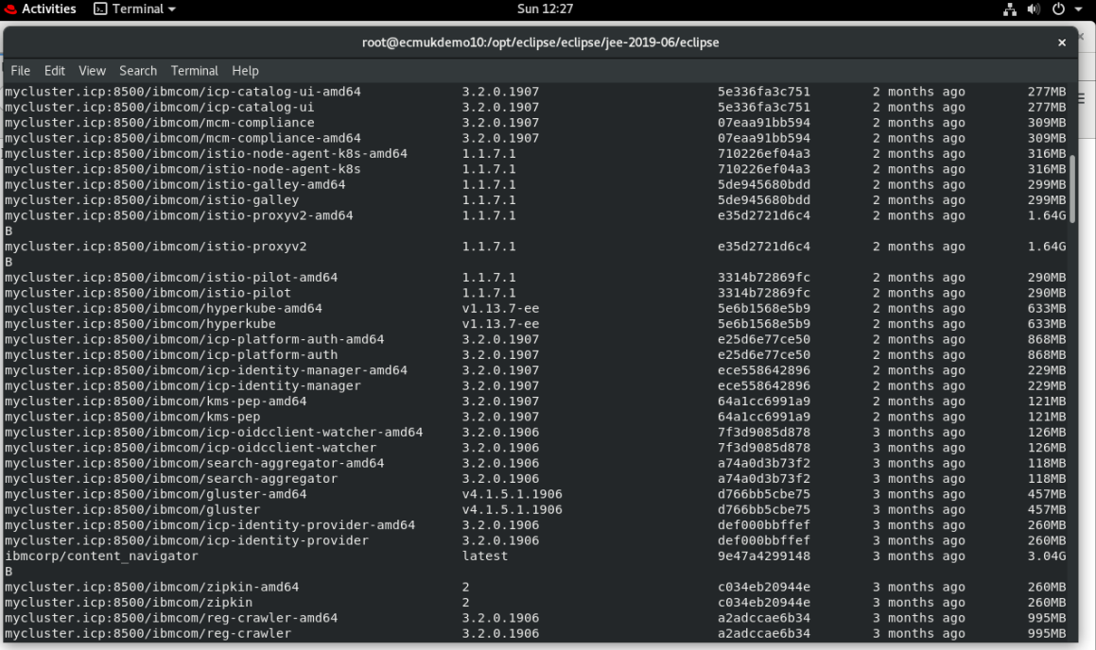
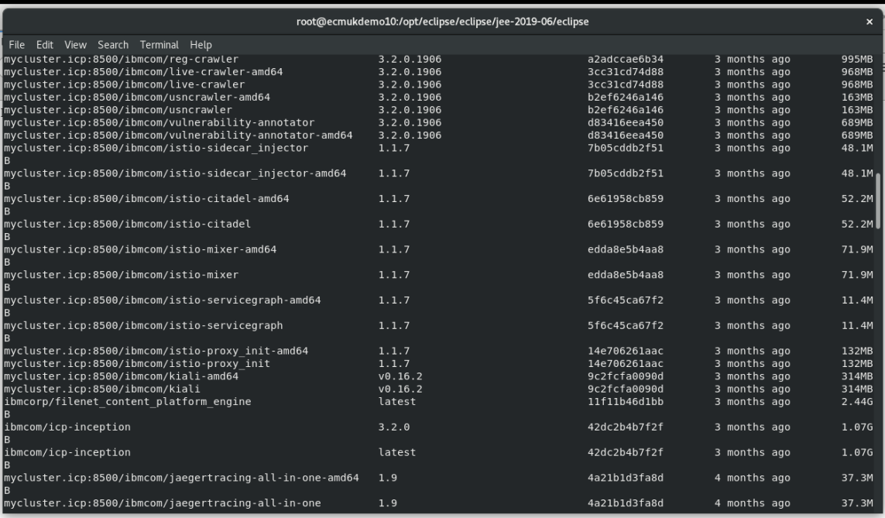
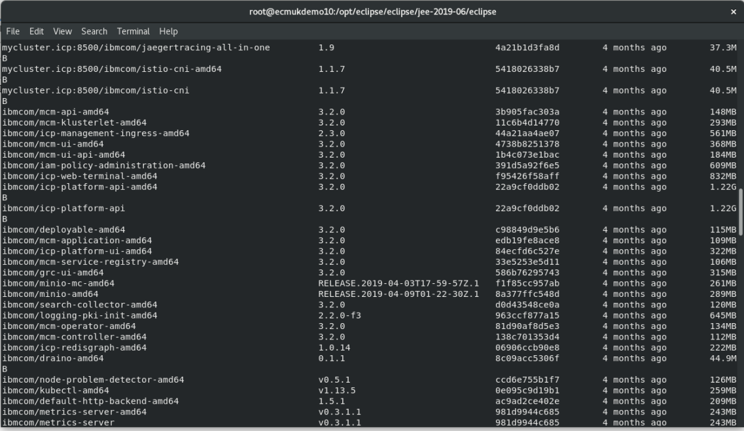
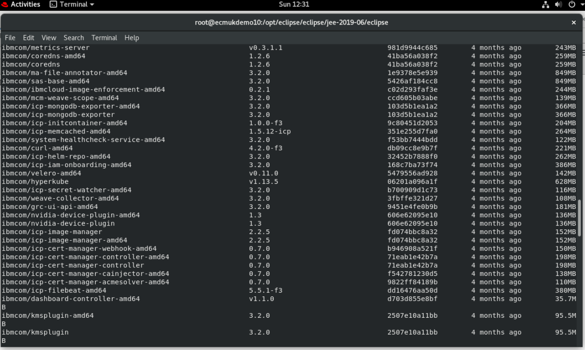
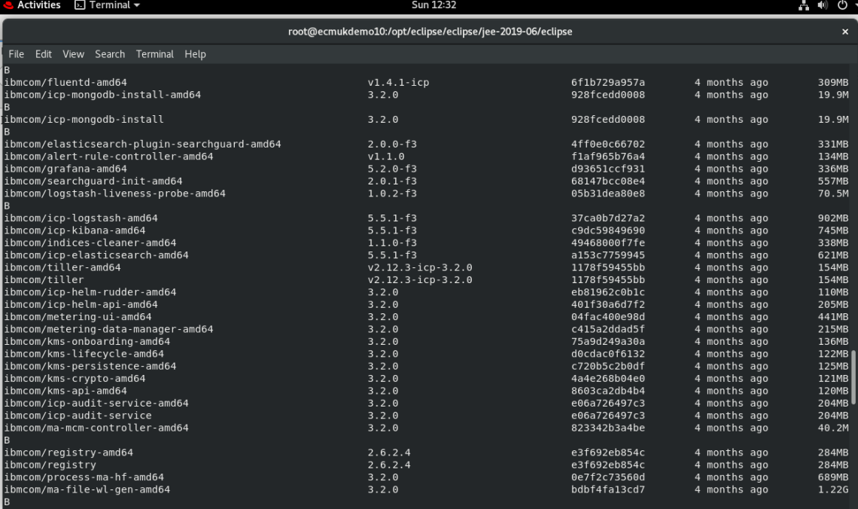
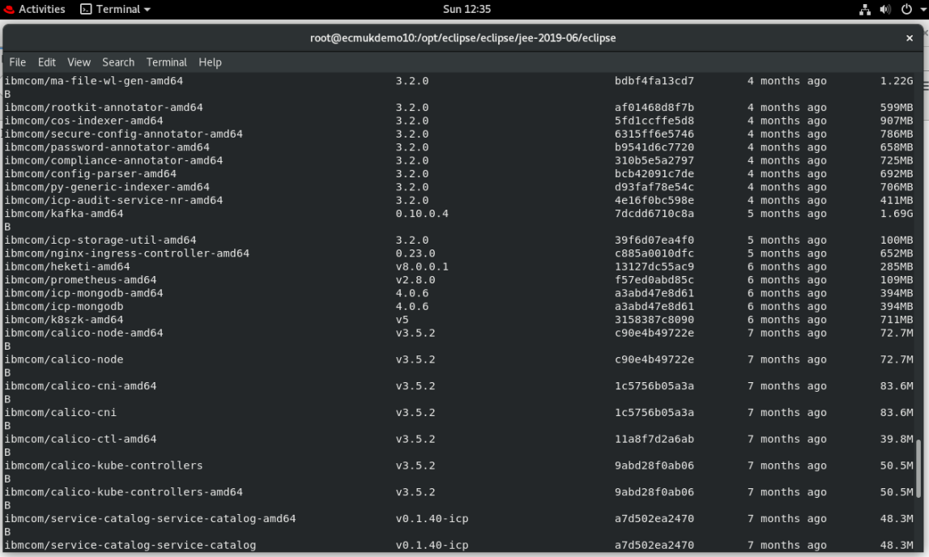
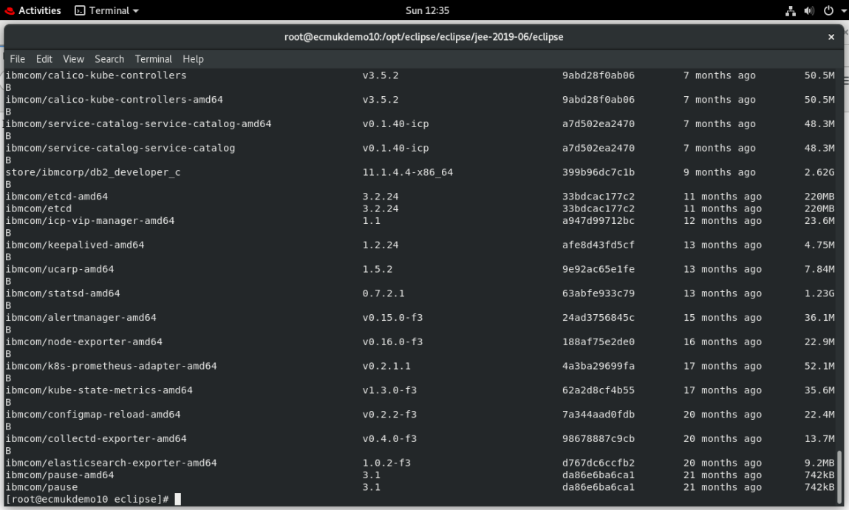
CTRL/C to stop the docker images loaded earlier
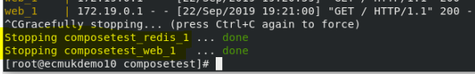

Edit the Compose file to add a bind mount
Edit docker-compose.yml in the project directory to add a bind mount for the web service:

version: '3'
services:
web:
build: .
ports:
- "5000:5000"
volumes:
- .:/code
environment:
FLASK_ENV: development
redis:
image: "redis:alpine"

The new volumes key mounts the project directory (current directory) on the host to /code inside the container, allowing you to modify the code on the fly, without having to rebuild the image. The environment key sets the FLASK_ENV environment variable, which tells flask run to run in development mode and reload the code on change.
NOTE: This mode should only be used in development.
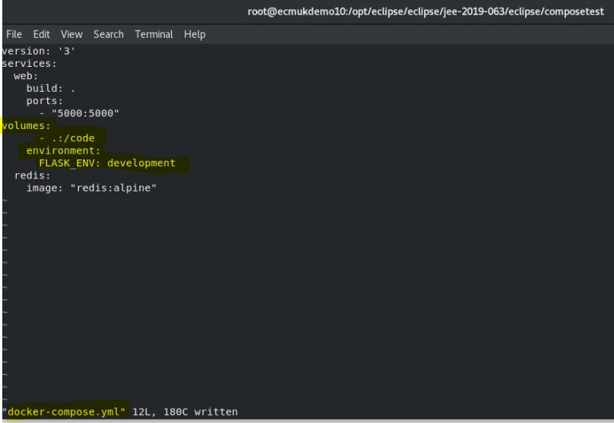
NB – volumes : line above has to be indented !!!
(see below for what happens otherwise)

docker-compose up –build
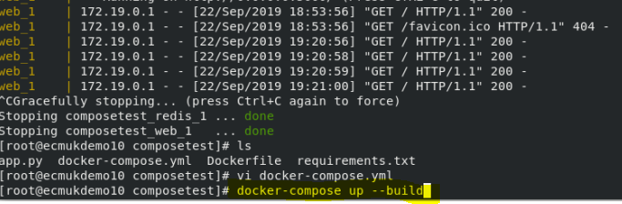
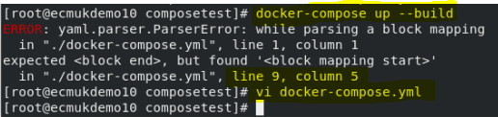
Indent the volumes: line!
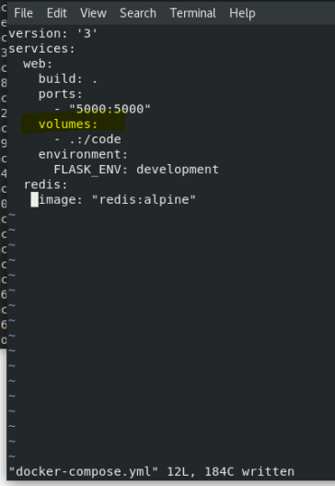
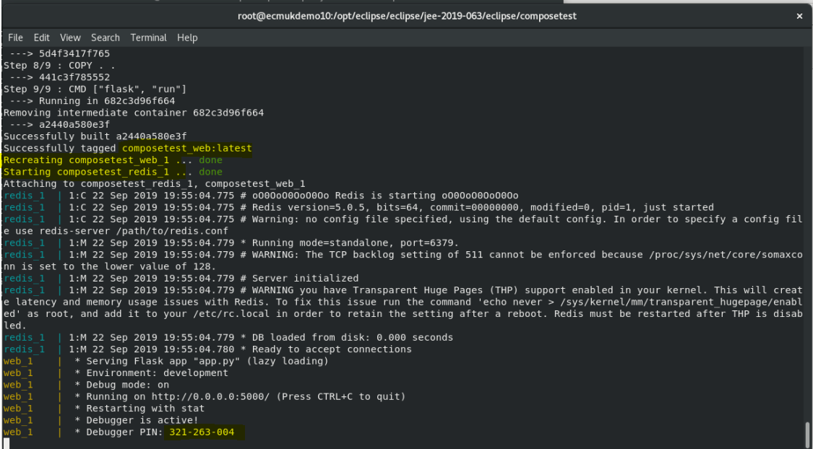

Update Change the greeting in app.py and save it. For example, change the Hello World! message to Hello from Docker!:
return 'Hello from Docker! I have been seen {} times.\nUpdated by ASB Development Software Limited'.format(count)
vi app.py
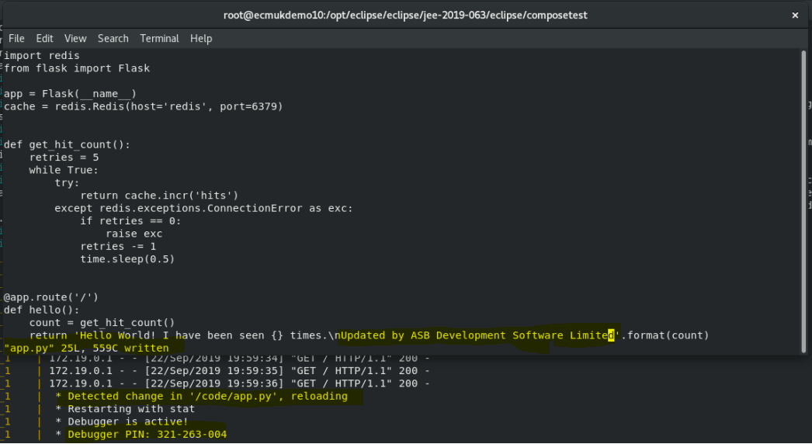
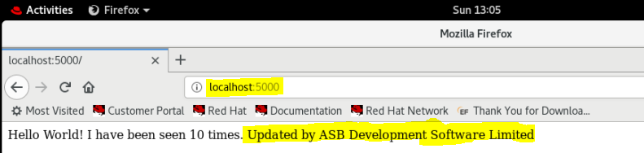

Experiment with some other commands
If you want to run your services in the background, you can pass the -d flag (for “detached” mode) to docker-compose up and use docker-compose ps to see what is currently running:
# docker-compose up -d
Starting composetest_redis_1...
Starting composetest_web_1...
$ docker-compose ps
Name Command State Ports
-------------------------------------------------------------------
composetest_redis_1 /usr/local/bin/run Up
composetest_web_1 /bin/sh -c python app.py Up 5000->5000/tcp
The docker-compose run command allows you to run one-off commands for your services. For example, to see what environment variables are available to the web service:
# docker-compose run web env
See docker-compose --help to see other available commands. You can also install command completion for the bash and zsh shell, which also shows you available commands.
If you started Compose with docker-compose up -d, stop your services once you’ve finished with them:
# docker-compose stop
You can bring everything down, removing the containers entirely, with the down command. Pass --volumes to also remove the data volume used by the Redis container:
# docker-compose down --volumes
At this point, you have seen the basics of how Compose works.

Appendix A – Example Test Docker Container
[root@ecmukdemo10 composetest]# ls
app.py Dockerfile requirements.txt
[root@ecmukdemo10 composetest]# vi docker-compose.yml
[root@ecmukdemo10 composetest]# ls
app.py docker-compose.yml Dockerfile requirements.txt
[root@ecmukdemo10 composetest]# docker-compose up
Creating network "composetest_default" with the default driver
Building web
Step 1/9 : FROM python:3.6-alpine
3.6-alpine: Pulling from library/python
9d48c3bd43c5: Pull complete
c0ea575d71b9: Pull complete
c355bcdd89db: Pull complete
4738b6e326ab: Pull complete
99f07e28b502: Pull complete
Digest: sha256:40f1783b628264dfaeafdfff900b8b4375e5ed96a8d23620dc5cc6bb7d52148c
Status: Downloaded newer image for python:3.6-alpine
---> 95a9e476c634
Step 2/9 : WORKDIR /code
---> Running in 353d39f951a7
Removing intermediate container 353d39f951a7
---> b44f3a341e4e
Step 3/9 : ENV FLASK_APP app.py
---> Running in acf004c6d1e0
Removing intermediate container acf004c6d1e0
---> de327ba27a82
Step 4/9 : ENV FLASK_RUN_HOST 0.0.0.0
---> Running in 6a10cc2a2ebf
Removing intermediate container 6a10cc2a2ebf
---> 1775405c3b09
Step 5/9 : RUN apk add --no-cache gcc musl-dev linux-headers
---> Running in 810ad76d6e36
fetch http://dl-cdn.alpinelinux.org/alpine/v3.10/main/x86_64/APKINDEX.tar.gz
fetch http://dl-cdn.alpinelinux.org/alpine/v3.10/community/x86_64/APKINDEX.tar.gz
(1/12) Installing binutils (2.32-r0)
(2/12) Installing gmp (6.1.2-r1)
(3/12) Installing isl (0.18-r0)
(4/12) Installing libgomp (8.3.0-r0)
(5/12) Installing libatomic (8.3.0-r0)
(6/12) Installing libgcc (8.3.0-r0)
(7/12) Installing mpfr3 (3.1.5-r1)
(8/12) Installing mpc1 (1.1.0-r0)
(9/12) Installing libstdc++ (8.3.0-r0)
(10/12) Installing gcc (8.3.0-r0)
(11/12) Installing linux-headers (4.19.36-r0)
(12/12) Installing musl-dev (1.1.22-r3)
Executing busybox-1.30.1-r2.trigger
OK: 121 MiB in 46 packages
Removing intermediate container 810ad76d6e36
---> 4bc7636af583
Step 6/9 : COPY requirements.txt requirements.txt
---> f94755f4113d
Step 7/9 : RUN pip install -r requirements.txt
---> Running in e70ca9408904
Collecting flask (from -r requirements.txt (line 1))
Downloading https://files.pythonhosted.org/packages/9b/93/628509b8d5dc749656a9641f4caf13540e2cdec85276964ff8f43bbb1d3b/Flask-1.1.1-py2.py3-none-any.whl (94kB)
Collecting redis (from -r requirements.txt (line 2))
Downloading https://files.pythonhosted.org/packages/bd/64/b1e90af9bf0c7f6ef55e46b81ab527b33b785824d65300bb65636534b530/redis-3.3.8-py2.py3-none-any.whl (66kB)
Collecting click>=5.1 (from flask->-r requirements.txt (line 1))
Downloading https://files.pythonhosted.org/packages/fa/37/45185cb5abbc30d7257104c434fe0b07e5a195a6847506c074527aa599ec/Click-7.0-py2.py3-none-any.whl (81kB)
Collecting itsdangerous>=0.24 (from flask->-r requirements.txt (line 1))
Downloading https://files.pythonhosted.org/packages/76/ae/44b03b253d6fade317f32c24d100b3b35c2239807046a4c953c7b89fa49e/itsdangerous-1.1.0-py2.py3-none-any.whl
Collecting Werkzeug>=0.15 (from flask->-r requirements.txt (line 1))
Downloading https://files.pythonhosted.org/packages/ce/42/3aeda98f96e85fd26180534d36570e4d18108d62ae36f87694b476b83d6f/Werkzeug-0.16.0-py2.py3-none-any.whl (327kB)
Collecting Jinja2>=2.10.1 (from flask->-r requirements.txt (line 1))
Downloading https://files.pythonhosted.org/packages/1d/e7/fd8b501e7a6dfe492a433deb7b9d833d39ca74916fa8bc63dd1a4947a671/Jinja2-2.10.1-py2.py3-none-any.whl (124kB)
Collecting MarkupSafe>=0.23 (from Jinja2>=2.10.1->flask->-r requirements.txt (line 1))
Downloading https://files.pythonhosted.org/packages/b9/2e/64db92e53b86efccfaea71321f597fa2e1b2bd3853d8ce658568f7a13094/MarkupSafe-1.1.1.tar.gz
Building wheels for collected packages: MarkupSafe
Building wheel for MarkupSafe (setup.py): started
Building wheel for MarkupSafe (setup.py): finished with status 'done'
Created wheel for MarkupSafe: filename=MarkupSafe-1.1.1-cp36-cp36m-linux_x86_64.whl size=31388 sha256=fec68302b18620dea6a6edeab84552c32f2253e959f660d7b16a7e0822639b58
Stored in directory: /root/.cache/pip/wheels/f2/aa/04/0edf07a1b8a5f5f1aed7580fffb69ce8972edc16a505916a77
Successfully built MarkupSafe
Installing collected packages: click, itsdangerous, Werkzeug, MarkupSafe, Jinja2, flask, redis
Successfully installed Jinja2-2.10.1 MarkupSafe-1.1.1 Werkzeug-0.16.0 click-7.0 flask-1.1.1 itsdangerous-1.1.0 redis-3.3.8
Removing intermediate container e70ca9408904
---> 5d4f3417f765
Step 8/9 : COPY . .
---> 4d834540a396
Step 9/9 : CMD ["flask", "run"]
---> Running in eff483e3a88f
Removing intermediate container eff483e3a88f
---> 49739187c70b
Successfully built 49739187c70b
Successfully tagged composetest_web:latest
WARNING: Image for service web was built because it did not already exist. To rebuild this image you must use `docker-compose build` or `docker-compose up --build`.
Pulling redis (redis:alpine)...
alpine: Pulling from library/redis
9d48c3bd43c5: Already exists
6bcae78f4e99: Pull complete
8cb2d2938e96: Pull complete
8144cfccc349: Pull complete
4ff1d177b4d1: Pull complete
a67c684f8341: Pull complete
Digest: sha256:50899ea1ceed33fa03232f3ac57578a424faa1742c1ac9c7a7bdb95cdf19b858
Status: Downloaded newer image for redis:alpine
Creating composetest_web_1 ... done
Creating composetest_redis_1 ... done
Attaching to composetest_redis_1, composetest_web_1
redis_1 | 1:C 22 Sep 2019 18:51:51.882 # oO0OoO0OoO0Oo Redis is starting oO0OoO0OoO0Oo
redis_1 | 1:C 22 Sep 2019 18:51:51.882 # Redis version=5.0.5, bits=64, commit=00000000, modified=0, pid=1, just started
redis_1 | 1:C 22 Sep 2019 18:51:51.882 # Warning: no config file specified, using the default config. In order to specify a config file use redis-server /path/to/redis.conf
redis_1 | 1:M 22 Sep 2019 18:51:51.884 * Running mode=standalone, port=6379.
redis_1 | 1:M 22 Sep 2019 18:51:51.884 # WARNING: The TCP backlog setting of 511 cannot be enforced because /proc/sys/net/core/somaxconn is set to the lower value of 128.
redis_1 | 1:M 22 Sep 2019 18:51:51.884 # Server initialized
redis_1 | 1:M 22 Sep 2019 18:51:51.884 # WARNING you have Transparent Huge Pages (THP) support enabled in your kernel. This will create latency and memory usage issues with Redis. To fix this issue run the command 'echo never > /sys/kernel/mm/transparent_hugepage/enabled' as root, and add it to your /etc/rc.local in order to retain the setting after a reboot. Redis must be restarted after THP is disabled.
redis_1 | 1:M 22 Sep 2019 18:51:51.885 * Ready to accept connections
web_1 | * Serving Flask app "app.py"
web_1 | * Environment: production
web_1 | WARNING: This is a development server. Do not use it in a production deployment.
web_1 | Use a production WSGI server instead.
web_1 | * Debug mode: off
web_1 | * Running on http://0.0.0.0:5000/ (Press CTRL+C to quit)
web_1 | 172.19.0.1 - - [22/Sep/2019 18:53:56] "GET / HTTP/1.1" 200 -
web_1 | 172.19.0.1 - - [22/Sep/2019 18:53:56] "GET /favicon.ico HTTP/1.1" 404 -
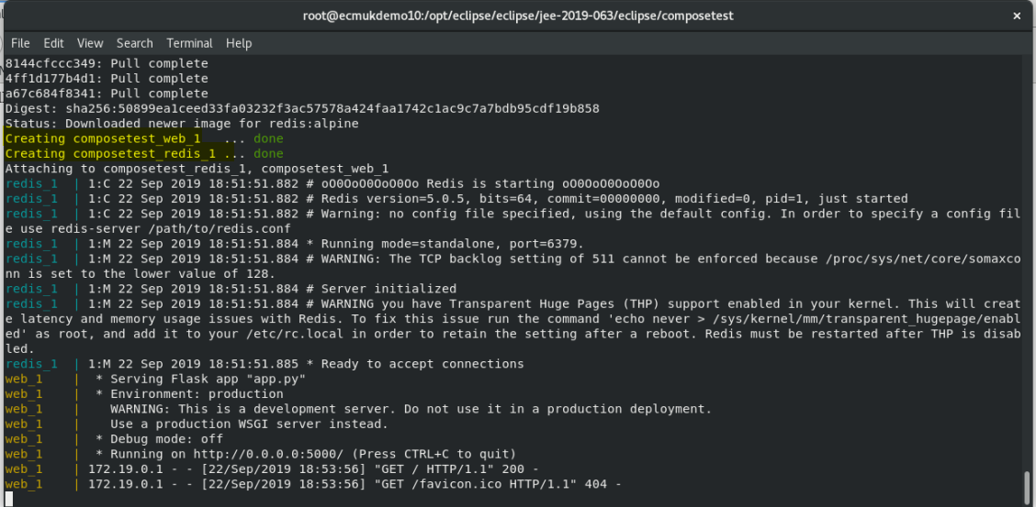

Appendix B - Example Eclipse plugin python container log
Running development environment...
*
*
*

A new CLI update is available.
Please go to https://github.com/appsody/appsody/releases/latest and update from 0.4.3 --> 0.4.5.

*
*
*
Running command: docker pull appsody/python-flask:0.1
Running docker command: docker run --rm -P --name cw-asbcodewindtest-63660d70-dd77-11e9-8727-53a434350696 --network codewind_network -v /root/codewind-workspace/ASBCodeWindTest/:/project/userapp -v asbcodewindtest-deps:/project/deps -v /root/codewind-workspace/.extensions/codewind-appsody-extension/bin/appsody-controller:/appsody/appsody-controller -t --entrypoint /appsody/appsody-controller appsody/python-flask:0.1 --mode=run
[Container] Running Install: cd /project/userapp;pipenv lock -r > requirements.txt;python -m pip install -r requirements.txt -t /project/deps
[Container] Creating a virtualenv for this project…
[Container] Pipfile: /project/userapp/Pipfile
[Container] Using /usr/local/bin/python (3.7.4) to create virtualenv…
[Container] ?25l
⠋0m Creating virtual environment...K
⠋0m Creating virtual environment...K
Etc….
⠙0m Creating virtual environment...K
Already using interpreter /usr/local/bin/python
[Container] Using base prefix '/usr/local'
[Container] New python executable in /root/.local/share/virtualenvs/userapp-pHZHaS8v/bin/python
[Container] Installing setuptools, pip, wheel...
[Container] done.
[Container]
[Container]
K?25h32m22m✔ Successfully created virtual environment!39m22m 0m
[Container] Virtualenv location: /root/.local/share/virtualenvs/userapp-pHZHaS8v
[Container] Pipfile.lock not found, creating…
[Container] Locking dev-packages dependencies…
[Container] Locking packages dependencies…
[Container] Updated Pipfile.lock (a65489)!
[Container] Running: python -m flask run --host=0.0.0.0 --port=8080
[Container] * Serving Flask app "server"
[Container] * Running on http://0.0.0.0:8080/ (Press CTRL+C to quit)
[Container] 172.18.0.3 - - 22/Sep/2019 20:27:43 "GET /health HTTP/1.1" 200 -
[Container] 172.18.0.3 - - 22/Sep/2019 20:27:53 "GET /health HTTP/1.1" 200 -
Etc… etc..
[Container] 172.18.0.3 - - 22/Sep/2019 21:20:53 "GET /health HTTP/1.1" 200 -
[Container] 172.18.0.3 - - 22/Sep/2019 21:21:03 "GET /health HTTP/1.1" 200 -
[Error] Error waiting in 'appsody run' exit status 137
Running development environment...
*
*
*

A new CLI update is available.
Please go to
https://github.com/appsody/appsody/releases/latest and update from 0.4.3 --> 0.4.5.

*
*
*
Running command: docker pull appsody/python-flask:0.1
Running docker command: docker run --rm -P --name cw-asbcodewindtest-63660d70-dd77-11e9-8727-53a434350696 --network codewind_network -v /root/codewind-workspace/ASBCodeWindTest/:/project/userapp -v asbcodewindtest-deps:/project/deps -v /root/codewind-workspace/.extensions/codewind-appsody-extension/bin/appsody-controller:/appsody/appsody-controller -t --entrypoint /appsody/appsody-controller appsody/python-flask:0.1 --mode=run
[Container] Running Install: cd /project/userapp;pipenv lock -r > requirements.txt;python -m pip install -r requirements.txt -t /project/deps
[Container] Warning: Python 3.6 was not found on your system…
[Container] You can specify specific versions of Python with:
[Container] $ pipenv --python path/to/python
[Container] Running: python -m flask run --host=0.0.0.0 --port=8080
[Container] * Serving Flask app "server"
[Container] * Running on http://0.0.0.0:8080/ (Press CTRL+C to quit)
[Container] 172.18.0.3 - - 22/Sep/2019 21:21:17 "GET /health HTTP/1.1" 200 -
[Container] 172.18.0.3 - - 22/Sep/2019 21:21:19 "GET /health HTTP/1.1" 200 -
[Container] 172.18.0.3 - - 22/Sep/2019 21:21:21 "GET /health HTTP/1.1" 200 -
[Container] 172.18.0.3 - - 22/Sep/2019 21:21:23 "GET /health HTTP/1.1" 200 -
Stopping development environment
Running command: docker stop cw-asbcodewindtest-63660d70-dd77-11e9-8727-53a434350696
Closing down development environment, sleeping 60 seconds: exit status 2
Running development environment...
*
*
*

A new CLI update is available.
Please go to https://github.com/appsody/appsody/releases/latest and update from 0.4.3 --> 0.4.5.

*
*

*
Running command: docker pull appsody/python-flask:0.1
Running docker command: docker run --rm -P --name cw-asbcodewindtest-63660d70-dd77-11e9-8727-53a434350696 --network codewind_network -v /root/codewind-workspace/ASBCodeWindTest/:/project/userapp -v asbcodewindtest-deps:/project/deps -v /root/codewind-workspace/.extensions/codewind-appsody-extension/bin/appsody-controller:/appsody/appsody-controller -t --entrypoint /appsody/appsody-controller appsody/python-flask:0.1 --mode=run
[Container] Running Install: cd /project/userapp;pipenv lock -r > requirements.txt;python -m pip install -r requirements.txt -t /project/deps
[Container] Warning: Python 3.6 was not found on your system…
[Container] You can specify specific versions of Python with:
[Container] $ pipenv --python path/to/python
[Container] Running: python -m flask run --host=0.0.0.0 --port=8080
[Container] * Serving Flask app "server"
[Container] * Running on http://0.0.0.0:8080/ (Press CTRL+C to quit)
[Container] 172.18.0.3 - - 22/Sep/2019 21:21:37 "GET /health HTTP/1.1" 200 -
[Container] 172.18.0.3 - - 22/Sep/2019 21:21:39 "GET /health HTTP/1.1" 200 -
[Container] 172.18.0.3 - - 22/Sep/2019 21:21:41 "GET /health HTTP/1.1" 200 -
Etc… etc
[Container] 172.18.0.3 - - 22/Sep/2019 21:25:53 "GET /health HTTP/1.1" 200 -
[Container] 172.18.0.3 - - 22/Sep/2019 21:26:13 "GET /health HTTP/1.1" 200 -
[Container] 172.18.0.3 - - 22/Sep/2019 21:26:33 "GET /health HTTP/1.1" 200 -
[Container] 172.18.0.3 - - 22/Sep/2019 21:26:53 "GET /health HTTP/1.1" 200 -
[Container] 172.18.0.3 - - 22/Sep/2019 21:27:13 "GET /health HTTP/1.1" 200 -
[Container] 172.18.0.3 - - 22/Sep/2019 21:27:33 "GET /health HTTP/1.1" 200 –

[Container] 172.18.0.3 - - 22/Sep/2019 21:31:53 "GET /health HTTP/1.1" 200 -
Closing down development environment, sleeping 60 seconds: exit status 2

