- After uninstall all WebSphere plugins and installed WAS 9.0 tools from the following::

http://public.dhe.ibm.com/ibmdl/export/pub/software/websphere/wasdev/updates/wdt/2020-03_comp/

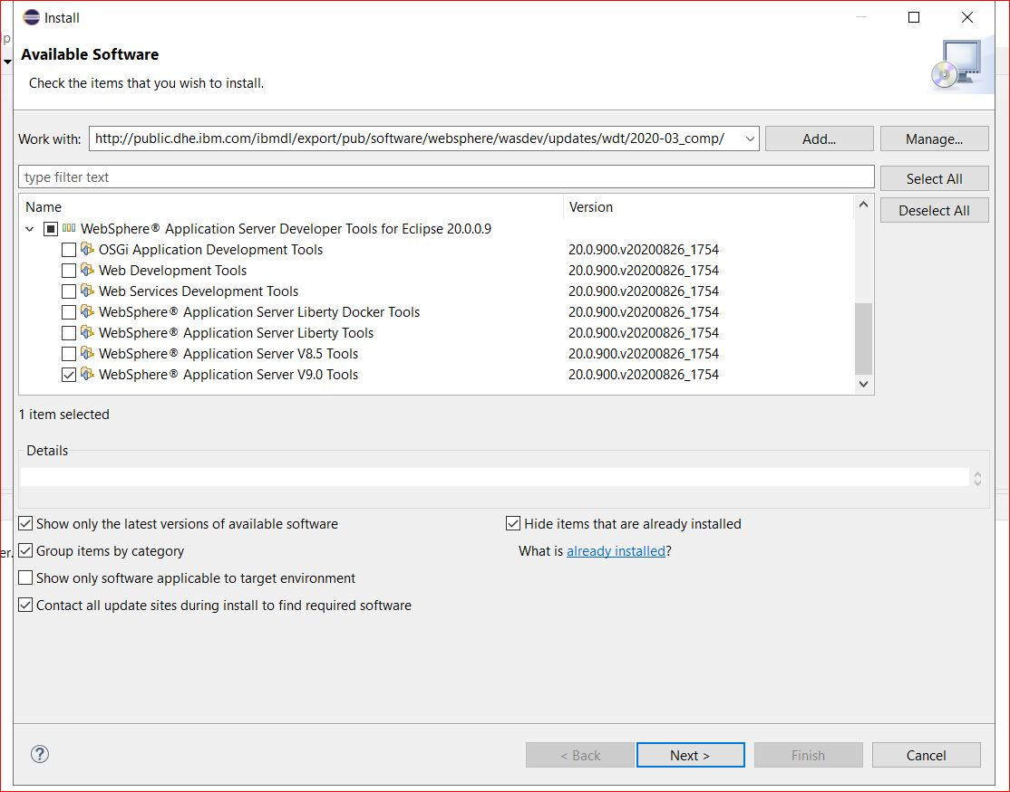

- After installed successfully Eclipse restarted. Then I captured all WDT full names as follows:

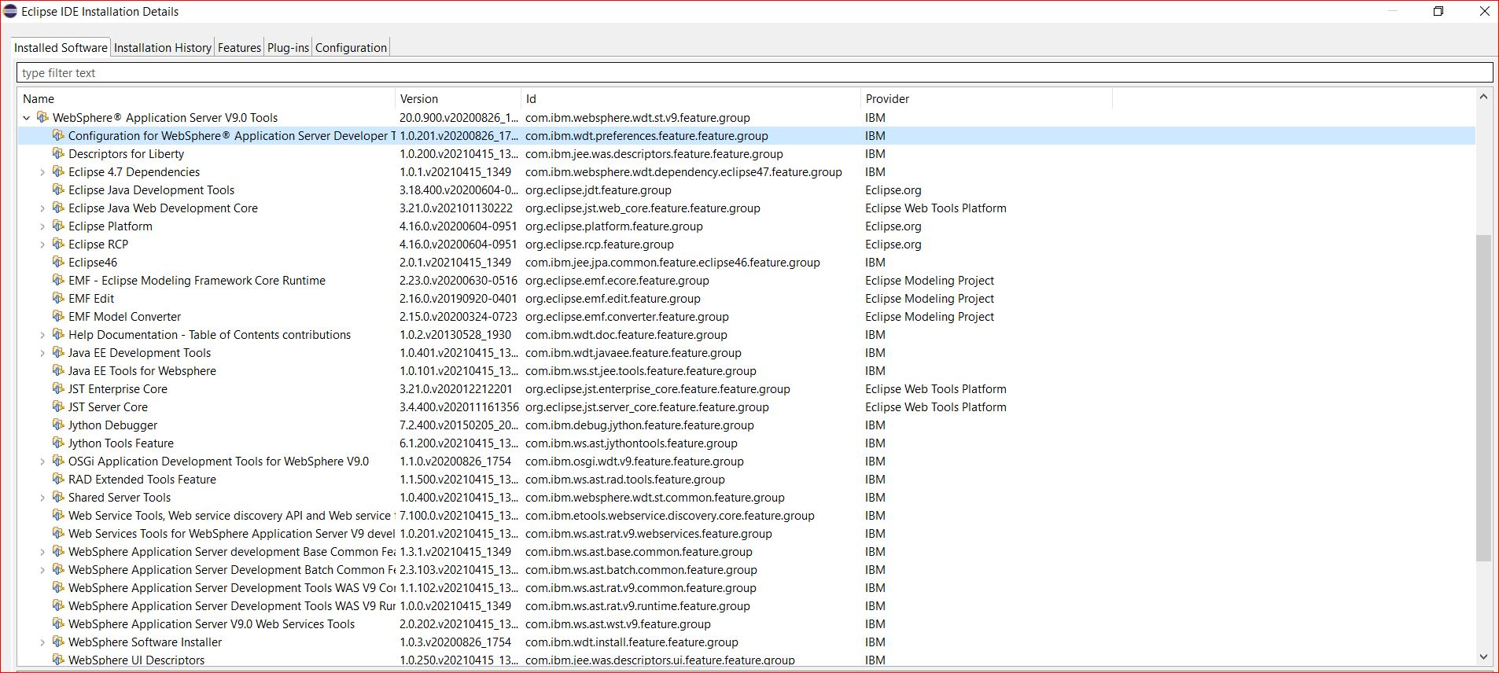

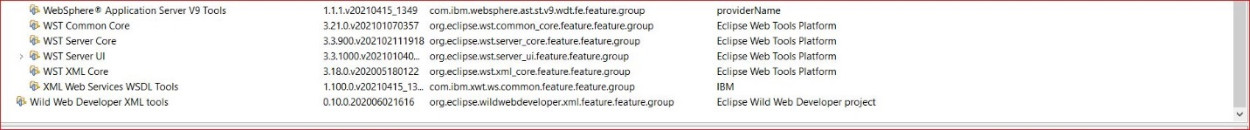

- Environment variable set for JAVA_HOME (JRE IBM location)

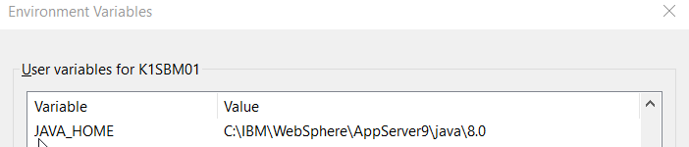

- Eclipse.ini for after setup IBM JRE location

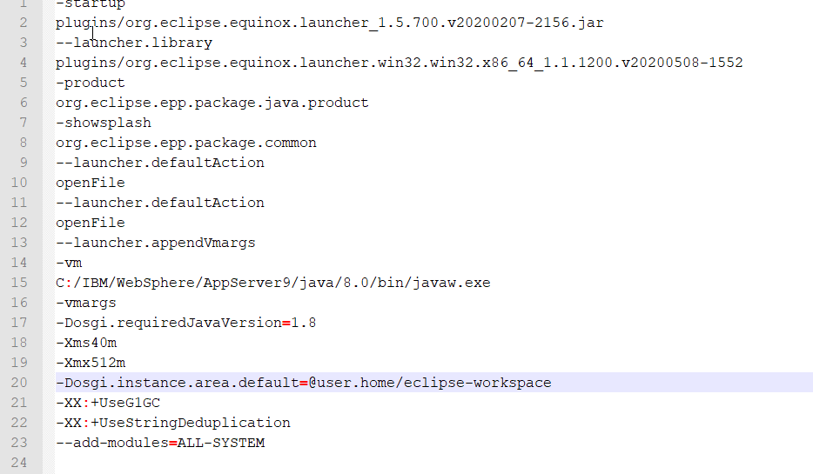

- Using eclipse 2020-06 version and the following is DIR for this version

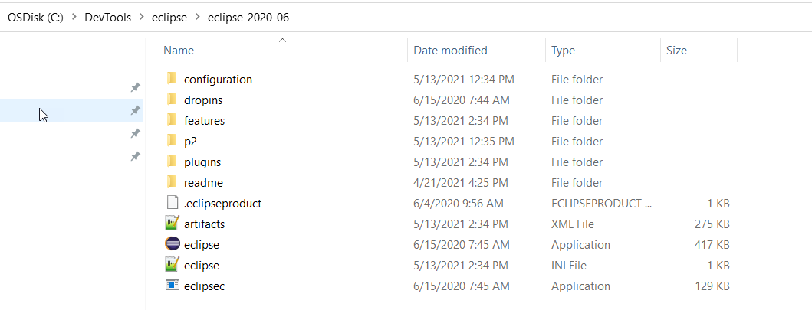
- Restarted eclipse after WAS 9 installation and the following

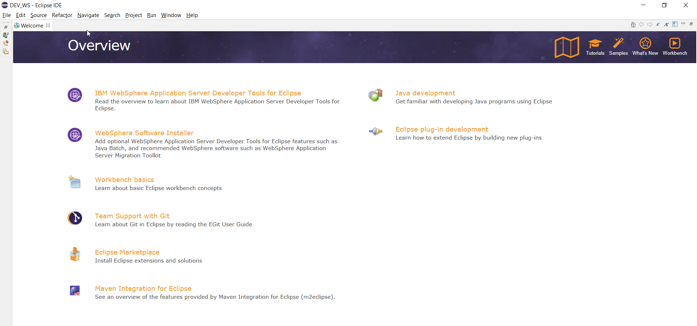

- Run java snippet to check correct Java version

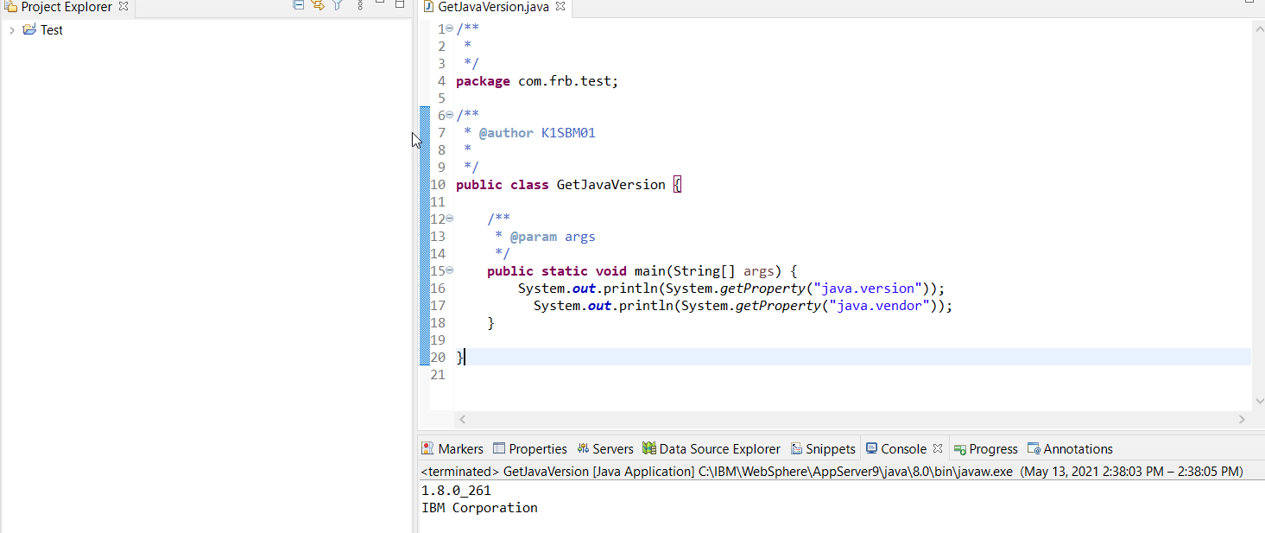

- Server New Select IBM Select WAS v 9.0 Click on Next

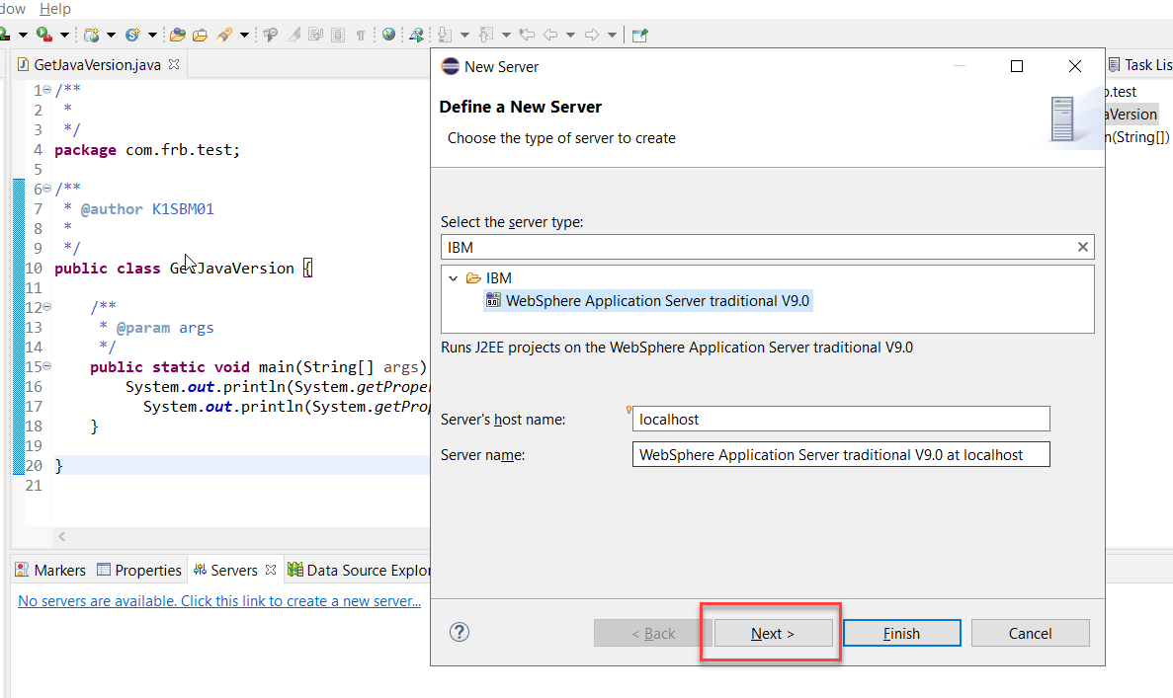

- This time it’s not asking profile screen and directly asking Add/Remove section as below.

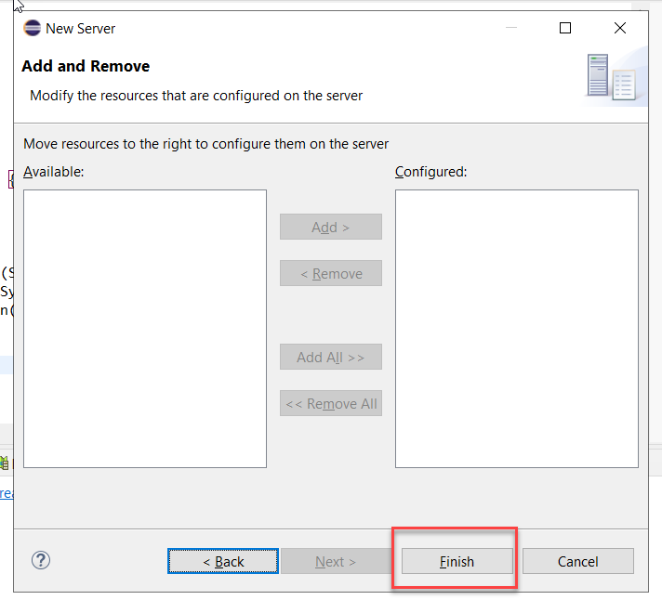

- Server right click on Start and getting following exception

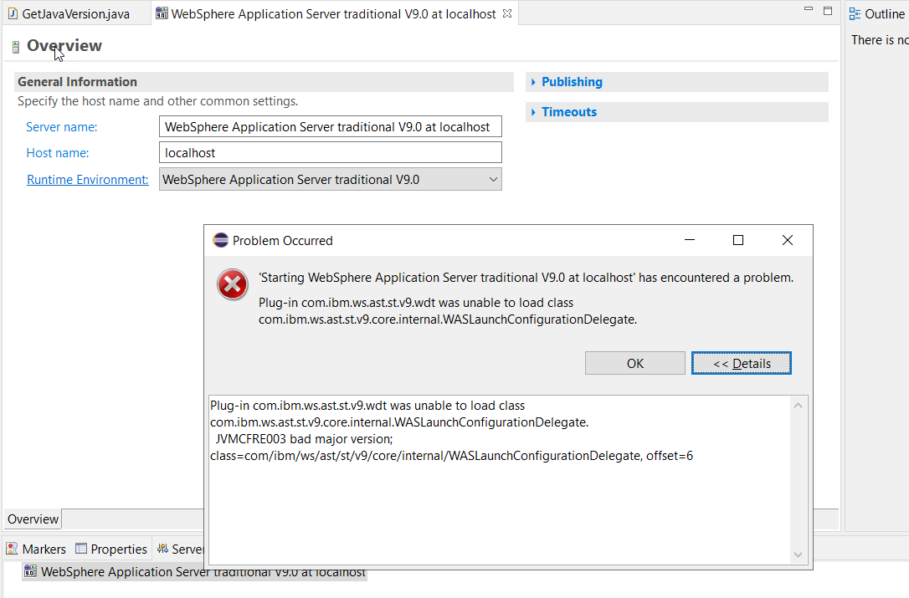

- Window preferences server Runtime Environments giving the following error
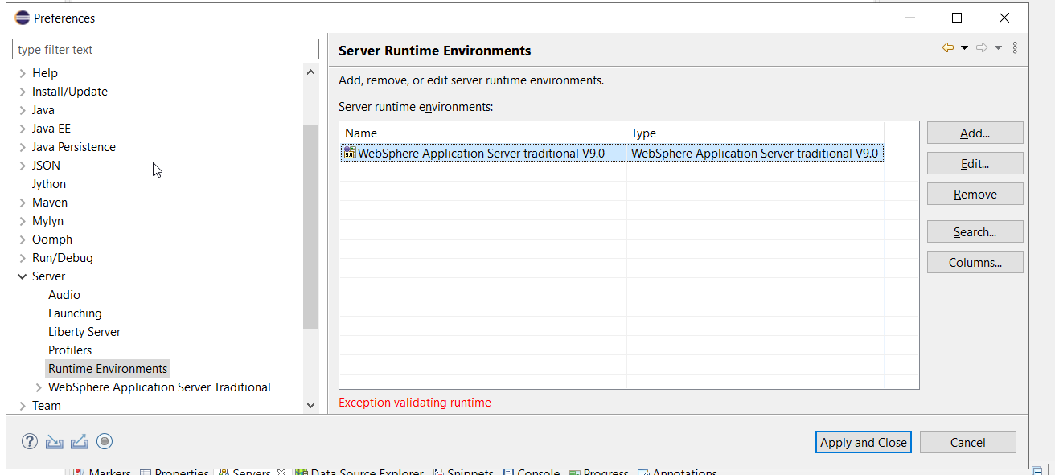

Now, I don’t see the following screens anymore after new installation and JRE location updated

