I am using the instruction Writing and reading to files at
https://www.ibm.com/docs/en/rbd/9.5.1?topic=tasks-writing-reading-files

my application has multiple projects, I want to set the ResourceAssociations in the project myServer which take data from oracle.

Following Setting up a resource association:
in myServer/EGLSource/myServer.eglbld, I created the part:
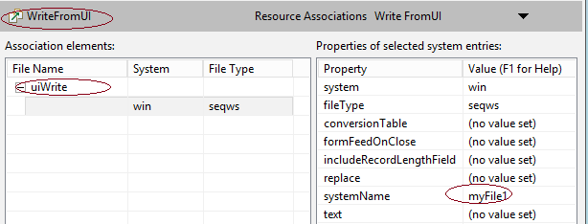

<ResourceAssociations name="WriteFromUI">
<description><![CDATA[Write FromUI]]></description>
<association fileName="uiWrite">
<win>
<seqws systemName="myFile1"/>
</win>
</association>
</ResourceAssociations>

And then added the Record:

record mySerialRecord type serialRecord
{fileName = "WriteFromUI"}
10 myInteger int;
10 myChar char(100);
End

Now I start to working on Writing to the file, I failed at item2.

In a function of my EGL program in myServer,
I tried to import it in the way:
import myProject.myData.mySerialRecord;

But I do not know what is the myData,
When I use:
import myServer.mySerialRecord;
I got error: myServer cannot be resolved.

I have to stop there. I am afraid the step 3. 4. 5 may not work too.

Please forward instruction

