- Successfully installed WebSphere V9.X Developer Tools from Eclipse Marketplace
- 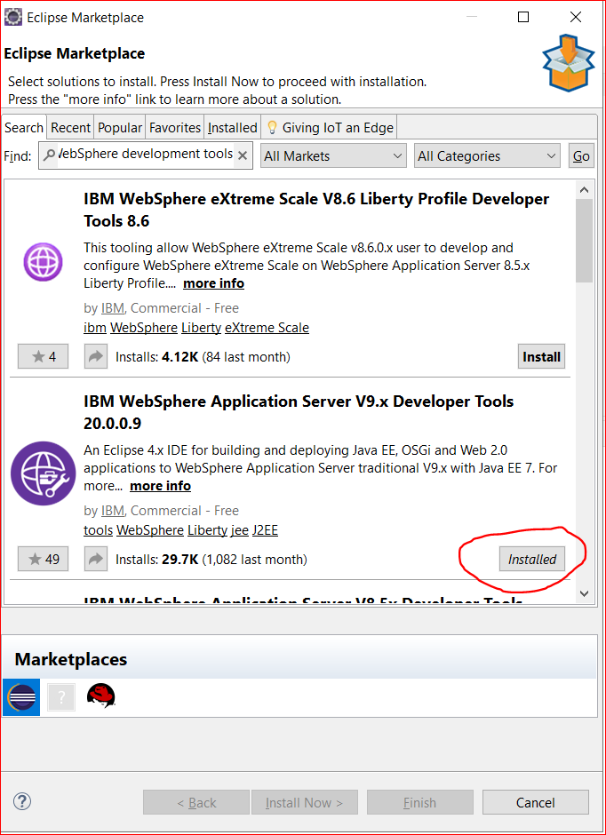

- Servers New Server Select IBM WebSphere and I see IBM JRE warning as below.

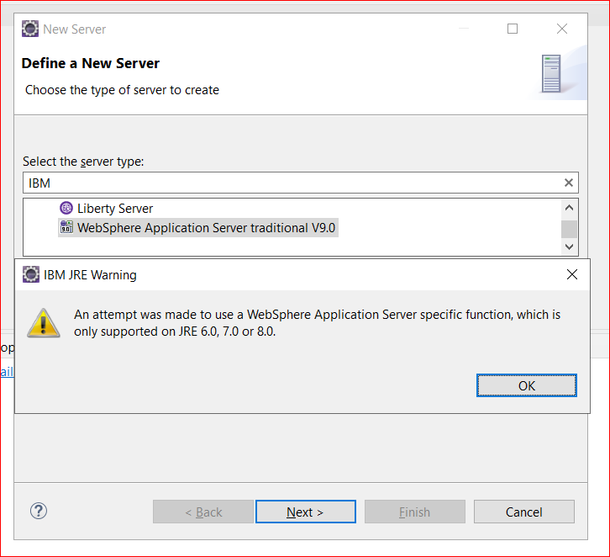

- Click OK then click on Next. It will ask WAS installation directory and selected IBM JRE as below.
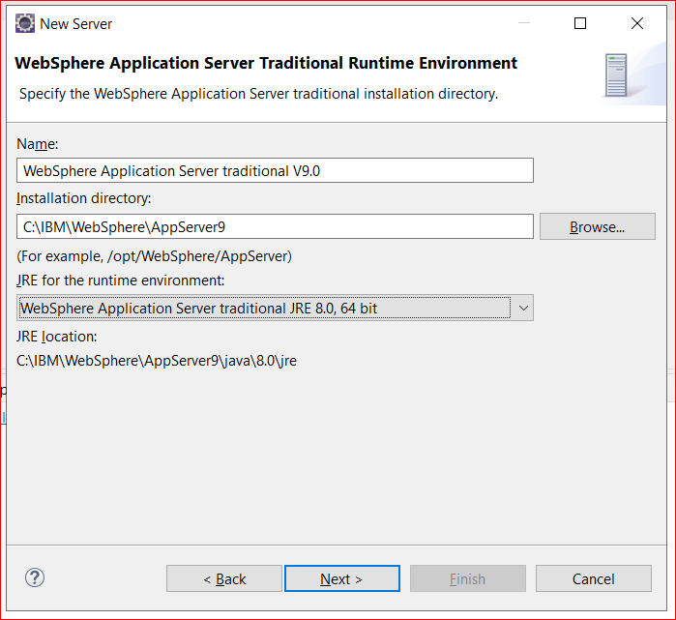

- Click on Next and it gives again IBM JRE warning as below.
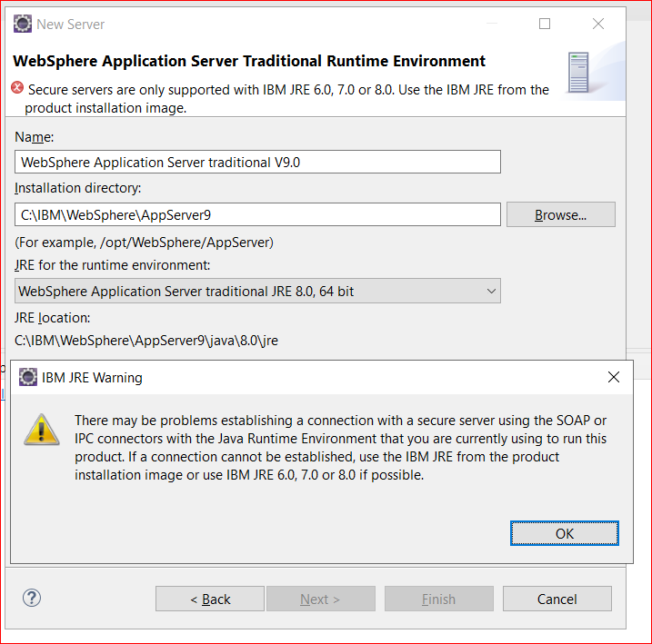

- Then click on OK and I can’t proceed further…..
