create a tradition dimension without any hierarchy
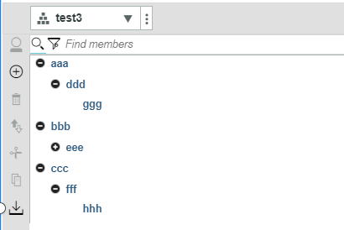
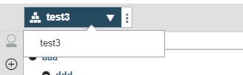

Create an empty hierarchy and start to add element in the default hierarchy
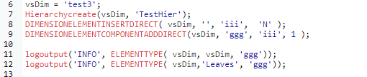

Note, I am using Direct version of dimension functions. Default hierarchy is right but not for Leaves hierarchy.
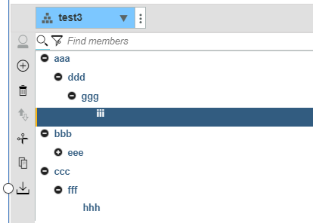
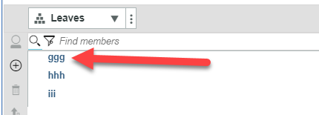
Apparently, they are out of sync now and can be confirmed with element type function.

Destroy the temp hierarchy and add another element
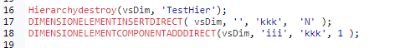

The default hierarchy is right still but not for the Leaves hierarchy.
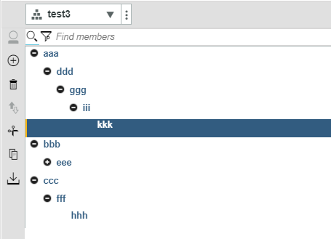
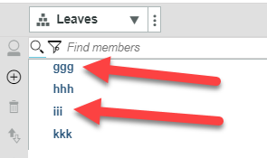

And now it only has default and Leaves hierarchies.
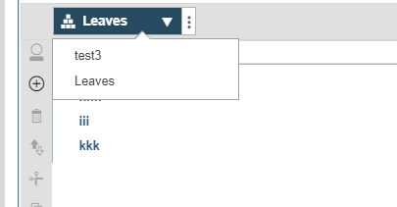

Now test same steps with NON-DIRECT dimension functions. Destroy and recreate dimension without any hierarchy.
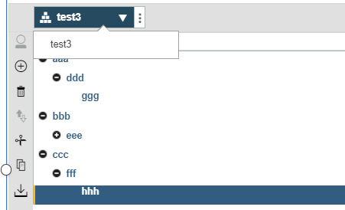

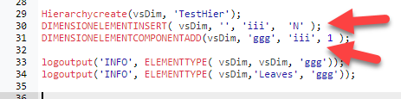
Default and Leaves hierarchies are both right.
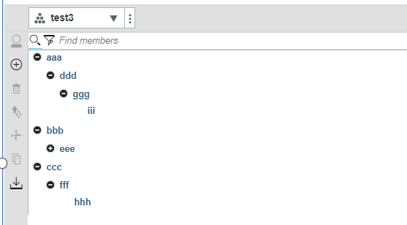
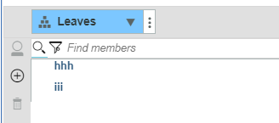
Interestingly, it still can read “N” element type of “ggg” in Leaves hierarchy, which is same as before. Looks like it is just hiding to display in Leaves hierarchy. Not sure if it could cause any potential problems or not.

Now insert another new element
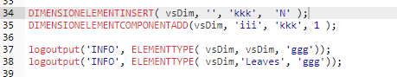

No surprise and it is right in the default and Leaves hierarchies.
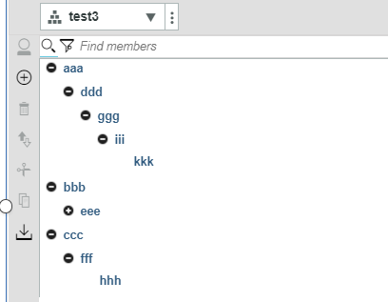
Interestingly again, now it only read “C” element type of “ggg” in default hierarchy. Element type in Leaves hierarchy didn’t return anything. Same as to check “iii”.

