IBM MQ Console on z/OS
gwydiontudur |Dec 5 2016 Updated
MQ Console is a browser-based MQ administration tool, which is available on all platforms that are supported by MQ V9.0.1, including z/OS. In this blog post I'll give an introduction to getting the MQ Console set up on z/OS, and some of the differences between the MQ Console on z/OS and on other platforms.

Installation
The MQ Console on z/OS is provided in a new optional "Unix System Services Web Components" feature (FMID JMS9016), which you'll need to select when performing the SMP/E install of MQ V9.0.1. When this feature is selected, it will install all the necessary files to use the MQ Console in a directory called "web" under the MQ installation directory in USS.

Creating and configuring the server
The MQ Console runs as an application in a WebSphere Liberty profile (WLP) server, which runs as a started task on z/OS. Before you can start the server for the first time there's a few things you'll need to do.
The first thing you'll need to do is to create the WLP server. Pick a location for the WLP user directory. The configuration files for the WLP server, and any log and trace files produced by the server, are all stored under this directory, so make sure that there's plenty of space available in the filesystem where this directory is located.
Then create the WLP server by changing into the web/bin directory under the MQ installation path in USS, and running the command
./crtmqweb.sh wlp_user-directory
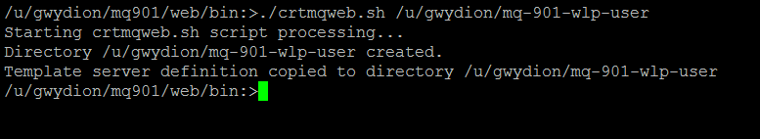
The crtmqweb.sh script copies the server definition to the WLP user directory specified as a parameter. You may need to change the permissions on the WLP user directory and its contents to give the user ID that the WLP server will run under read and write access.
To configure the server, edit the mqwebuser.xml file in the servers/mqweb directory of the WLP user directory. Bear in mind, when editing this file, that it's encoded in UTF-8.
You'll most likely need to configure a few parameters before starting the server. For example, setting the value of the httpHost variable to "*" so the server listens on all network interfaces, not just for requests on localhost (the default).

Security
The easiest way to configure the WLP server is to start with one of the three sample XML files that are provided in the web/mq/samp/configuration directory under the MQ installation path in USS.
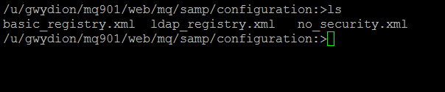
The samples are:
- basic_registry.xml - contains a sample basic user registry with a simple list of users and groups
- ldap_registry.xml - contains an example of how an LDAP registry can be configured
- no_security.xml - provides no user authentication.
There are various options for authenticating users in WLP, and on z/OS you may want to consider using a SAF registry, which would allow users to log in to the MQ Console with their z/OS user IDs. I won't go into the details of how to configure WLP to use a SAF registry here - that's probably worthy of a blog post in its own right - but the procedure is documented in the IBM Knowledge Center.
The other aspect of security to consider is securing the communication between your browser and the MQ Console. By default, the only way of connecting to the MQ Console is over HTTPS. However, the TLS certificate that is automatically generated by the WLP server when it's first started is not intended for production use. On z/OS, you'll probably want to use a certificate in a RACF keyring instead, which you can configure by following the example in the IBM Knowledge Center.

Almost there!
Once you've created and configured the WLP server, you'll need to create a JCL procedure to start the server. You can copy and edit the sample procedure supplied with MQ V9.0.1 called CSQ4WEBS. When you're choosing a name for your WLP procedure, bear in mind that you're likely to need a separate procedure for each version of MQ you will install from now on. So it's a good idea to call your WLP procedure for IBM MQ V9.0.1 something like MQW0901.
You can now start the WLP server by issuing the MVS command
START wlp-procname

Which queue managers can I work with?
The first thing you'll notice after logging into the MQ Console on z/OS will probably be the list of queue managers that are displayed in the queue manager widget. This list contains all the IBM MQ V9.0.1 queue managers that are defined on the system where the WLP server is running, regardless of whether they're currently running or stopped.
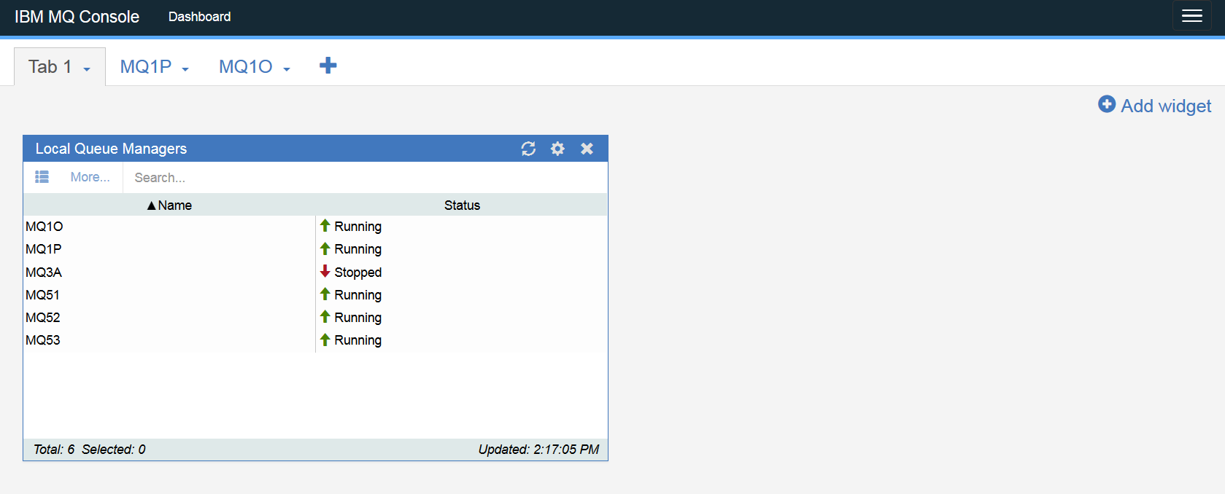
There is however one exception to this. Queue managers that have not been started since they were defined, or since the system was last IPLed, cannot be identified by the MQ Console. Therefore, they won't be displayed in the queue manager widget. So be aware that after your system is IPLed, the list of queue managers shown by the MQ Console may be shorter than usual, until the queue managers are started again.

MQ Console features on z/OS
Many of the features present on the MQ Console on distributed platforms are also available on z/OS. You can create and view objects such as queues, channels and channel authentication records, to name just a few.
However, there are some differences. For example, you can view and alter queue managers on z/OS from the MQ Console, but you cannot create, delete, start or stop queue managers. There are other functions that are specific to z/OS, such as creating shared queues, which are not yet available in the MQ Console. The full list of restrictions on z/OS are documented in the IBM Knowledge Center.
Existing objects, even if they're shared objects in a queue sharing group (QSG), can be displayed and managed from the MQ Console. For example, displaying a shared queue's properties will display its QSG disposition and the CF structure it's defined in.
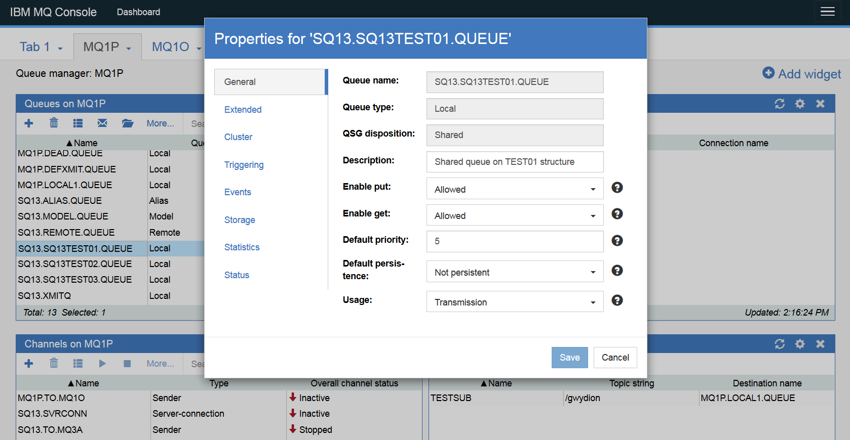
Hopefully this blog post will have helped you to get started with the MQ Console on z/OS. If there are any enhancements to the MQ Console you'd like us to consider, then do please let us know.

