without export DBACCESS_COLUMNS
dbaccess kandoodb
SELECT * FROM coa
)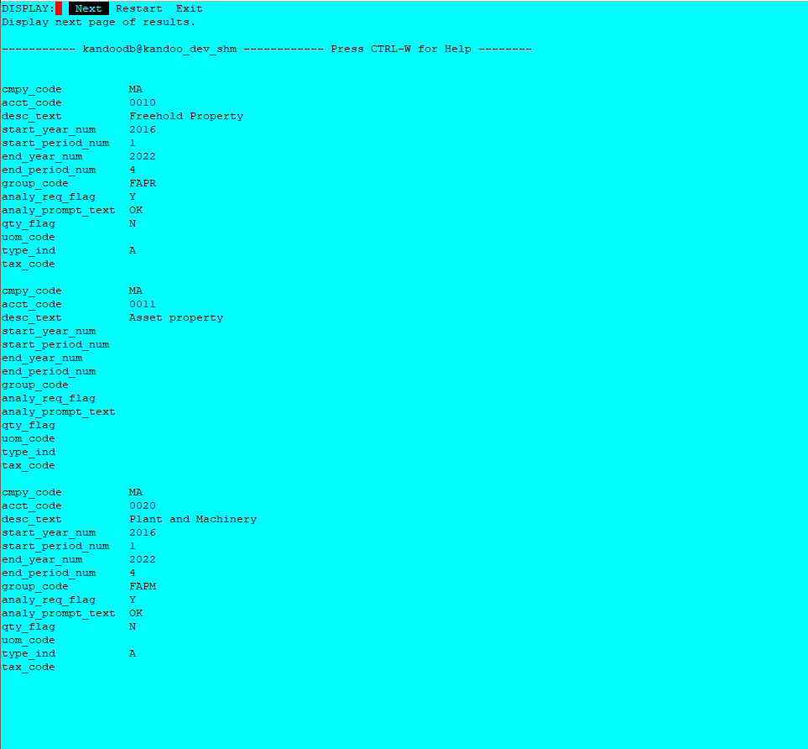
export DBACCESS_COLUMNS=1024
same query
dbaccess kandoodb
SELECT * FROM coa
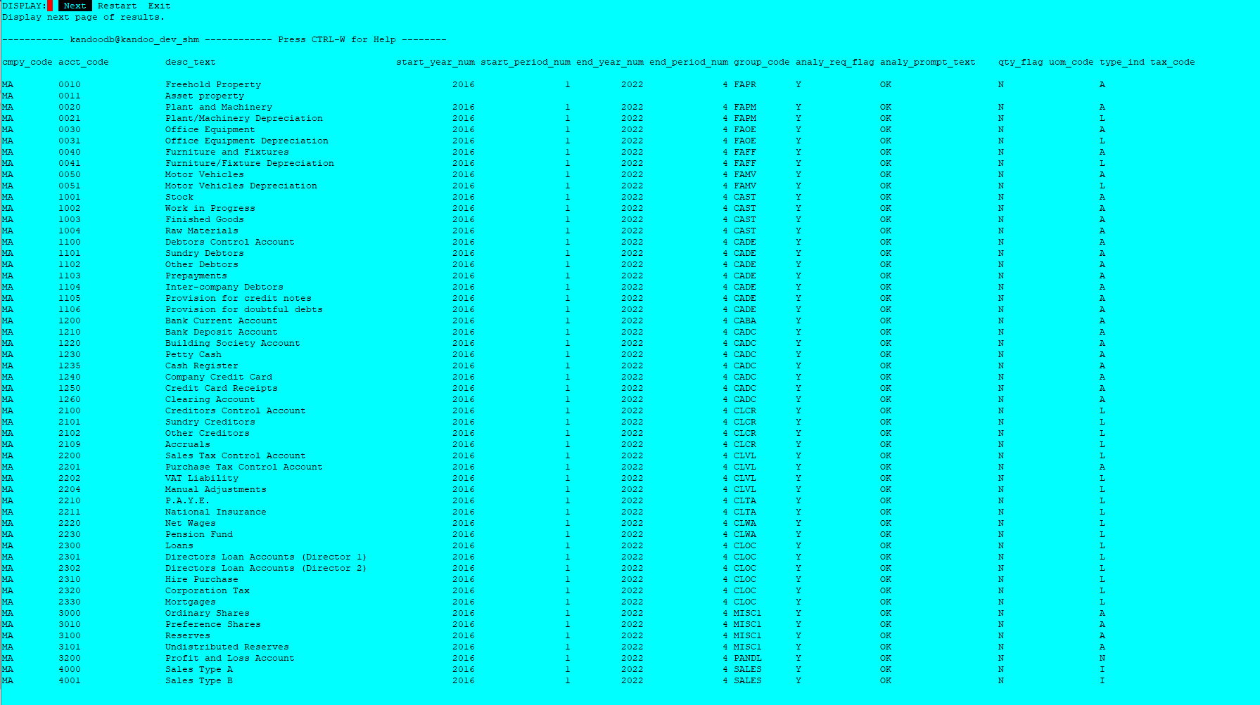

export DBACCESS_COLUMNS=1024
dbaccess kandoodb
SELECT * FROM customer
(take a “wider” table)

