Failover Clustering in MQ (MSCS)
ANILKSAHU |Aug 26 2014 Updated
This document is a self-help that describes how to configure MQ as a resource with failover cluster in Windows 2012. It will give a clear step by step process to be followed starting from the installation of failover clustering to putting MQ under Failover clustering successfully.

This will help customers who want to have a setup not only in Windows 2012 but also in Windows 2008 machine with minor changes.

What is Failover Cluster?
A “failover cluster” is a group of independent computers that work together to increase the availability and scalability of clustered roles (formerly called clustered applications and services). The clustered servers (called nodes) are connected by physical cables and by software. If one or more of the cluster nodes fail, other nodes begin to provide service (a process known as failover). In addition, the clustered nodes are proactively monitored to verify that they are working properly. If they are not working, they are restarted or moved to another node. With the Failover Clustering feature, users experience a minimum of disruptions in service.
Note: In Windows Server 2008 , Windows Server 2008 R2,windows 2012 and Windows server 2012 R2 the MSCS service has been renamed to Windows Server Failover Clustering.
MQ as a resource in Failover clustering
WebSphere MQ can be configured for clustering by making the queue manager the unit of failover to "Failover Clustering" by defining a queue manager as a resource. Fail over cluster can then monitor MQ, and transfer it to another computer in the cluster if there is a problem in the existing primary set up.
Lets now walk through on how to configure MQ as part of Failover Cluster in Windows 2012

Prerequisites for Failover Clustering:
To build a two-node failover cluster in windows 2012 , two physical systems or virtual machines (Vms) are required. You can create clusters with VM nodes using either Microsoft Hyper-V or VMware vSphere. I'll be creating the cluster using two physical servers, but the cluster configuration steps are same regardless of whether the cluster nodes are physical or virtual. However, a key point is that the nodes should be similarly configured to enable the backup node to handle the workloads that might need to be supported in the event of a failover or live migration.
It is important to configure both node (Machine A and B) identically:-
- Same Windows OS levels. (For this setup, I am using windows server 2012)
- Same MQ version and Same fixpack level) (For Example Machine A and B should be at MQ 7.5.0.1 )
- Same Domain name

Configuration of “ Failover Clustering”:
1.How to Install Failover Cluster Feature and Tools on both the Nodes?
The installation procedure for Failover Clustering in Windows Server 2012 is very similar to that in Windows Server 2008 and Windows Server 2008 R2 described in the following blog.
http://blogs.msdn.com/b/clustering/archive/2012/04/06/10291601.aspx
The Failover Clustering feature can be installed with either Server Manager or Windows PowerShell cmdlets.I have installed Failover clustering in Windows server 2012 in the following way using Server manager
a) In Server Manager, the Add Roles and Features Wizard is used to add roles and\or features. The Add Roles and Features Wizard are accessed in the Server Manager Menu bar by choosing Add Roles and Features from the list.
b) This starts the Add Roles and Features Wizard. The Installation Type is Role-based or feature-based installation.
c) Make sure the correct server is selected in the Server Selection screen.
d) In the Features screen, select Failover Clustering
e) Then click Add Features and then install.
Note: Once the Failover cluster feature is installed, the Failover Cluster Manager interface is available in the Tools category in the Menu bar. Failover Cluster Manager is also available by right clicking on a node in the cluster in the All Servers view.

2. How to Validate Failover Cluster?
Before creating a cluster, It is strongly recommend to validate the configuration. Validation helps to confirm that the configuration of the servers, network, and storage meets a set of specific requirements for failover clusters.
a)To open the failover cluster snap-in, click Start, click Administrative Tools, and then click Failover Cluster Management.
b)Confirm that Failover Cluster Management is selected and then, in the center pane under Management, click Validate a Configuration.
c)The Summary page appears after the tests run. To view Help topics that will help you interpret the results, click More about cluster validation tests.
d)In the Summary page, click View Report and read the test results.
As necessary, make changes in the configuration and rerun the tests.

3. How to Create new cluster ?
Create a new Cluster. There are some minor changes in the create cluster procedure in Windows Server 2012, but it is very similar to creating a cluster in Windows Server 2008 R2 as described in the following page.
http://blogs.msdn.com/b/clustering/archive/2012/05/01/10299698.aspx
a)To create a cluster, run the Create Cluster wizard.To open the failover cluster snap-in, click Start, click Administrative Tools, and then click Failover Cluster Management.
b)Confirm that Failover Cluster Management is selected and then, in the center pane under Management, click Create a cluster.
c)Follow the instructions in the wizard and specify:
The servers to include in the cluster.
The name of the cluster.
Any IP address information that is not automatically supplied by your DHCP settings.
d)To enable a cluster shared volume(CSV ) on an available disk, expand the Storage node and select the Disks node. Next, select the cluster disk that you want to use as a shared volume and click the Add to Cluster Shared Volumes link in the Failover Cluster Manager's Actions pane
e) Behind the scenes, Failover Cluster Manager configures the cluster disk's storage for Shared Volume, which includes adding a mount point in the system drive. In my example, I enabled CSVs on both Cluster Disk 1 and Cluster Disk 2, which added the following mount points:
C:\ClusterStorage\Volume1
C:\ClusterStorage\Volume2
At this point, the two-node Server 2012 cluster has been built and CSVs have been enabled.
How to add MQ as a Resource in Failover Clustering?

1. Prerequisites for adding QM to Failover Cluster
a)Create Queue manager .
Eg:Crtmqm mqsc_test
b) Start Queuemnager
Eg: using strmqm mqsc_test
c) Run 'haregtyp /r' to define the MQ MSCS resource type on both nodes.
d) Make a directory on the shared disk, e.g e:\WebSphere MQ
hamvmqm /m mscs_test /dd "e:\WebSphere MQ" /ld "e:\WebSphere MQ\log"
Once above command is executed,
Log Data will be available at “ e:\WebSphere MQ\log”
Queue manager Data will be available at e:\WebSphere MQ\qmgrs\<QM_NAME>

2. Putting QM under “Failover Clustering”

a) Log in to the cluster node computer hosting the queue manager, or log in to a remote workstation as a user with cluster administration permissions, and connect to the cluster node hosting the queue manager.
b) Start the Failover Cluster Management tool.
c) Right-click Failover Cluster Management > Connect Cluster ... to open a connection to the cluster.
d) Right-click on the cluster and select Configure Role to start the configuration wizard and click Next> .
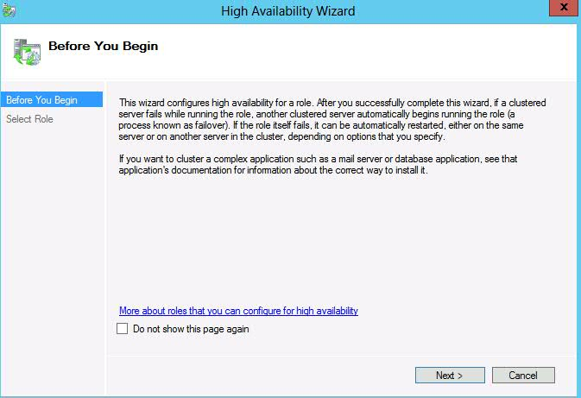
e) Select the role “Other Server” that we are going to configure for high availability. Click Next>
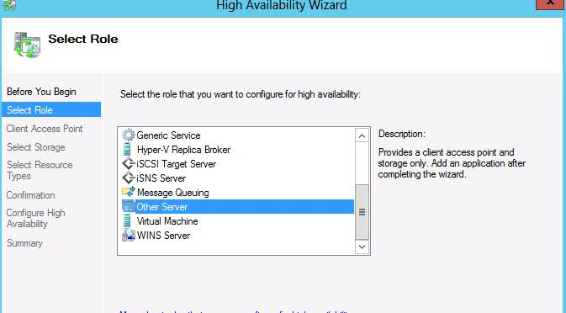
f) Click Next > .Type the name which we will use during the access to clustered role. Select an appropriate IP address as a client access point. Here in my example Name is MQS and ip- address I have choosen is 9.xxx.xxx.xxx. Click Next>.
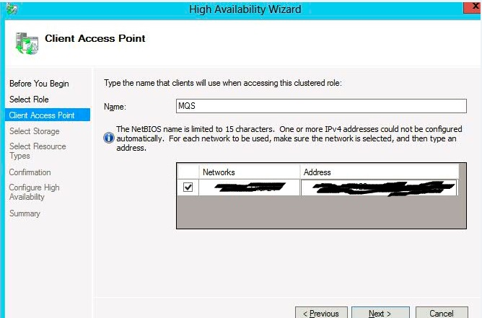

g) Select the storage volume where we have shared the queue manager data and logs. That will help the customer for exclusive use of Queue manager . Click Next>
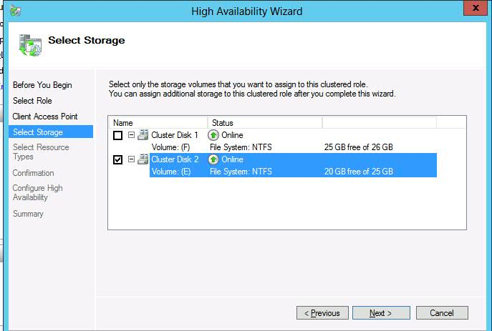

h) Select the IBM MQSeries MSCS resource on the "Select Resource Type" panel. Click Next>, you will get and confirmation in the following way.

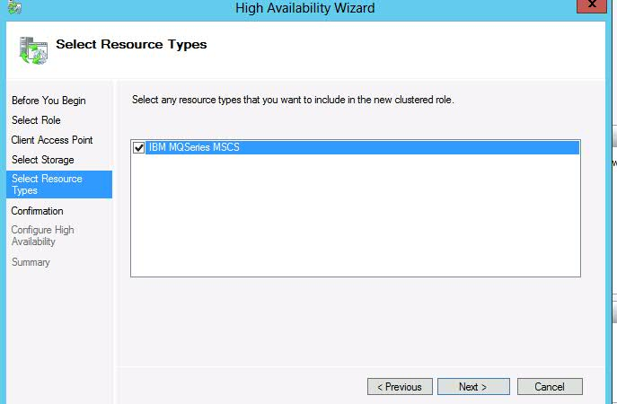

i)Then summary will be shown as below. Click Finish.
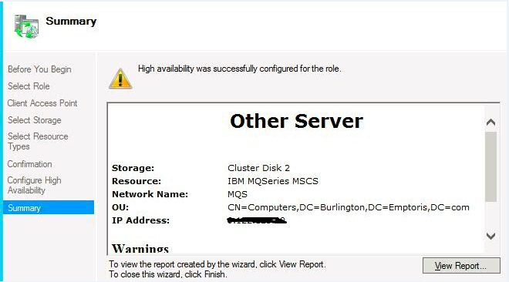

j) The Role in the Active machine will be shown as below.
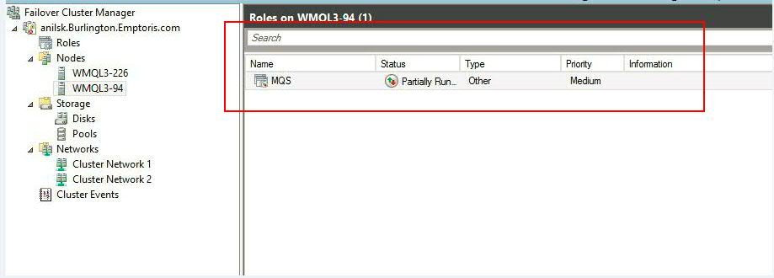

k) Select the newly defined service which contains a resource called 'New IBM MQSeries MSCS'. Select properties.
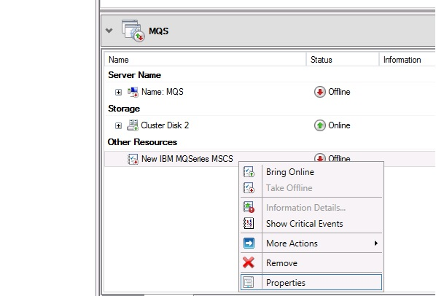
And configure as follows.
i. Under General ,you can edit the name if you want to change. In my case it is mscs_test.

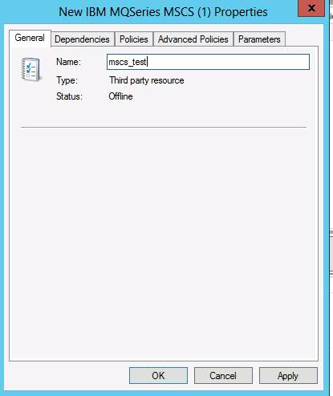

- Under Dependencies select the drive where the Queue manger data and logs have shared ,IP address where the service will run(Eg: 9.xxx.xxx.xxx) and the “name of the role”(Eg:MQS).
https://www.imwuc.org/community/user/communities/community-home/librarydocuments/viewdocument?DocumentKey=79b1b205-e74b-4e5c-9960-589487093c64
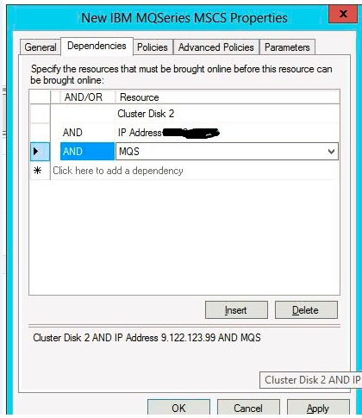

- Under Advanced policies select “Run this resource in a separate Resource monitor”.

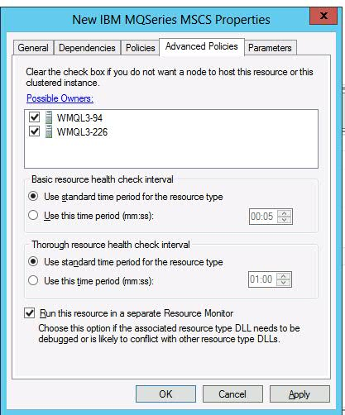

iv) Under Parameters Write the Queue Manager Name.

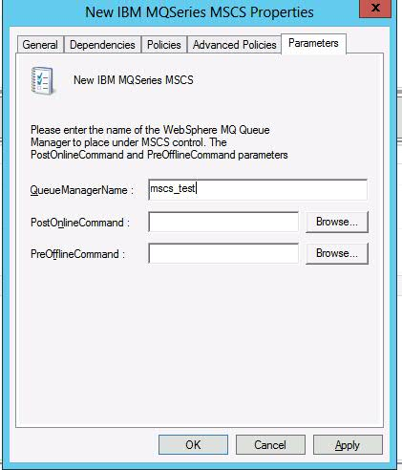

m) Now select the resource panel “mscs_test” (in my case) and right click.Click “Bring Online”
.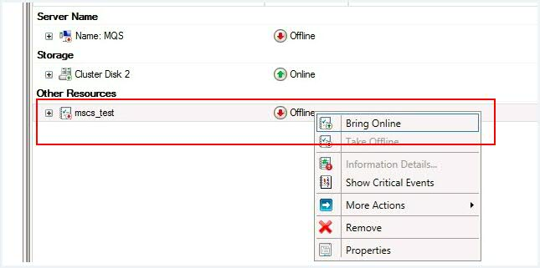

n) It will go offline on node “Machine A” and then online on node “Machine B” as per our example.

Note:You can check on the “Failover Cluster Manager Wizard” under Node by clicking on Machine B which will the show (eg:“MQS” here) Running.
Docs used to debug problems with MQ Failover Cluster

a)Cluster log file This comes from the cluster server itself by setting environment variable 'ClusterLog=C:\TEMP\Cluster.log' where C:\TEMP\Cluster.log is the fully qualified file path of where the log file will get written. Note it probably gets overwritten on reboot of the node.

b)MQ Trace with MSCS trace is incorporated into the main MQ trace .so just enable tracing as usual (strmqtrc -t detail -t all).

My Notes:
For successful MSCS security, follow these guidelines.

The guidelines are as follows:
- Make sure you that you have identical software installations on each computer in the cluster.
- Create a common namespace (security environment) across the cluster.
- Make the nodes of the MSCS cluster members of a domain, within which the user account that is the cluster owner is a domain account.
- Make the other user accounts on the cluster also domain accounts, so that they are available on both nodes. This is automatically the case if you already have a domain, and the accounts relevant to IBM® MQ are domain accounts.
- If you do not currently have a domain, consider setting up a mini-domain to cater for the cluster nodes and relevant accounts. Your aim is to make your cluster of two computers look like a single computing resource.
Remember that an account that is local to one computer does not exist on the other one. Even if you create an account with the same name on the other computer, its security identifier (SID) is different, so, when your application is moved to the other node, the permissions do not exist on that node.

During a failover or move, IBM MQ MSCS support ensures that all files that contain queue manager objects have equivalent permissions on the destination node. Explicitly, the code checks that the Administrators and mqm groups, and the SYSTEM account, have full control, and that if Everyone had read access on the old node, that permission is added on the destination node.
You can use a domain account to run your IBM MQ Service. Make sure that it exists in the local mqm group on each computer in the cluster.

If you are running more than one queue manager on a computer, you can choose one of these setups.
The setups are as follows:
- All the queue managers in a single group. In this configuration, if a problem occurs with any queue manager, all the queue managers in the group failover to the other computer as a group.
- A single queue manager in each group. In this configuration, if a problem occurs with the queue manager, it alone fails over to the other computer without affecting the other queue managers.
- A mixture of the first two setups.
There are two modes in which you might run a cluster system with IBM® MQ on Windows: Active/Passive or Active/Active.

Active/Passive mode
- In Active/Passive mode, computer A has the running application on it, and computer B is backup, only being used when MSCS detects a problem.

- You can use this mode with only one shared disk, but, if any application causes a failover, all the applications must be transferred as a group (because only one computer can access the shared disk at a time).
- You can configure MSCS with A as the preferred computer. Then, when computer A has been repaired or replaced and is working properly again, MSCS detects this and automatically switches the application back to computer A.
- If you run more than one queue manager, consider having a separate shared disk for each. Then put each queue manager in a separate group in MSCS. In this way, any queue manager can failover to the other computer without affecting the other queue managers.

Active/Active mode

- In Active/Active mode, computers A and B both have running applications, and the groups on each computer are set to use the other computer as backup. If a failure is detected on computer A, MSCS transfers the state data to computer B, and reinitiates the application there. computer B then runs its own application and A's.
- For this setup you need at least two shared disks. You can configure MSCS with A as the preferred computer for A's applications, and B as the preferred computer for B's applications. After failover and repair, each application automatically ends up back on its own computer.
- For IBM MQ this means that you could, for example, run two queue managers, one on each of A and B, with each exploiting the full power of its own computer. After a failure on computer A, both queue managers will run on computer B. This will mean sharing the power of the one computer, with a reduced ability to process large quantities of data at speed. However, your critical applications will still be available while you find and repair the fault on A.

New queue manager create for MSCS use.
This procedure ensures that a new queue manager is created in such a way that it is suitable for preparing and placing under MSCS control.
You start by creating the queue manager with all its resources on a local drive, and then migrate the log files and data files to a shared disk. (You can reverse this operation.) Do not attempt to create a queue manager with its resources on a shared drive.

You can create a queue manager for use with MSCS in two ways, either from a command prompt, or in the IBM® MQ Explorer. The advantage of using a command prompt is that the queue manager is created stopped and set to manual startup, which is ready for MSCS. (The IBM MQ Explorer automatically starts a new queue manager and sets it to automatic startup after creation. You have to change this.)

Creating a queue manager from a command prompt

Follow these steps to create a queue manager from a command prompt, for use with MSCS:

- Ensure that you have the environment variable MQSPREFIX set to refer to a local drive, for example C:\IBM MQ. If you change this, reboot the machine so that the System account picks up the change. If you do not set the variable, the queue manager is created in the IBM MQ default directory for queue managers.
- Create the queue manager using the crtmqm command. For example, to create a queue manager called mscs_test in the default directory, use:

- crtmqm mscs_test
- Proceed to Moving a queue manager to MSCS storage.

This procedure configures an existing queue manager to make it suitable for putting under MSCS control.
To achieve this, you move the log files and data files to shared disks to make them available to the other computer in the event of a failure. For example, the existing queue manager might have paths such as C:\WebSphere MQ\log\QMname and C:\WebSphere MQ\qmgrs\QMname.

If the queue manager being moved uses TLS connections and the TLS key repository is in the queue manager data directory on the local machine, then the key repository will be moved with the rest of the queue manager to the shared disk. By default, the queue manager attribute that specifies the TLS key repository location, SSLKEYR, is set to MQ_INSTALLATION_PATH\qmgrs\QMGRNAME\ssl\key, which is under the queue manager data directory. MQ_INSTALLATION_PATH represents the high-level directory in which IBM MQ is installed. The hamvmqm command does not modify this queue manager attribute. In this situation you must modify the queue manager attribute, SSLKEYR, using the IBM MQ Explorer or the MQSC command ALTER QMGR, to point to the new TLS key repository file.

The procedure is as follows:
- Shut down the queue manager, and check that there are no errors.
- If the queue manager's log files or queue files are already stored on a shared disk, skip the rest of this procedure and proceed directly to Putting a queue manager under MSCS control.
- Make a full media backup of the queue files and log files and store the backup in a safe place (see Queue manager log files for why this is important).
- If you already have a suitable shared disk resource proceed to step 6. Otherwise, using the MSCS Cluster Administrator to create a resource of type shared disk with sufficient capacity to store the queue manager log files and data (queue) files.
- Test the shared disk by using the MSCS Cluster Administrator to move it from one cluster node to the other and back again.
- Make sure that the shared disk is online on the cluster node where the queue manager log and data files are stored locally.
- Run the utility program to move the queue manager as follows:

- hamvmqm /m qmname /dd " e: \
- IBM MQ " /ld " e: \
- IBM MQ \log"
substituting your queue manager name for qmname, your shared disk drive letter for e, and your chosen directory for IBM MQ. The directories are created if they do not already exist.
- Test the queue manager to ensure that it works, using the IBM MQ Explorer. For example:
  - Right-click the queue manager tree node, then select Start. The queue manager starts.
  - Right-click the Queues tree node, then select New > Local Queue..., and give the queue a name.
  - Click Finish.
  - Right-click the queue, then select Put Test Message.... The Put Test Message panel is displayed.
  - Type some message text, then click Put Test Message, and close the panel.
  - Right-click the queue, then select Browse Messages.... The Message Browser panel is displayed.
  - Ensure your message is on the queue, then click Close. The Message Browser panel closes.
  - Right-click the queue, then select Clear Messages.... The messages on the queue are cleared.
  - Right-click the queue, then select Delete.... A confirmation panel is displayed, click OK. The queue is deleted.
  - Right-click the queue manager tree node, then select Stop.... The End Queue Manager panel is displayed.
  - Click OK. The queue manager stops.
- As IBM MQ Administrator ensure that the startup attribute of the queue manager is set to manual. In the IBM MQ Explorer, set the Startup field to manual in the queue manager properties panel.

Creating a queue manager using the IBM MQ Explorer

Follow these steps to create a queue manager using the IBM MQ Explorer, for use with MSCS:
- Start the IBM MQ Explorer from the Start menu.
- In the Navigator View, expand the tree nodes to find the Queue Managers tree node.
- Right-click the Queue Managers tree node, and selectNew > Queue Manager. The Create Queue Manager panel is displayed.
- Complete the dialog (Step 1), then click Next>.
- Complete the dialog (Step 2), then click Next>.
- Complete the dialog (Step 3), ensuring that Start Queue Manager and Create Server Connection Channel are not selected, then click Next>.
- Complete the dialog (Step 4), then click Finish.
- Proceed to Moving a queue manager to MSCS storage.

Support for MSCS utility programs
A list of the IBM® MQ support for MSCS utility programs that you can run at a command prompt.
IBM MQ support for MSCS includes the following utility programs:
Register/unregister the resource type
haregtyp.exe
After you unregister the IBM MQ MSCS resource type you can no longer create any resources of that type. MSCS does not let you unregister a resource type if you still have instances of that type within the cluster:
- Using the MSCS Cluster Administrator, stop any queue managers that are running under MSCS control, by taking them offline as described in Taking a queue manager offline from MSCS.
- Using the MSCS Cluster Administrator, delete the resource instances.
- At a command prompt, unregister the resource type by entering the following command:

- haregtyp /u
If you want to register the type (or re-register it at a later time), enter the following command at a command prompt:

haregtyp /r
After successfully registering the MSCS libraries, you must reboot the system if you have not done so since installing IBM MQ.
Move a queue manager to MSCS storage
hamvmqm.exe
See Moving a queue manager to MSCS storage.
Delete a queue manager from a node
hadltmqm.exe
Consider the case where you have had a queue manager in your cluster, it has been moved from one node to another, and now you want to destroy it. Use the IBM MQ Explorer to delete it on the node where it currently is. The registry entries for it still exist on the other computer. To delete these, enter the following command at a prompt on that computer:

hadltmqm /m qmname
where qmname is the name of the queue manager to remove.
Check and save setup details
amqmsysn.exe
This utility presents a dialog showing full details of your IBM MQ MSCS Support setup, such as might be requested if you call IBM support. There is an option to save the details to a file.
To place a queue manager under MSCS control on Windows Server 2012, use the following procedure:
- Log in to the cluster node computer hosting the queue manager, or log in to a remote workstation as a user with cluster administration permissions, and connect to the cluster node hosting the queue manager.
- Start the Failover Cluster Management tool.
- Right-click Failover Cluster Management > Connect Cluster ... to open a connection to the cluster.
- In contrast to the group scheme used in the MSCS Cluster Administrator on previous versions of Windows, the Failover Cluster Management tool uses the concept of services and applications. A configured service or application contains all the resources necessary for one application to be clustered. You can configure a queue manager under MSCS as follows:
  - Right-click on the cluster and select Configure Role to start the configuration wizard.
  - Select Other Server on the "Select Service or Application" panel.
  - Select an appropriate IP address as a client access point.
This address should be an unused IP address to be used by clients and other queue managers to connect to the virtual queue manager. This IP address is not the normal (static) address of either node; it is an additional address that floats between them. Although MSCS handles the routing of this address, it does not verify that the address can be reached.
  - Assign a storage device for exclusive use by the queue manager. This device needs to be created as a resource instance before it can be assigned.
You can use one drive to store both the logs and queue files, or you can split them up across drives. In either case, if each queue manager has its own shared disk, ensure that all drives used by this queue manager are exclusive to this queue manager, that is, that nothing else relies on the drives. Also ensure that you create a resource instance for every drive that the queue manager uses.
The resource type for a drive depends on the SCSI support you are using; refer to your SCSI adapter instructions. There might already be groups and resources for each of the shared drives. If so, you do not need to create the resource instance for each drive. Move it from its current group to the one created for the queue manager.
For each drive resource, set possible owners to both nodes. Set dependent resources to none.
  - Select the MQSeries MSCS resource on the "Select Resource Type" panel.
  - Complete the remaining steps in the wizard.
- Before bringing the resource online, the MQSeries® MSCS resource needs additional configuration:
  - Select the newly defined service which contains a resource called 'New MQSeries MSCS'.
  - Right-click Properties on the MQ resource.
  - Configure the resource:
    - Name ; choose a name that makes it easy to identify which queue manager it is for.
    - Run in a separate Resource Monitor ; for better isolation
    - Possible owners ; set both nodes
    - Dependencies ; add the drive and IP address for this queue manager.
Warning: Failure to add these dependencies means that IBM MQ attempts to write the queue manager status to the wrong cluster disk during failovers. Because many processes might be attempting to write to this disk simultaneously, some IBM MQ processes could be blocked from running.
    - Parameters ; as follows:
      - QueueManagerName (required); the name of the queue manager that this resource is to control. This queue manager must exist on the local computer.
      - PostOnlineCommand (optional); you can specify a program to run whenever the queue manager resource changes its state from offline to online. For more details see PostOnlineCommand and PreOfflineCommand in MSCS.
      - PreOfflineCommand (optional); you can specify a program to run whenever the queue manager resource changes its state from online to offline. For more details see PostOnlineCommand and PreOfflineCommand in MSCS.
Note: The looksAlive poll interval is set to default value of 5000 ms. The isAlive poll interval is set to default value of 60000 ms. These defaults can only be modified after the resource definition has been completed. For further details see looksAlive and isAlive polling on MSCS.
  - Optionally, set a preferred node (but note the comments in Using preferred nodes in MSCS )
  - The Failover Policy is set by default to sensible values, but you can tune the thresholds and periods that control Resource Failover and Group Failover to match the loads placed on the queue manager.
- Test the queue manager by bringing it online in the MSCS Cluster Administrator and subjecting it to a test workload. If you are experimenting with a test queue manager, use the IBM MQ Explorer. For example:
  - Right-click the Queues tree node, then select New > Local Queue..., and give the queue a name.
  - Click Finish. The queue is created, and displayed in the content view.
  - Right-click the queue, then select Put Test Message.... The Put Test Message panel is displayed.
  - Type some message text, then click Put Test Message, and close the panel.
  - Right-click the queue, then select Browse Messages.... The Message Browser panel is displayed.
  - Ensure that your message is on the queue, then click Close. The Message Browser panel closes.
  - Right-click the queue, then select Clear Messages.... The messages on the queue are cleared.
  - Right-click the queue, then select Delete.... A confirmation panel is displayed, click OK. The queue is deleted.
- Test that the queue manager can be taken offline and back online using the MSCS Cluster Administrator.
- Simulate a failover.
In the MSCS Cluster Administrator, right-click the group containing the queue manager and select Move Group. This can take some minutes to do. (If at other times you want to move a queue manager to another node quickly, follow the procedure in Moving a queue manager to MSCS storage.) You can also right-click and select Initiate Failure ; the action (local restart or failover) depends on the current state and the configuration settings.

