Archive Action – only works for ‘start table’.
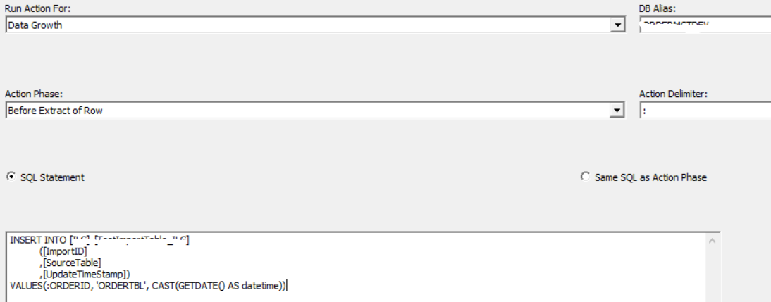

We need to be able to insert data from the highlighted tables into the temp tables for example.
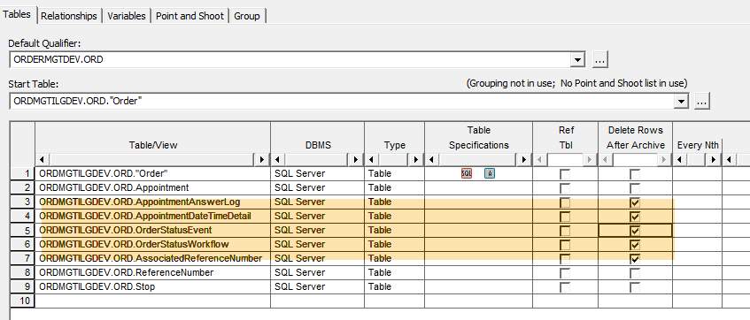

Does Optim cross databases yet? There was a problem with Optim linking databases together, has it been fixed.

