IBM Cloud Identity
And ServiceNow
Integration

Setup Guide

Version 1
February 2019
Document Purpose

This document presents the steps to integrate IBM Cloud Identity (CI) with ServiceNow. This document assumes you have an existing CI tenant and have some knowledge of CI administration. If you do not have a CI tenant, please see other collateral to acquire your own CI tenant.

NOTE: Remember that ServiceNow deletes developer instances after 10 days. Therefore, you must access your developer instance “My Instance” page periodically (at least once every 10 days) and click Extend Instance to prevent your instance from being removed.

For any comments/corrections, please contact Bryan Blackwell (bryanb@us.ibm.com)

Document Conventions
The following conventions are used in this document:

- A step to be performed by the student.
A note, some special information or warning.

A piece of code

Normal paragraph font is used for general information.

Document Control

Release Date | Version | Authors | Comments
15 Feb 2019 | 1 | Bryan Blackwell | Initial Draft

Table of Contents

1 Acquire ServiceNow Developer Instance 4
1.1 Become a member of the ServiceNow Developer Site 4
1.2 Define your ServiceNow Developer Instance 6
2 Add ServiceNow application to your CI tenant 11
3 Configure ServiceNow 15
3.1 Create ServiceNow Login ID 16
3.2 Activate the Single Sign On plugin 17
3.3 Configure SSO properties 21
3.4 Add CI as the Identity Provider 22
3.5 Get sys_id of the CI Identity Provider 28
3.6 Enable SAML for Users 30
3.7 Other configurations not included in this document 33
4 Verify Single Sign-on 34
Use the following URLs to verify that the single sign-on configuration works 34
4.1 SSO from CI 34
Notices 36

Acquire ServiceNow Developer Instance

Become a member of the ServiceNow Developer Site
Access https://developer.servicenow.com/app.do#!/home and click Register in the upper right action bar

Complete the registration and click Submit

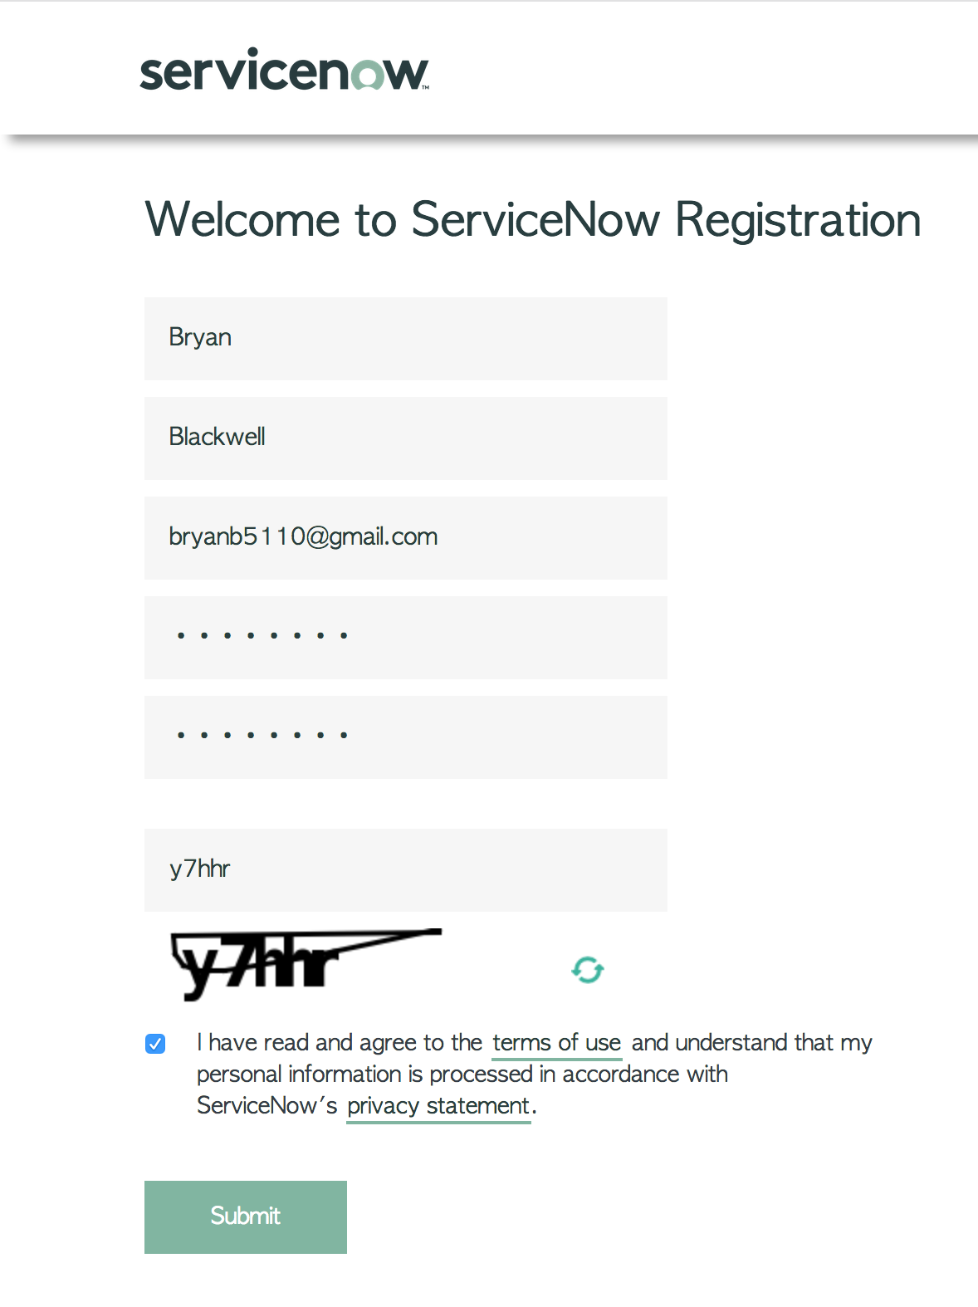

Check your e-mail

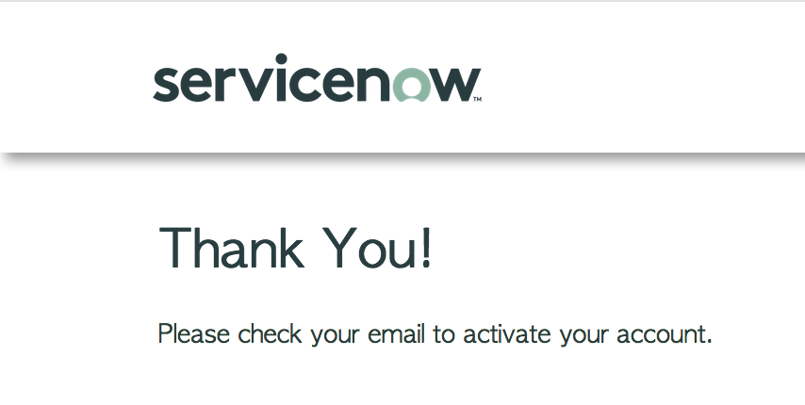

Click Verify Email

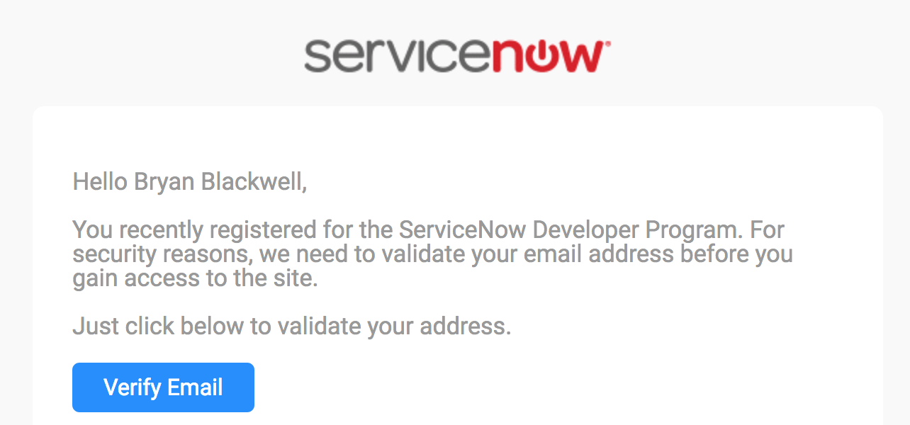

Click Sign In

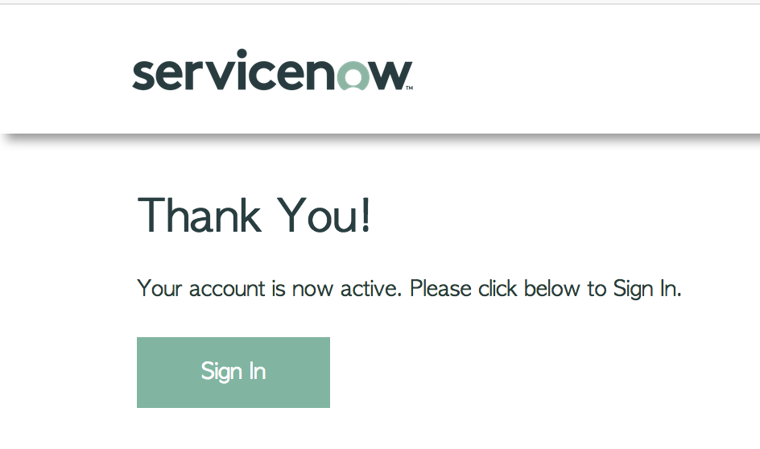

Define your ServiceNow Developer Instance

Sign In to the Developer Site

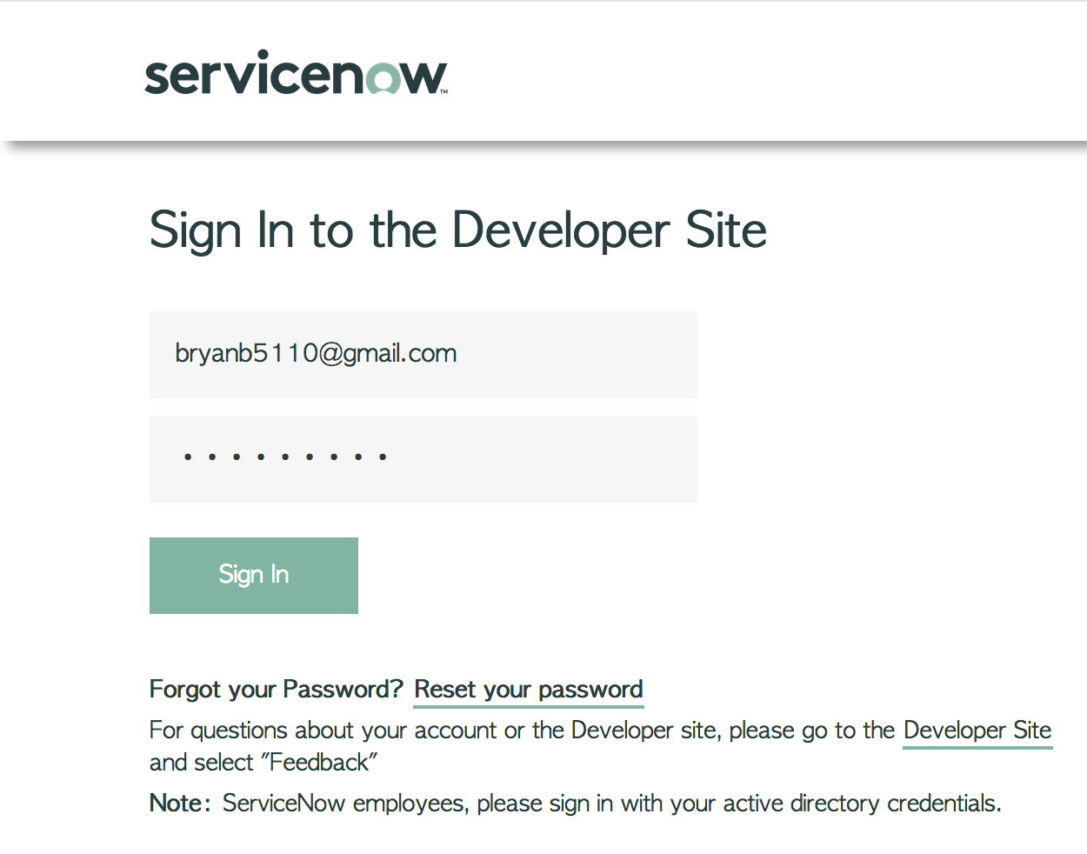

Accept the ServiceNow Developer Agreement and click Submit

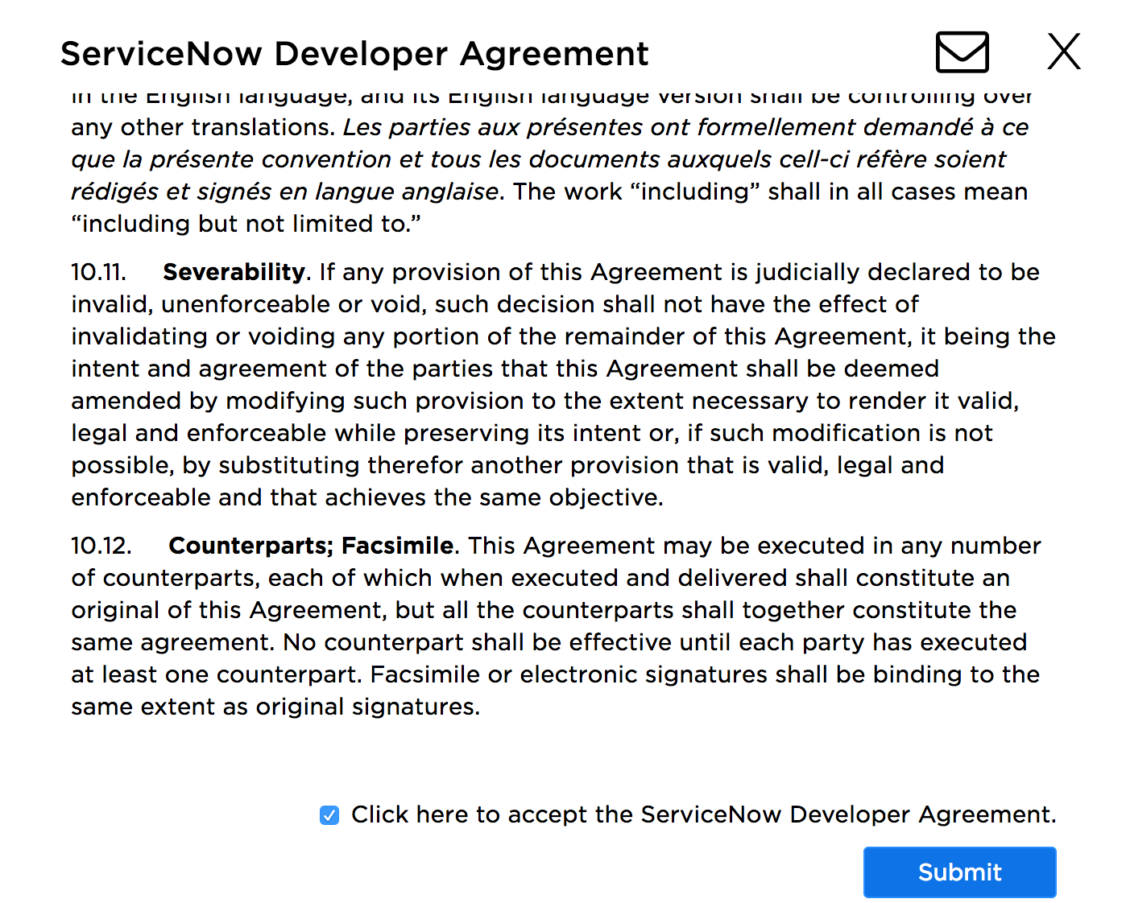

Answer the additional questions and click Submit

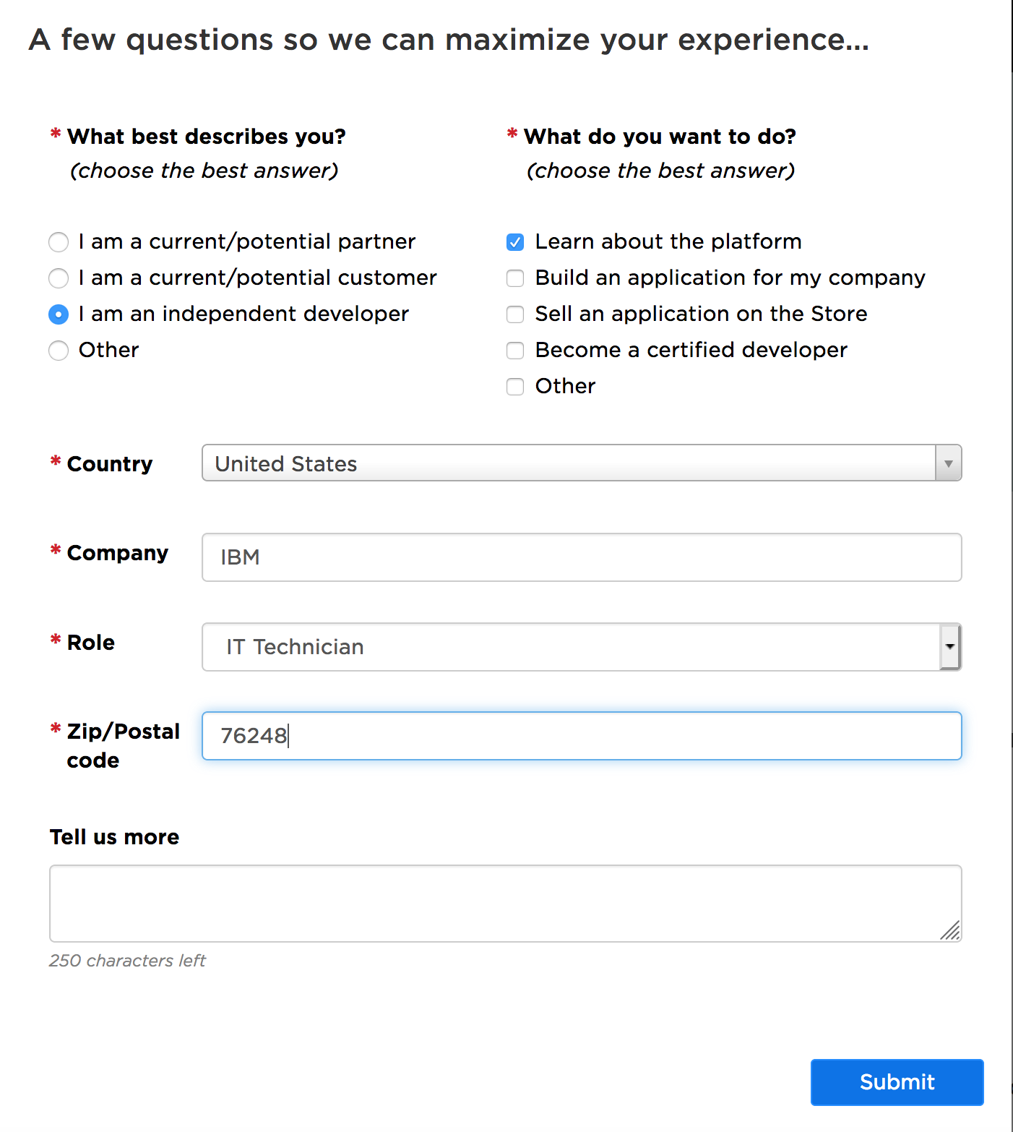

You should be directed to the ServiceNow Developer Site. If not, log in to the ServiceNow developer site (https://developer.servicenow.com/app.do#!/home). Click Manage and then click Instance

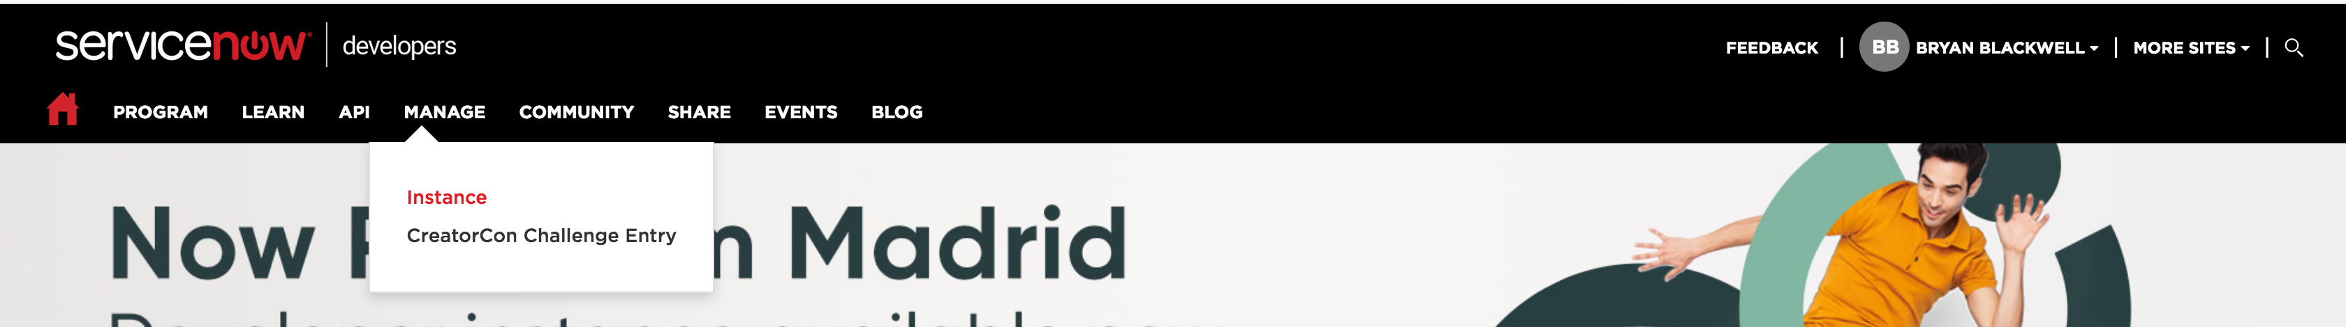

Click Request Instance

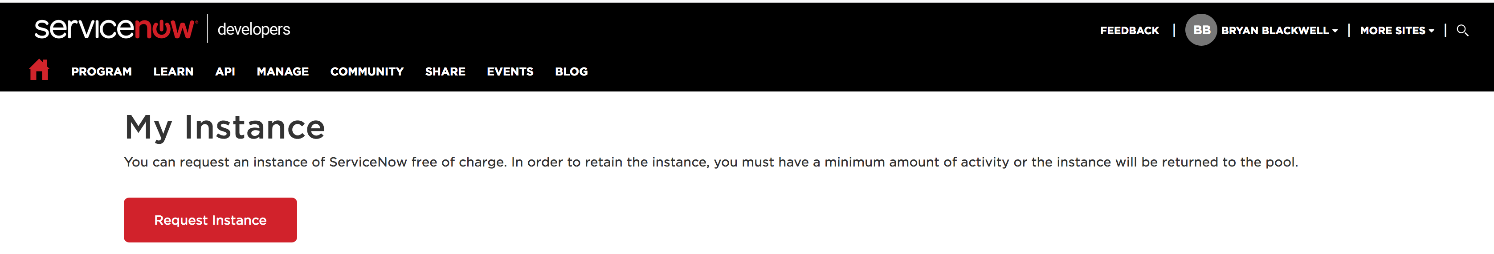

State your reason to use ServiceNow and click I Understand

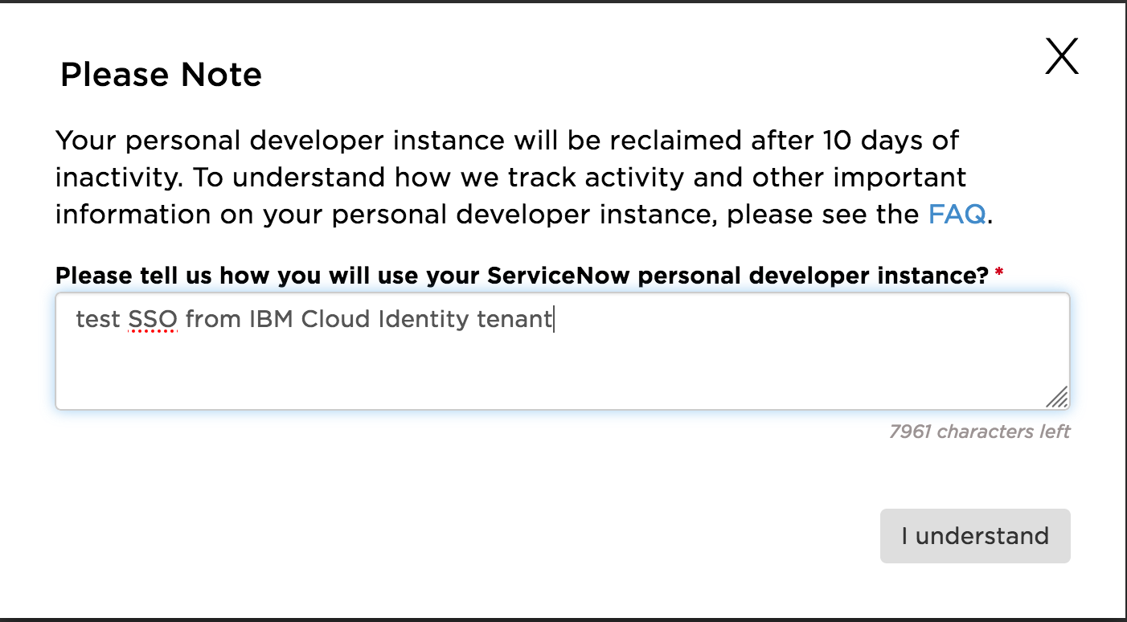

I chose the Madrid release. Click the release you want.

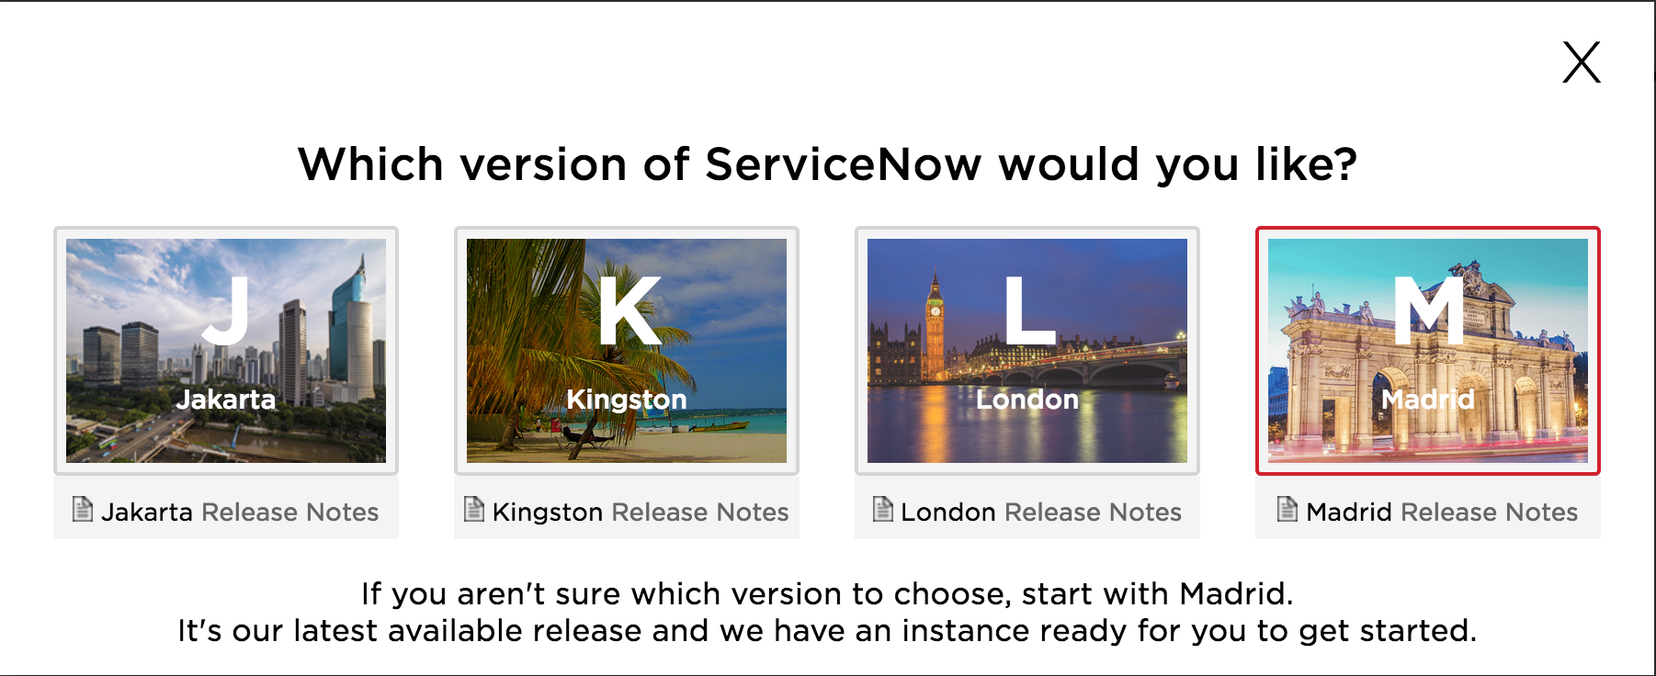

Take note of all your instance details

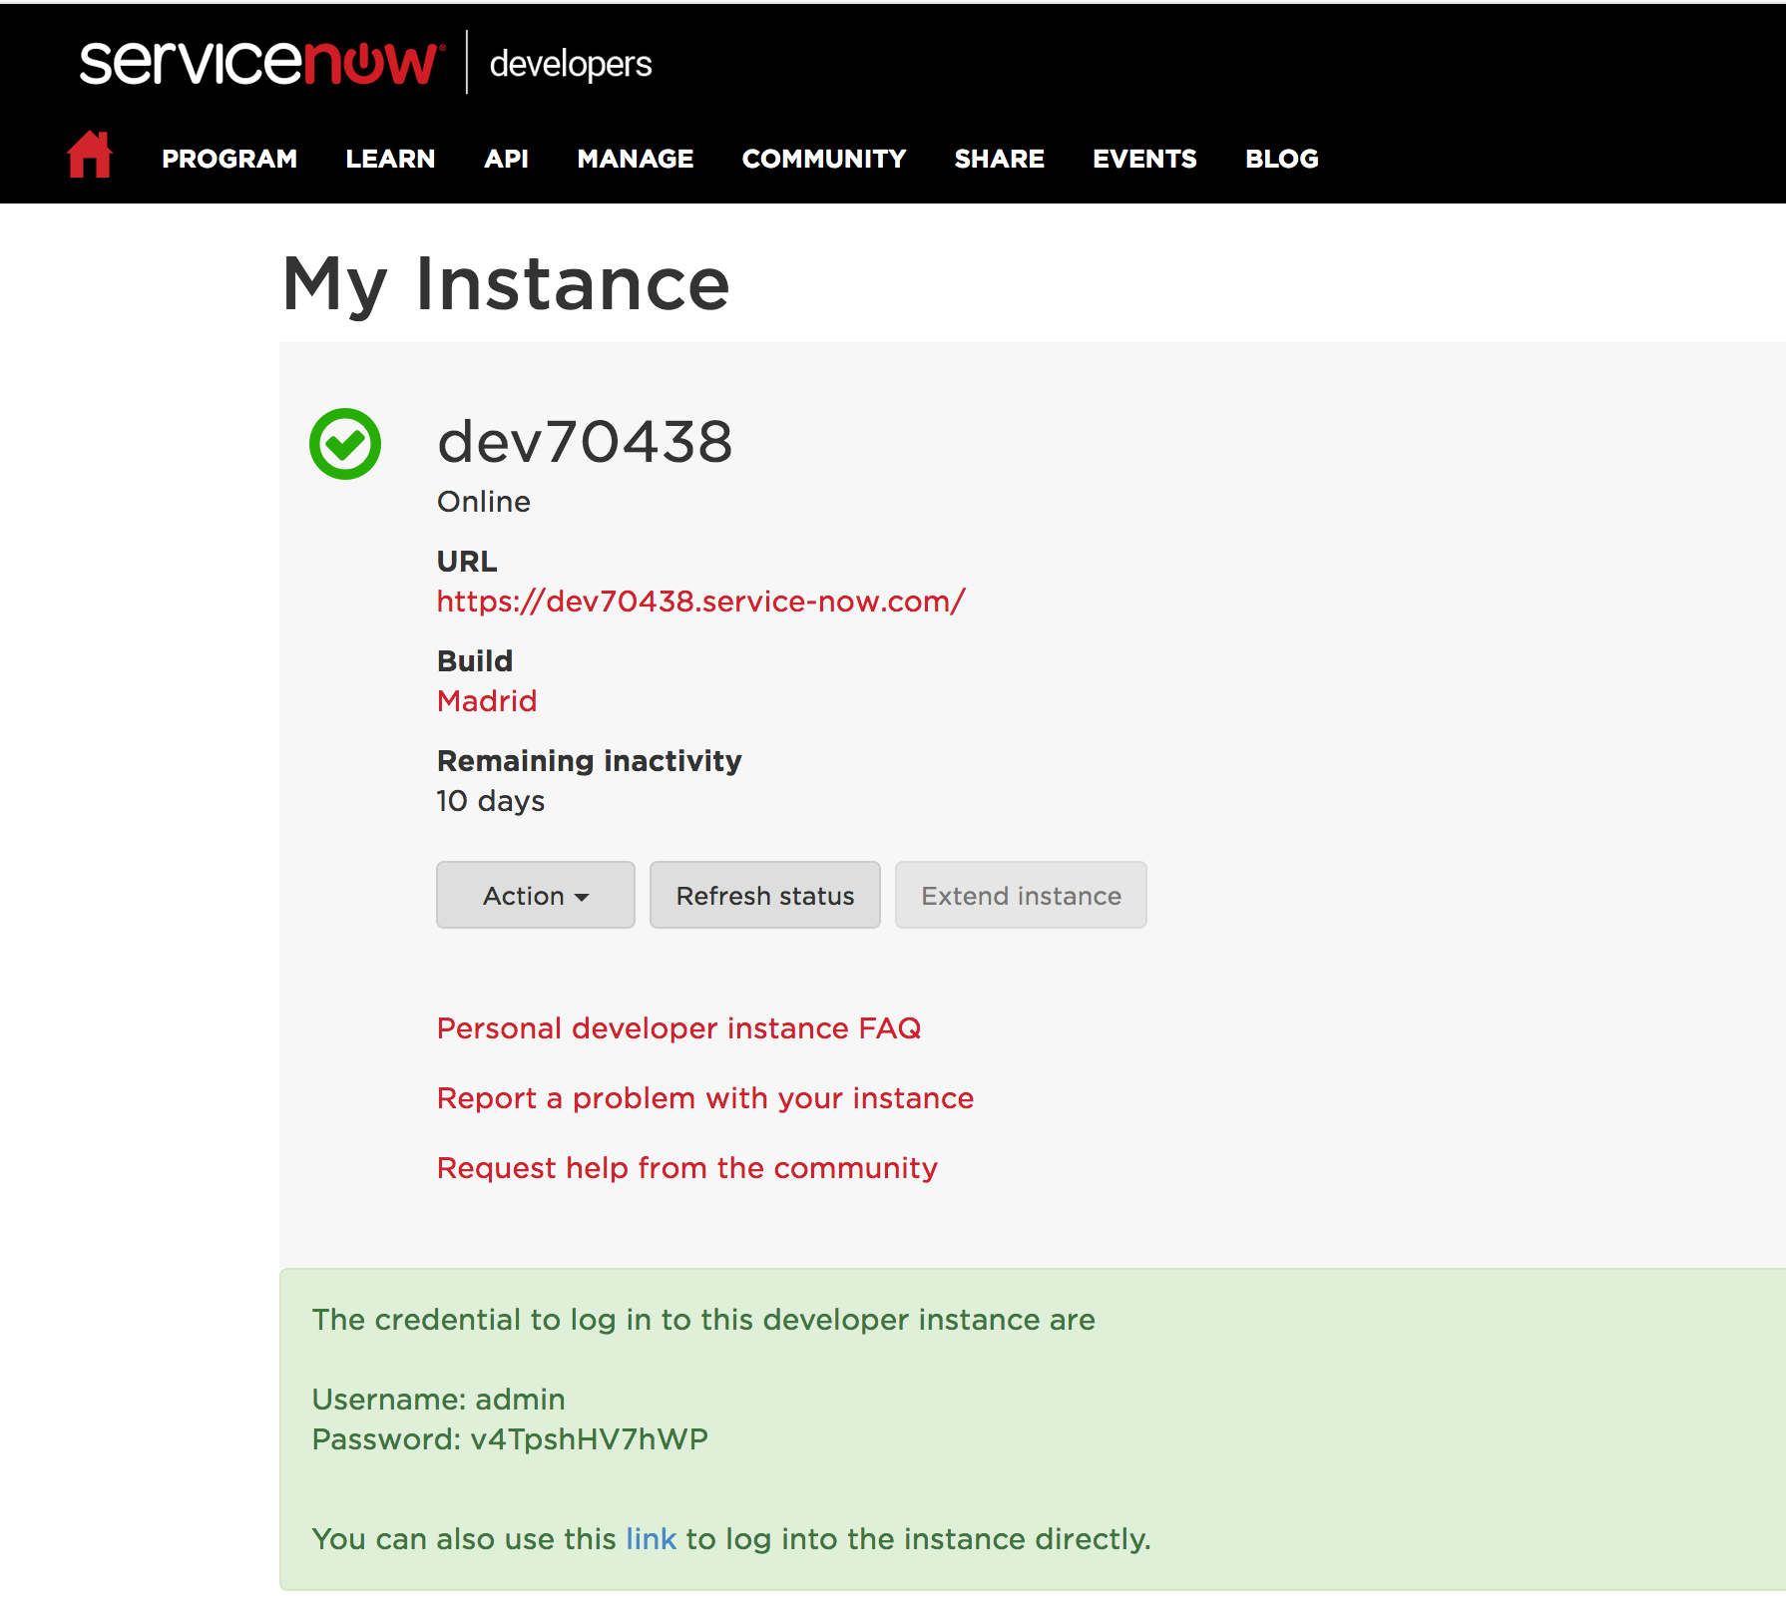

NOTE: Remember that ServiceNow deletes developer instances after 10 days. Therefore, you must access your developer instance “My Instance” page periodically (at least once every 10 days) and click Extend Instance to prevent your instance from being removed.

Add ServiceNow application to your CI tenant
Login to your CI tenant as an Administrator. Switch to the Admin page. Click Applications. Click Add

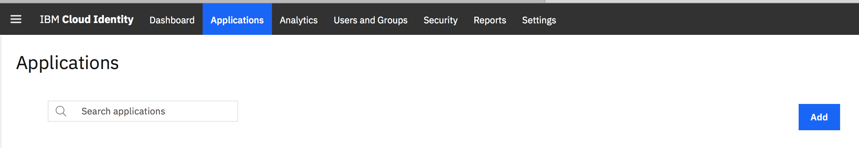

Search for ServiceNow, click it and click OK

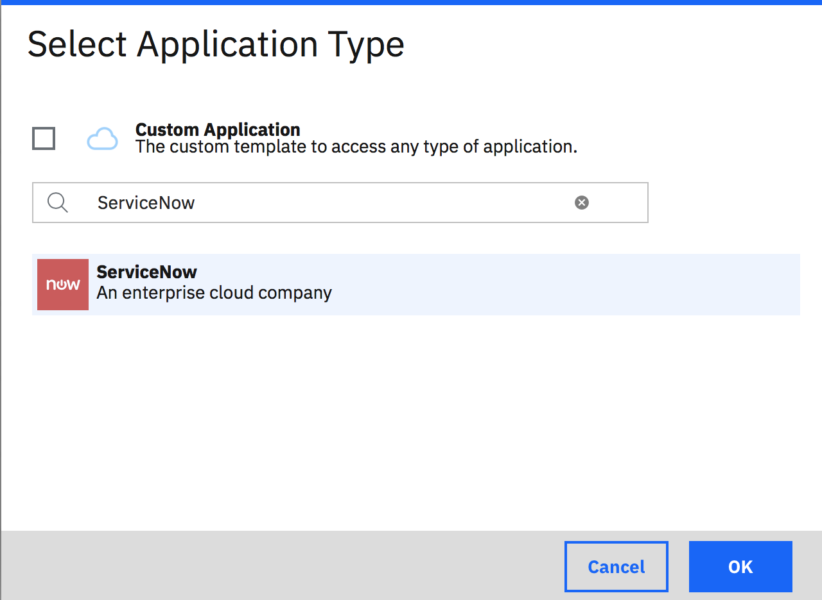

On the General tab ensure Enabled and Show on launchpad are checked. Enter your ServiceNow developer instance in the Instance Name field and click Save

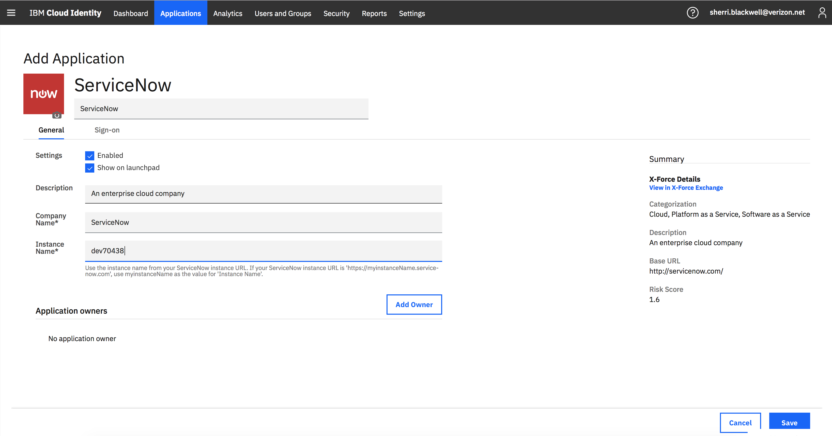

On the entitlements page, you can either allow All users are entitled to this application or add a specific user. I suggest adding a specific user. I chose to use my IBM ID. Regardless, the user that logs into ServiceNow will have to be created in ServiceNow with a valid e-mail address.

Click Add

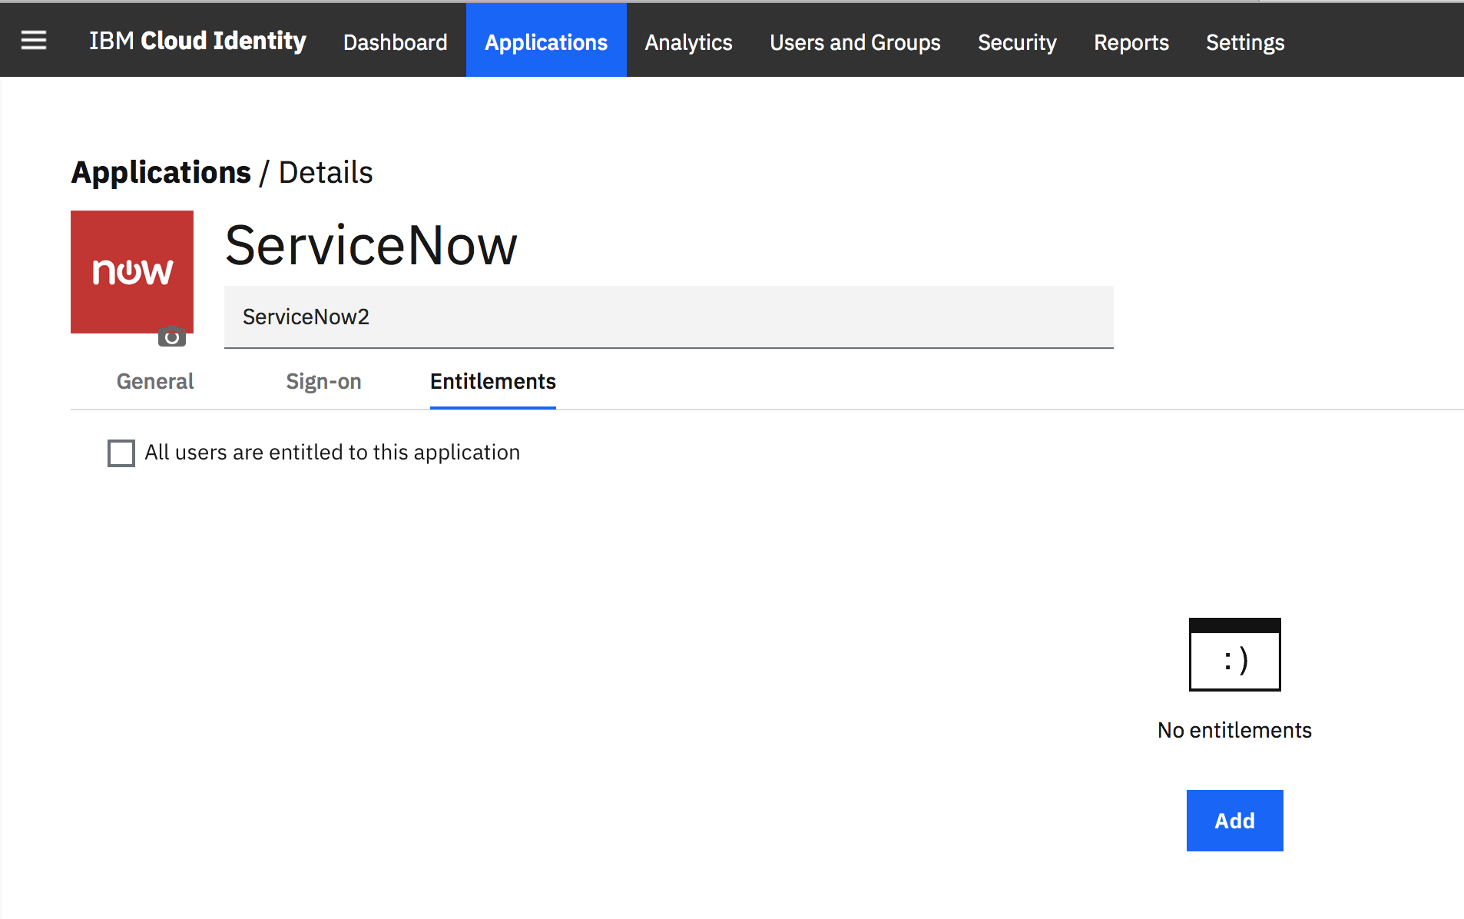

Find your user, click them, click Add and click OK

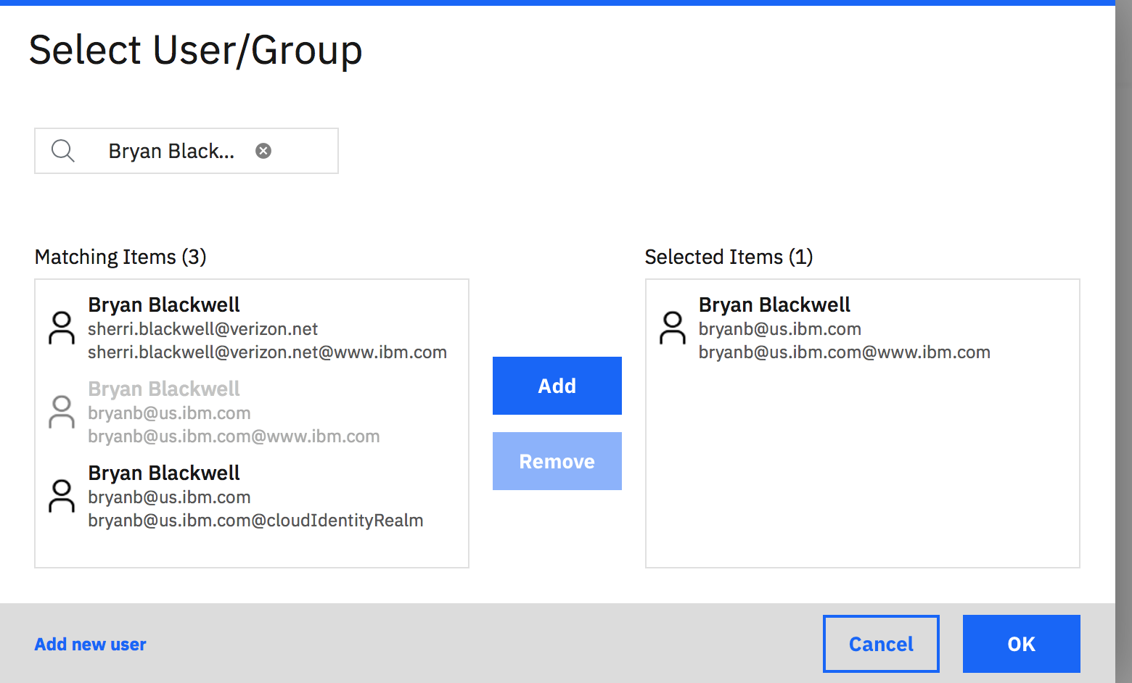

Don’t forget to click Save

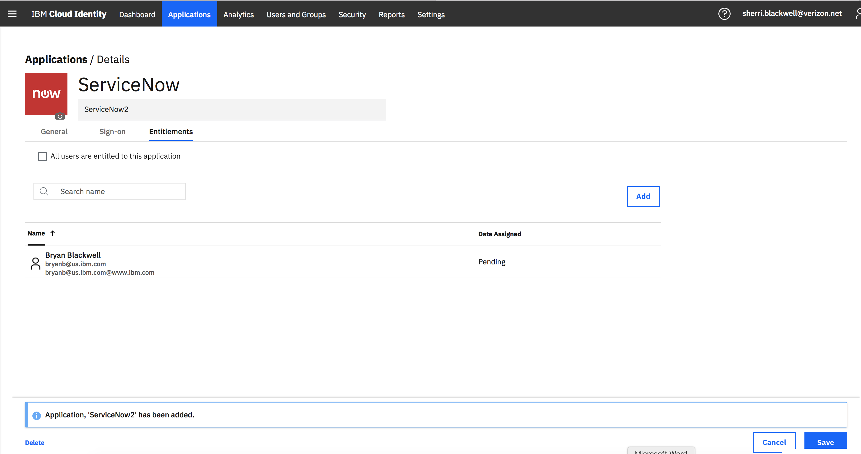

Click on the Sign-on tab. The Provider ID (this is your fully qualified ServiceNow instance) and Assertion URL are filled. Change the SAML Subject Name Identifier to email and click Save.

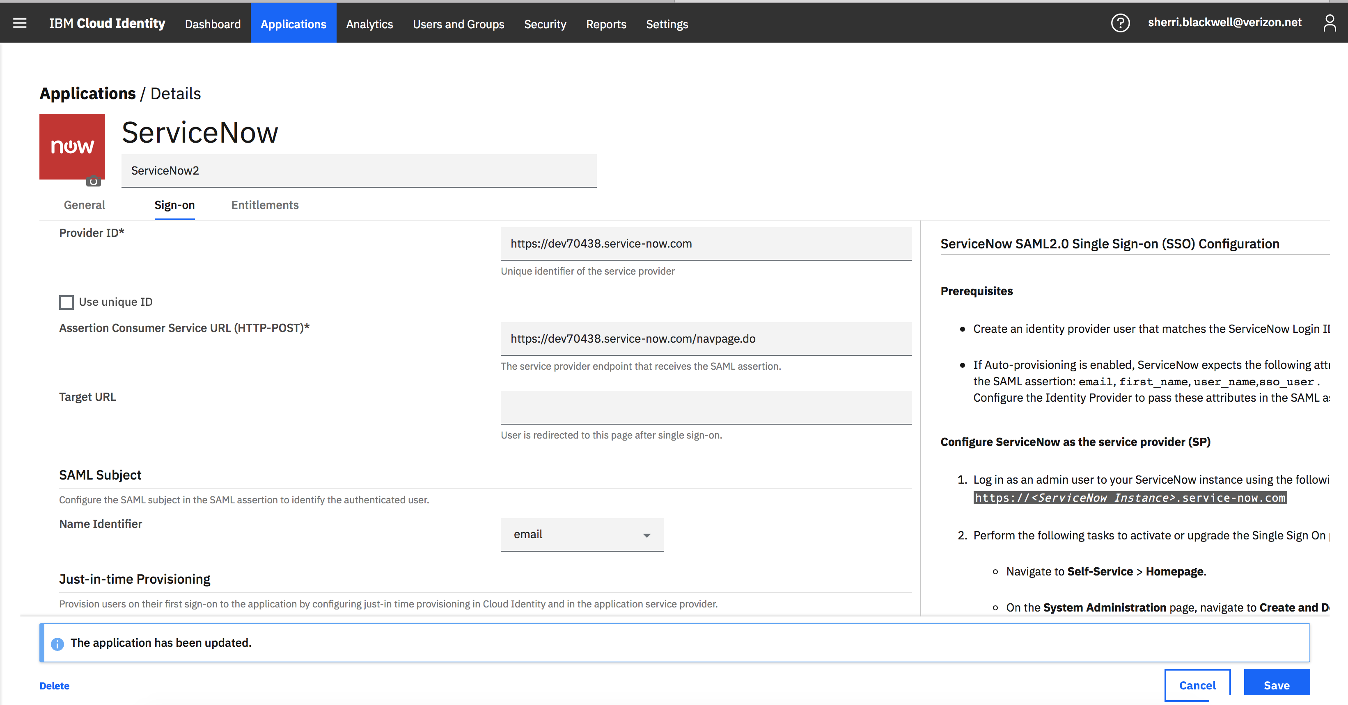

We will now follow the steps in the left-hand column of the Sign-on tab to complete the integration

Configure ServiceNow
Return to your ServiceNow Developer instance and login as Admin. Change your password if prompted
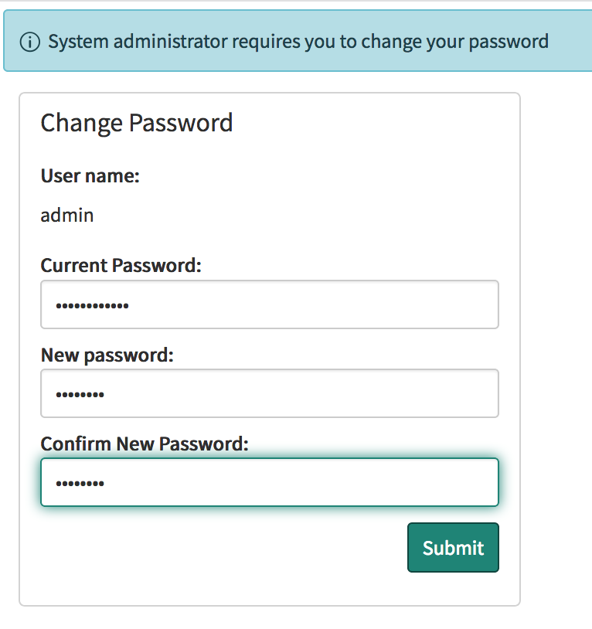

Create ServiceNow Login ID
In the upper left Filter navigator area enter users. Scroll down, under User Administration, click Users

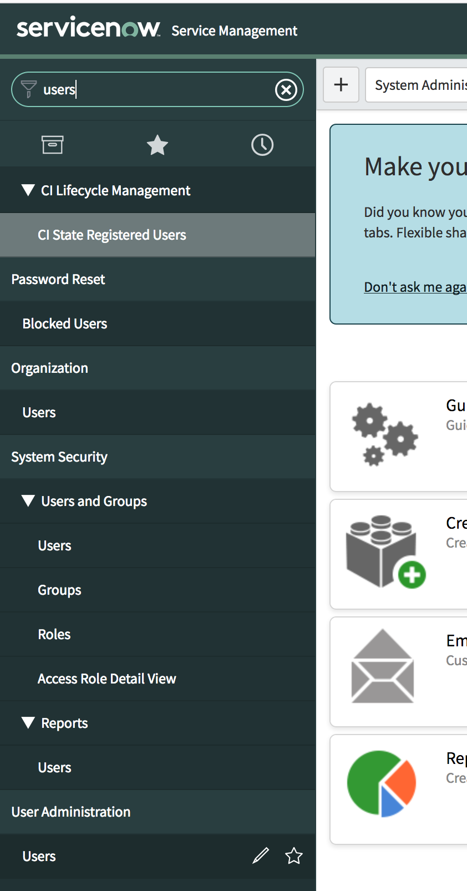

Click New

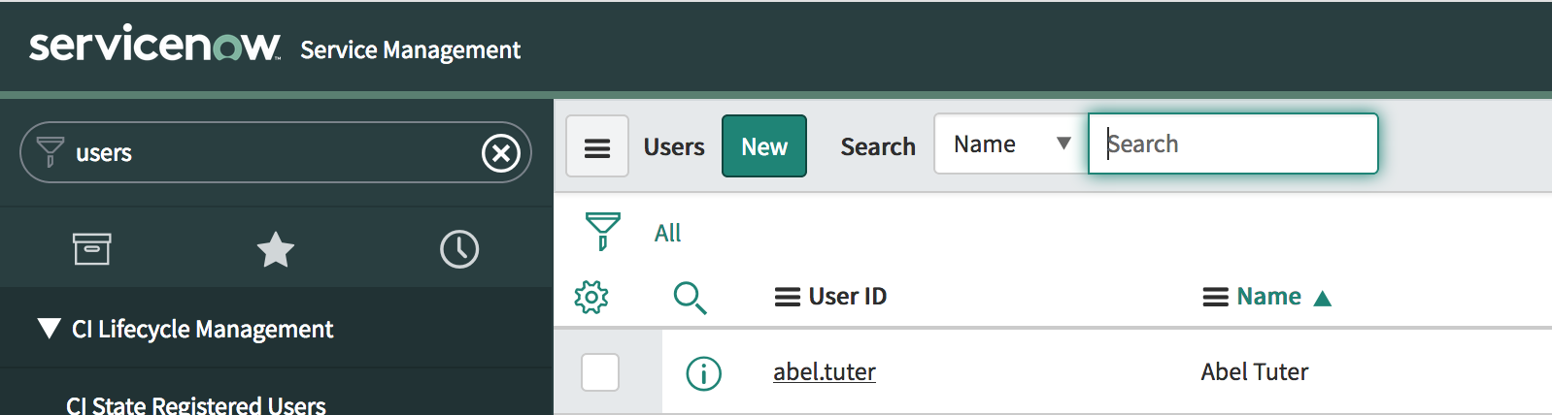

At a minimum enter the user ID, First Name, Last name, Password, Email and check the Active check box. Insure this matches the user you selected in your CI tenant. Click Submit.

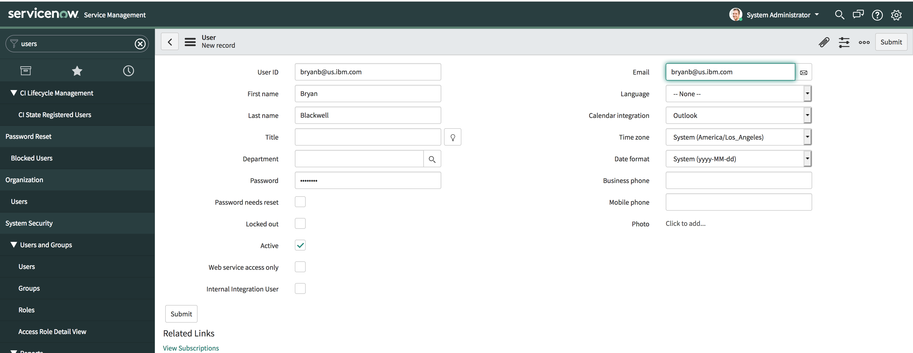

Activate the Single Sign On plugin
- Navigate to Self-Service > Homepage.
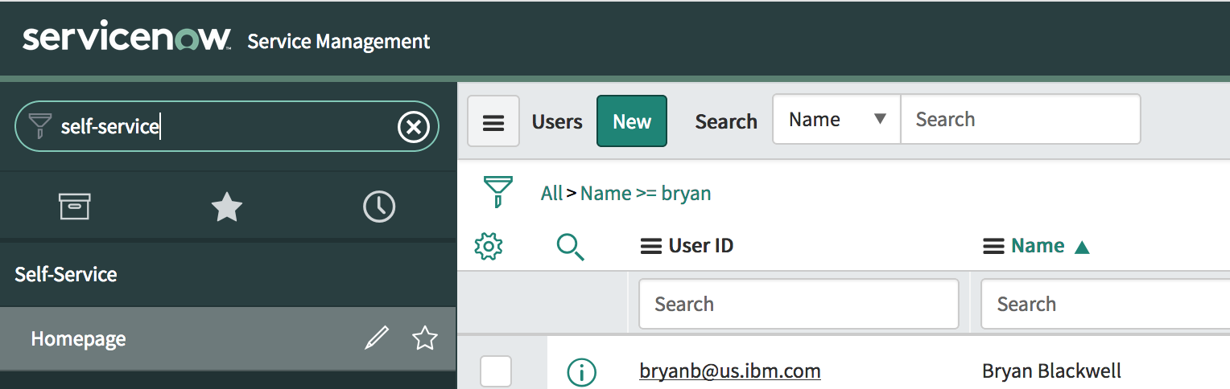

- On the System Administration page, navigate to Create and Deploy
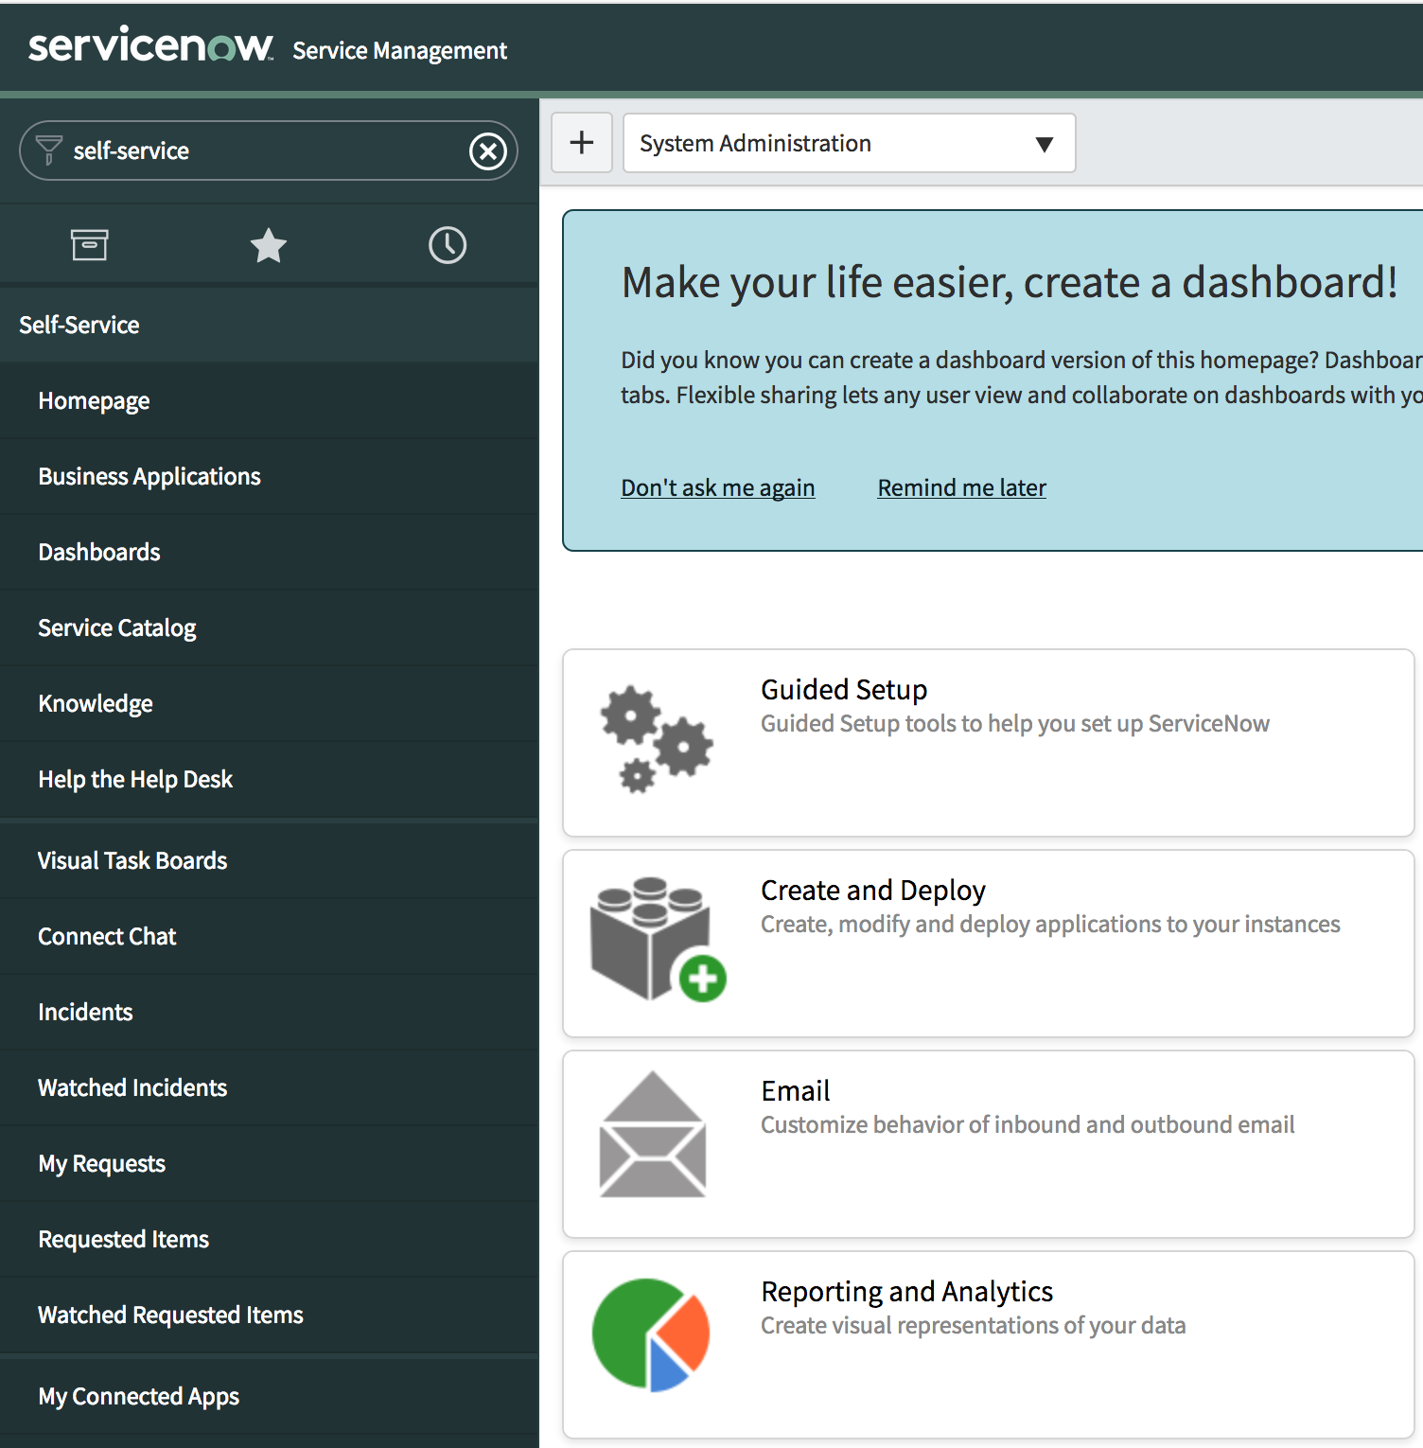

- Click Plugins.
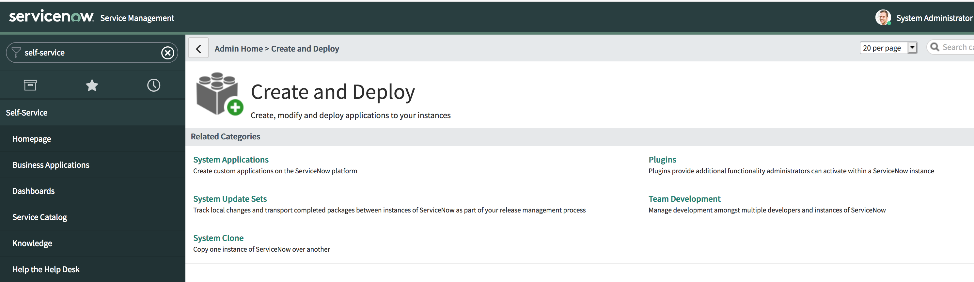
- Click Plugins again
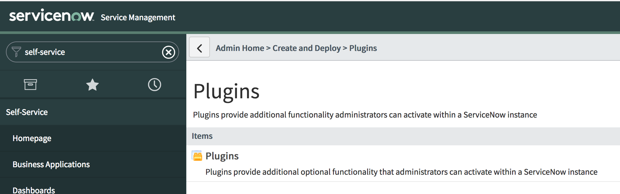
- Search for the Integration - Multiple Provider Single Sign-On Installer plugin and click Install.
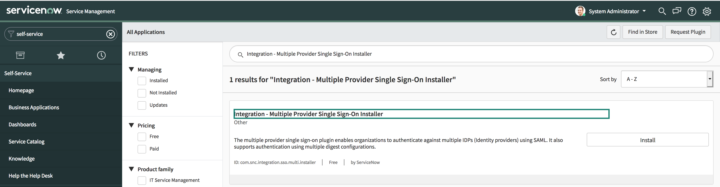

- Click Activate
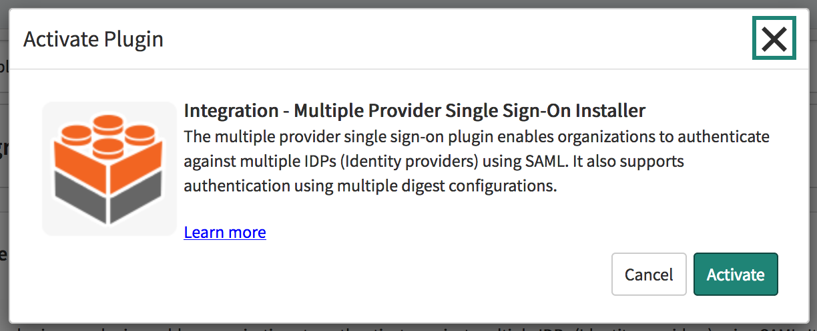

- After the plugin is activated or upgraded, click Close & Reload Form.
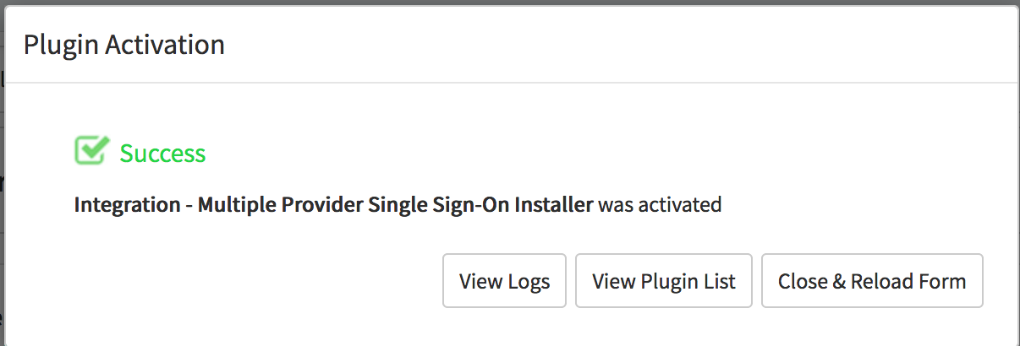

Configure SSO properties
  - Navigate to Multi-Provider SSO > Properties.
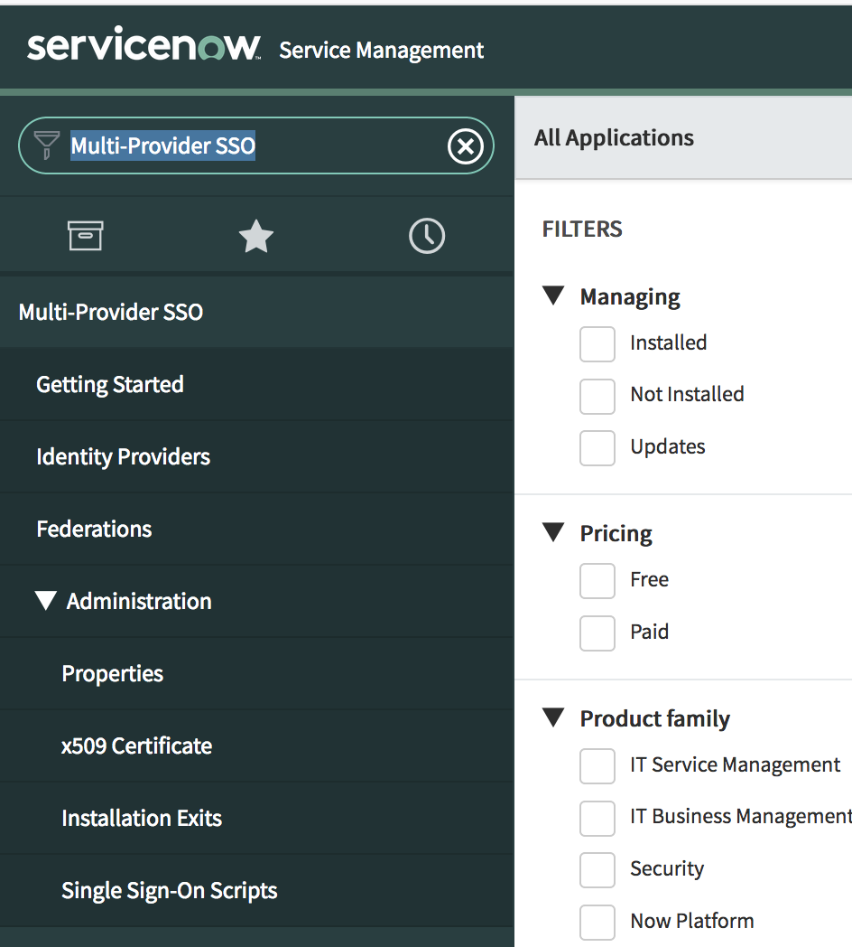

  - Select the Enable Multi-Provider SSO check box and click Save
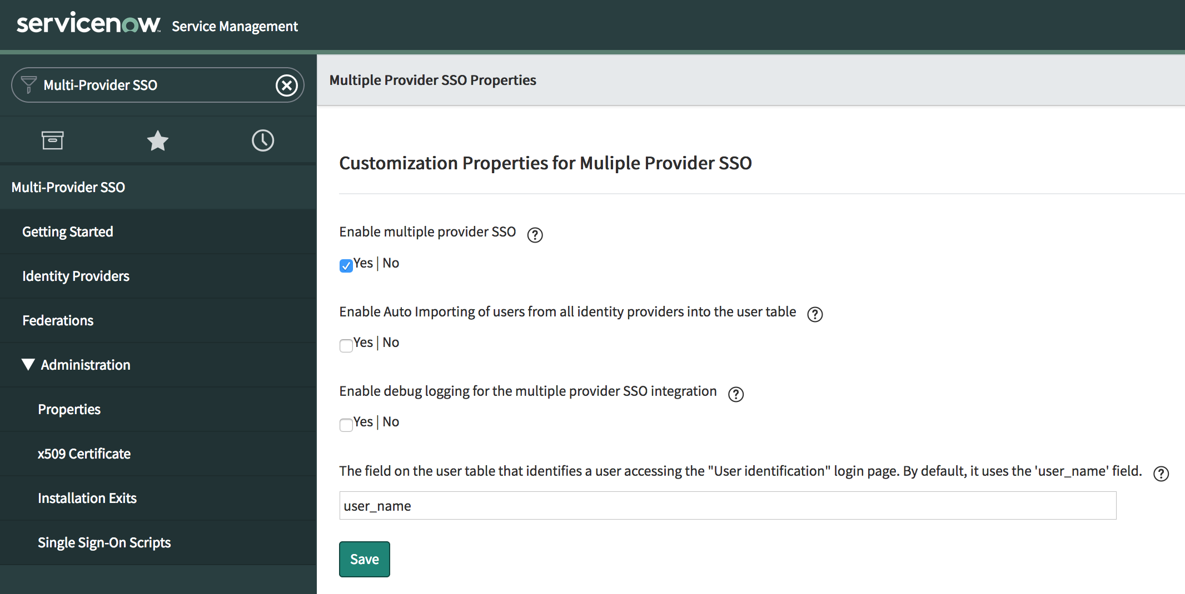
  - If you want the debug messages to appear at the bottom of the content frame, select the Enable debug logging for the Multi-Provider SSO integration check box.

Add CI as the Identity Provider
Perform the following tasks to add the Identity Provider:
- Navigate to Multi-Provider SSO > Identity Providers.
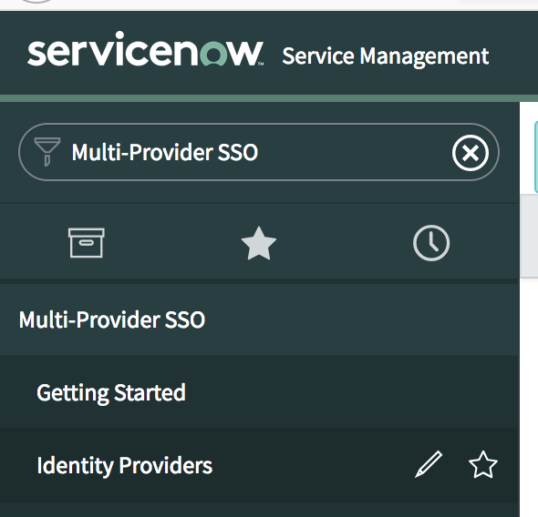
- To create a new Identity Provider, click New.
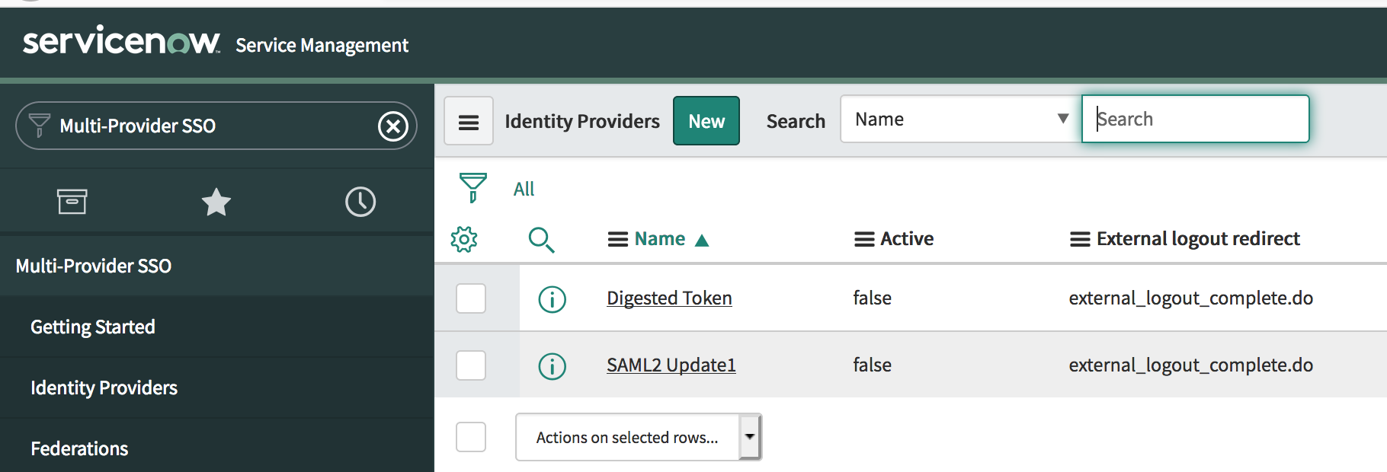
- Select SAML on the What kind of SSO are you trying to create? page.
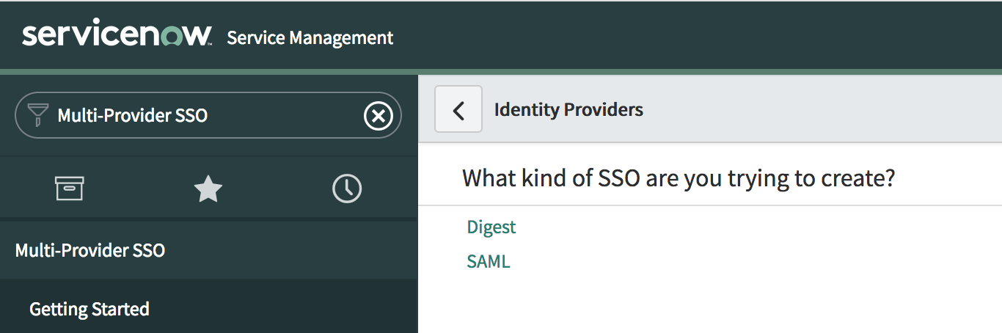
- To import identity provider metadata, perform the following tasks:
  - In the Import Identity Provider Metadata pop-up, select XML.
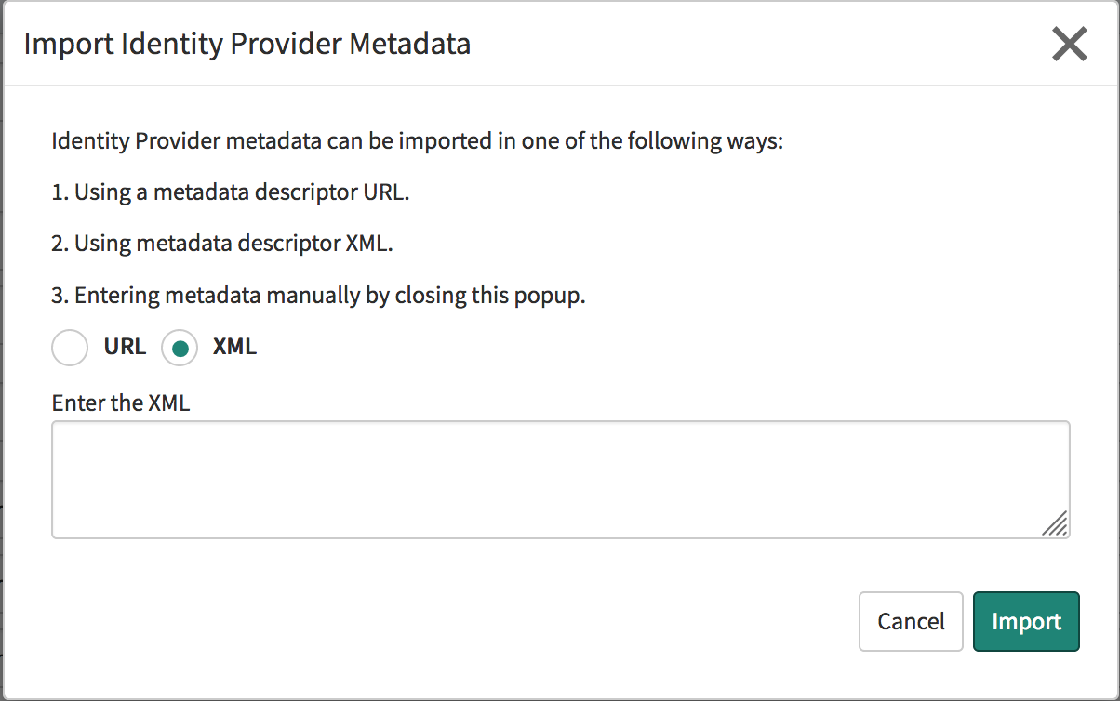
  - Paste the contents of the Identity Provider federation Metadata in this text field.
You can download the Identity Provider metadata using the following URL:
https://bryanb5110.ice.ibmcloud.com/appaccess/v1.0/templates/federations/metadata
OF COURSE YOU MUST USE YOUR OWN CI TENANT URL
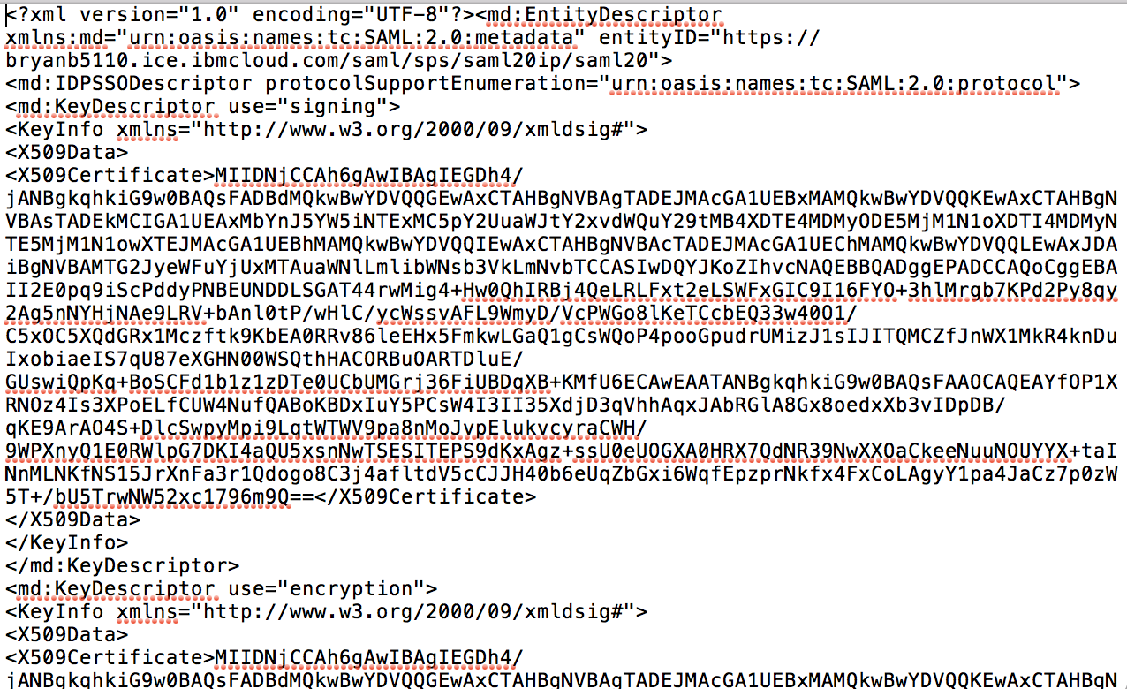
  - Open the file, <CTRL>A, <CTRL>C
  - Return the Import Identity Provider Metadata, <CTL>V and Click Import.
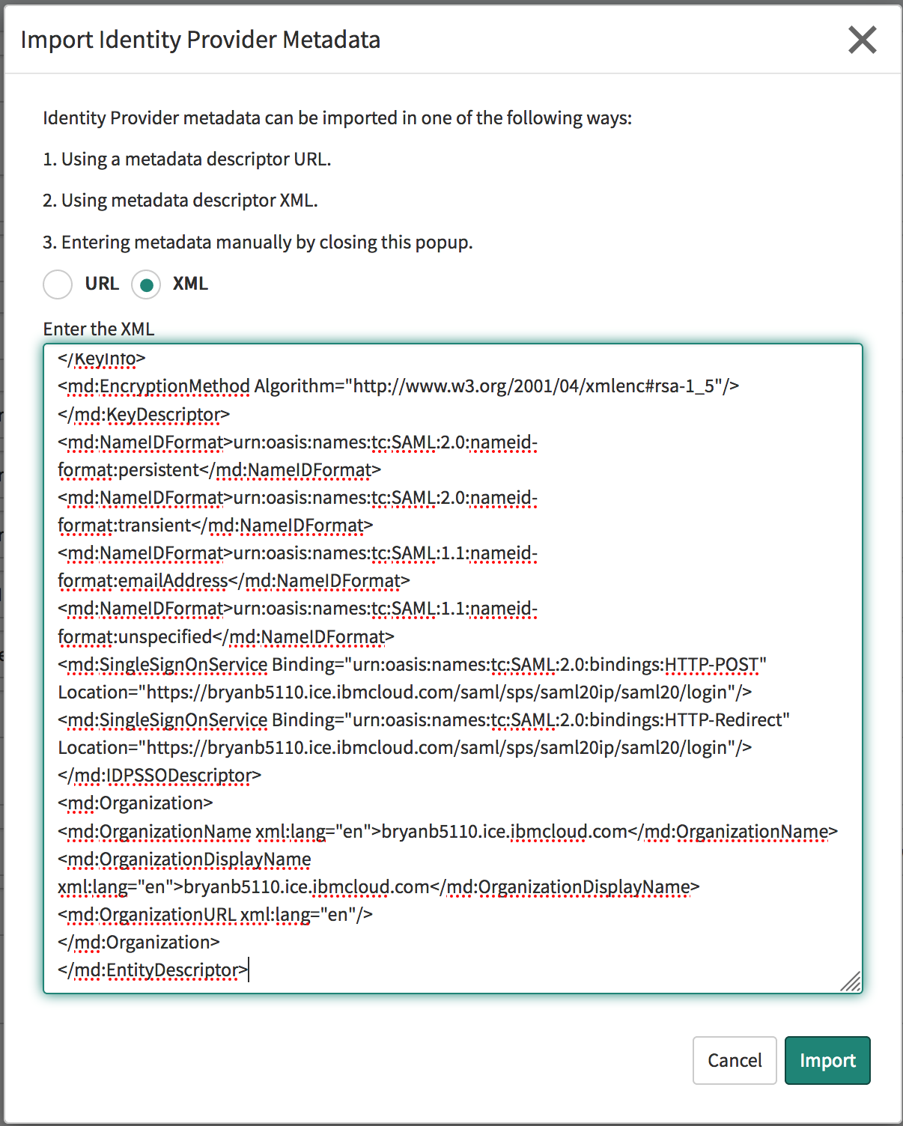

- After the metadata is imported, perform the following tasks:
  - Under the Advanced tab, in the property User Field, specify the value according to your requirement. The default value is email. This is the value mapped to the SAML subject in your CI tenant.
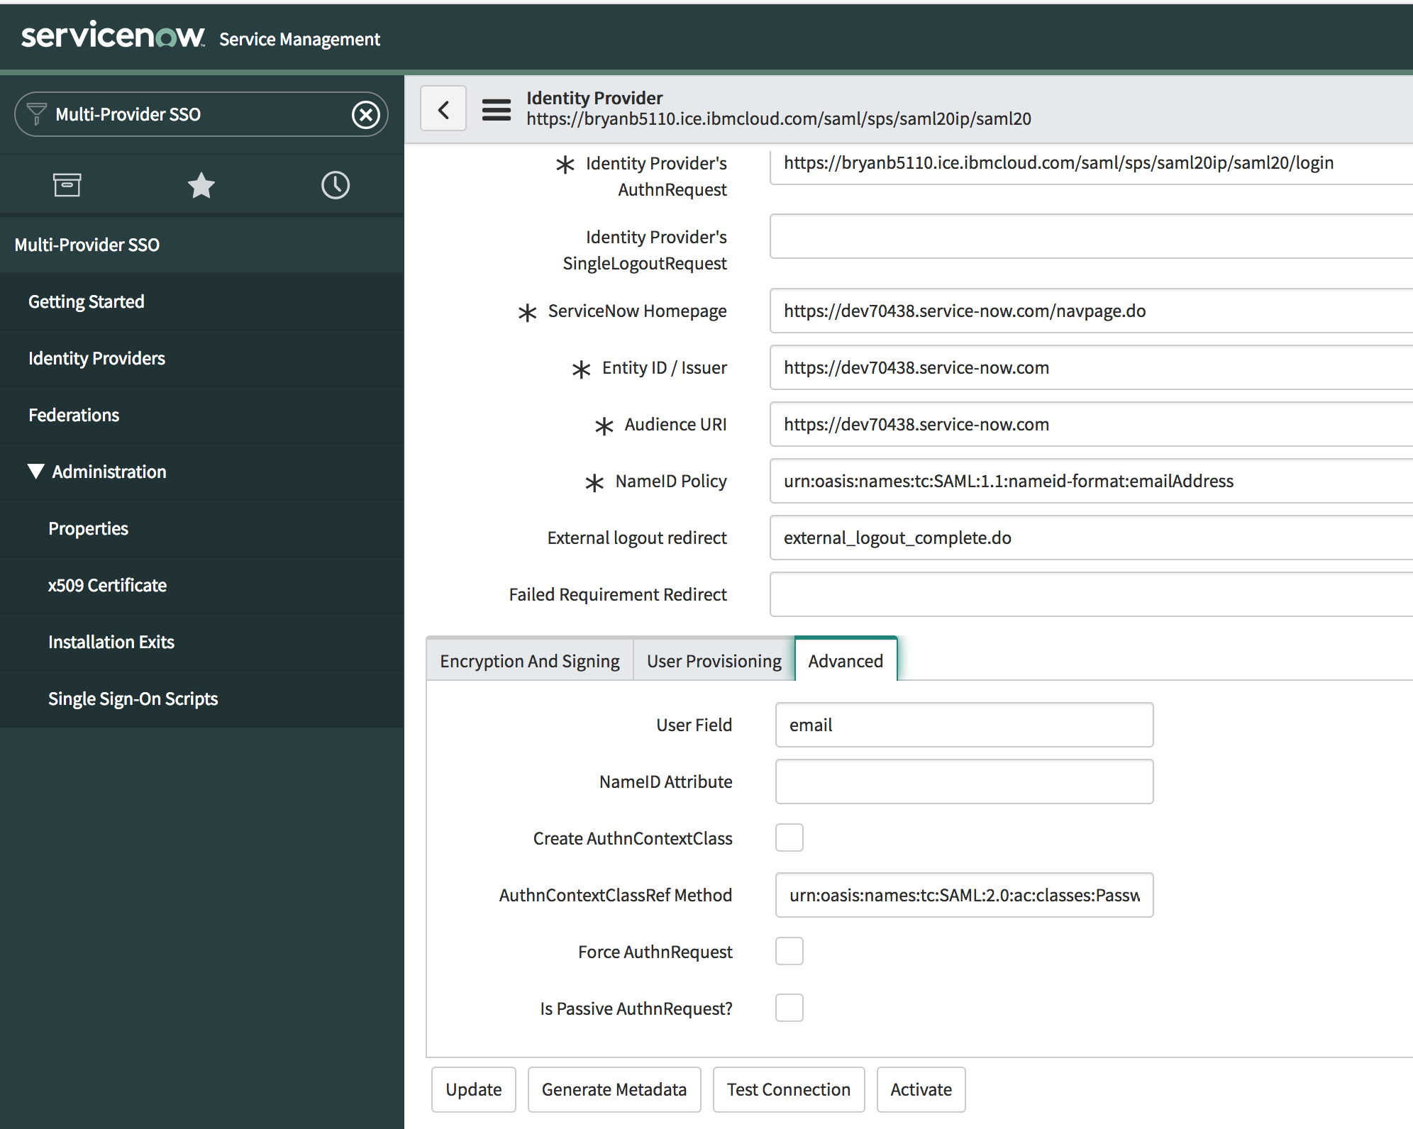
  - Click Update to save your changes.
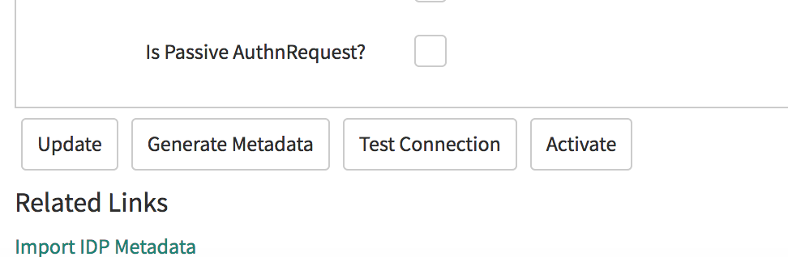
  - Click Test Connection to test the SAML SSO configuration. Allow pop ups if they are blocks
  - Login with the CI users that is entitled to ServiceNow
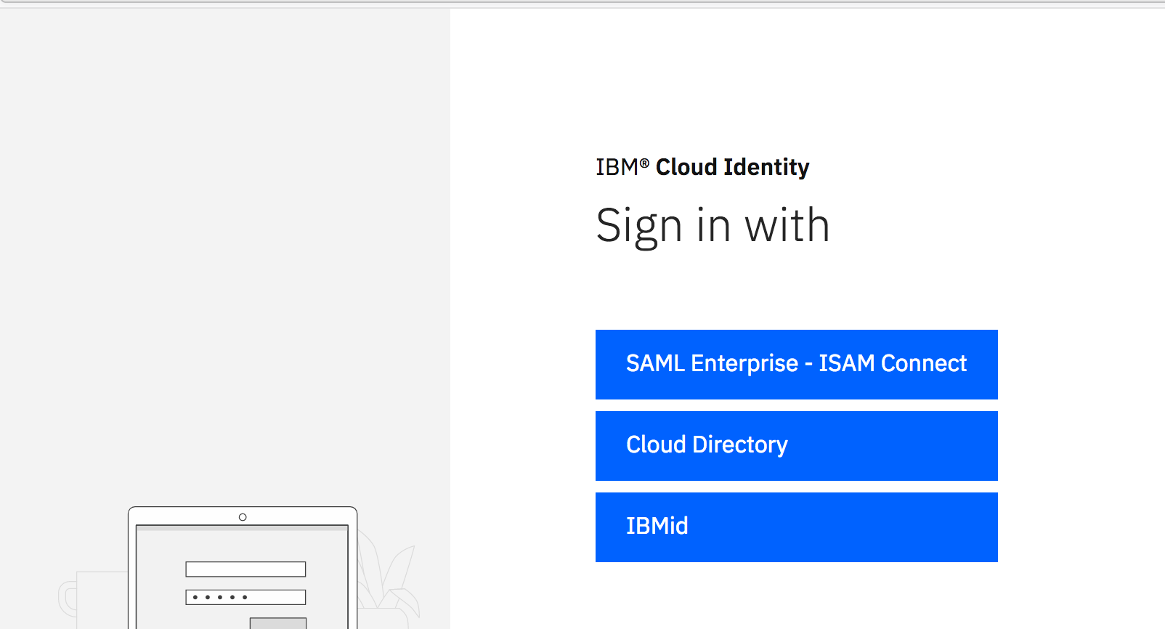
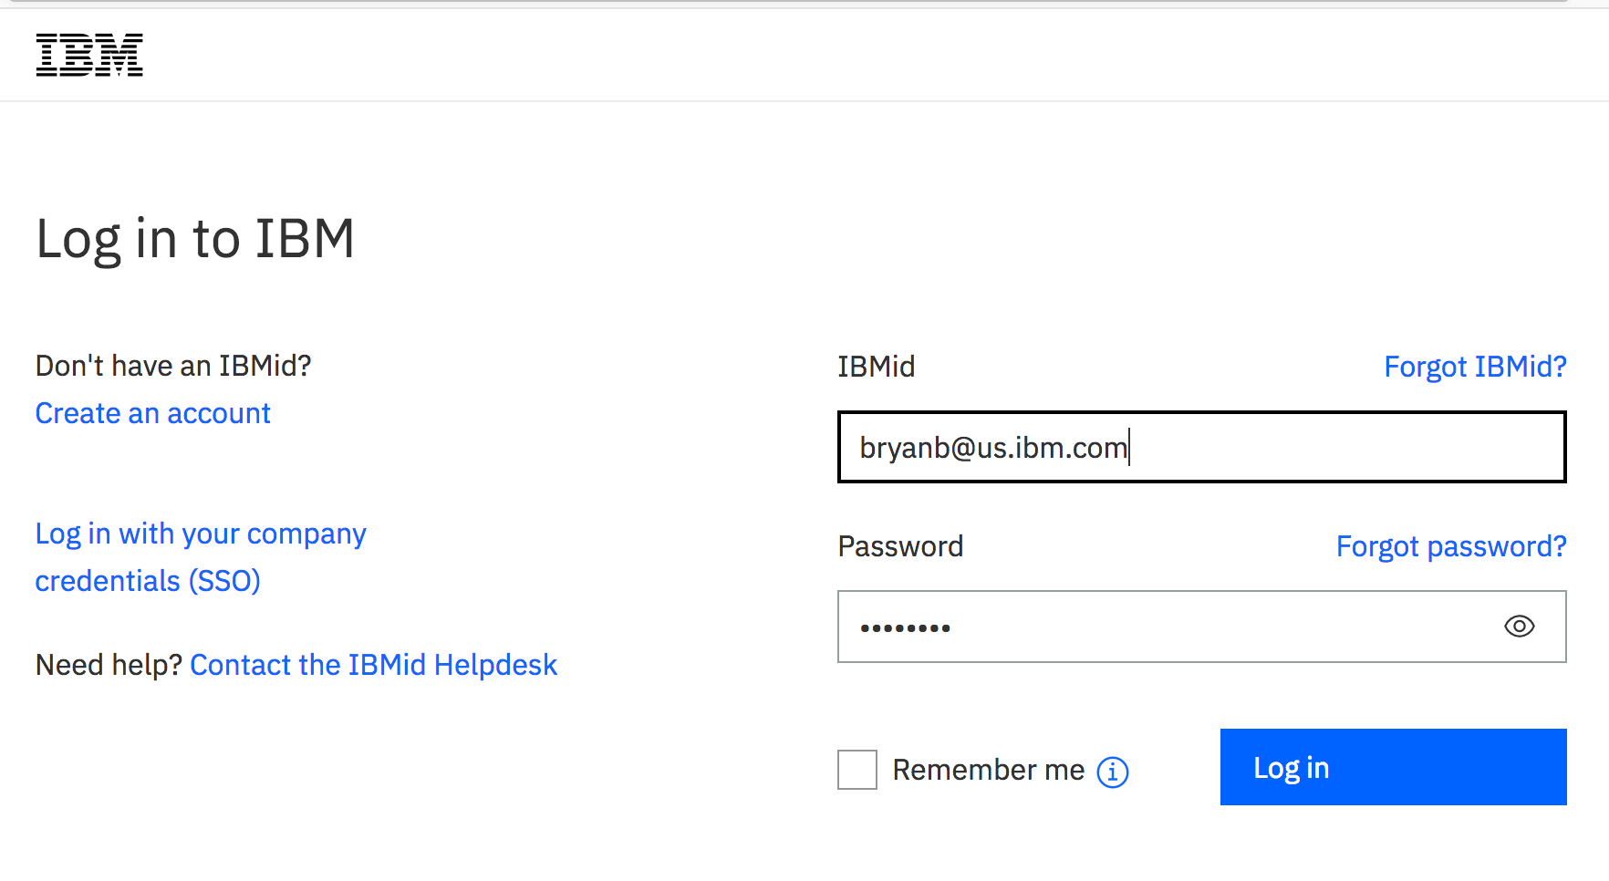

  - You can ignore the Logout Test Results at this time. If all SSO Login Test Results are successful, click Activate to activate the Identity Provider.
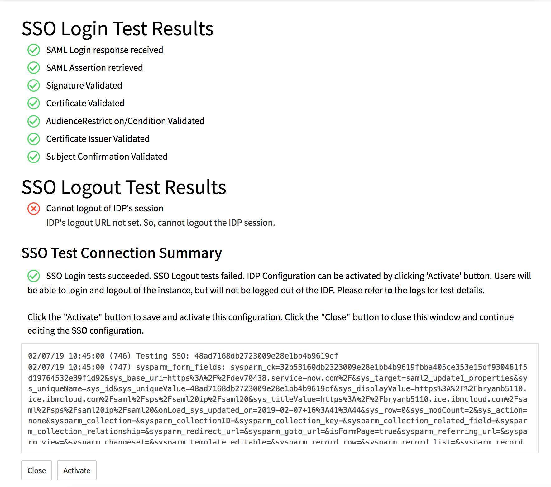

Get sys_id of the CI Identity Provider
You need sys_id of the Identity Provider record in ServiceNow to enable single sign-on for the users, perform following tasks to get the sys_id

  - Navigate to Multi-Provider SSO > Identity Providers.
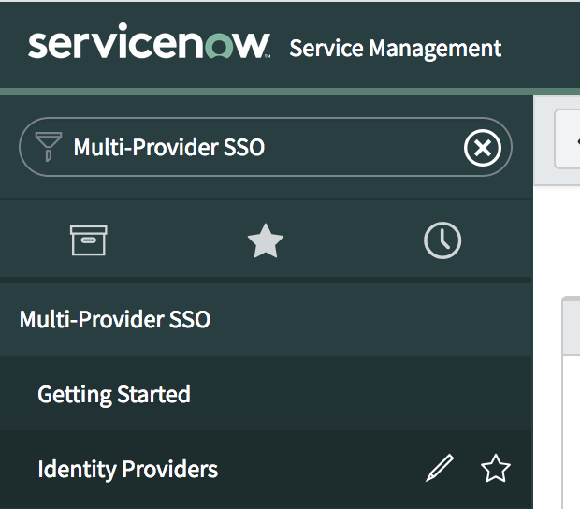
  - Right-click the Identity Provider record.
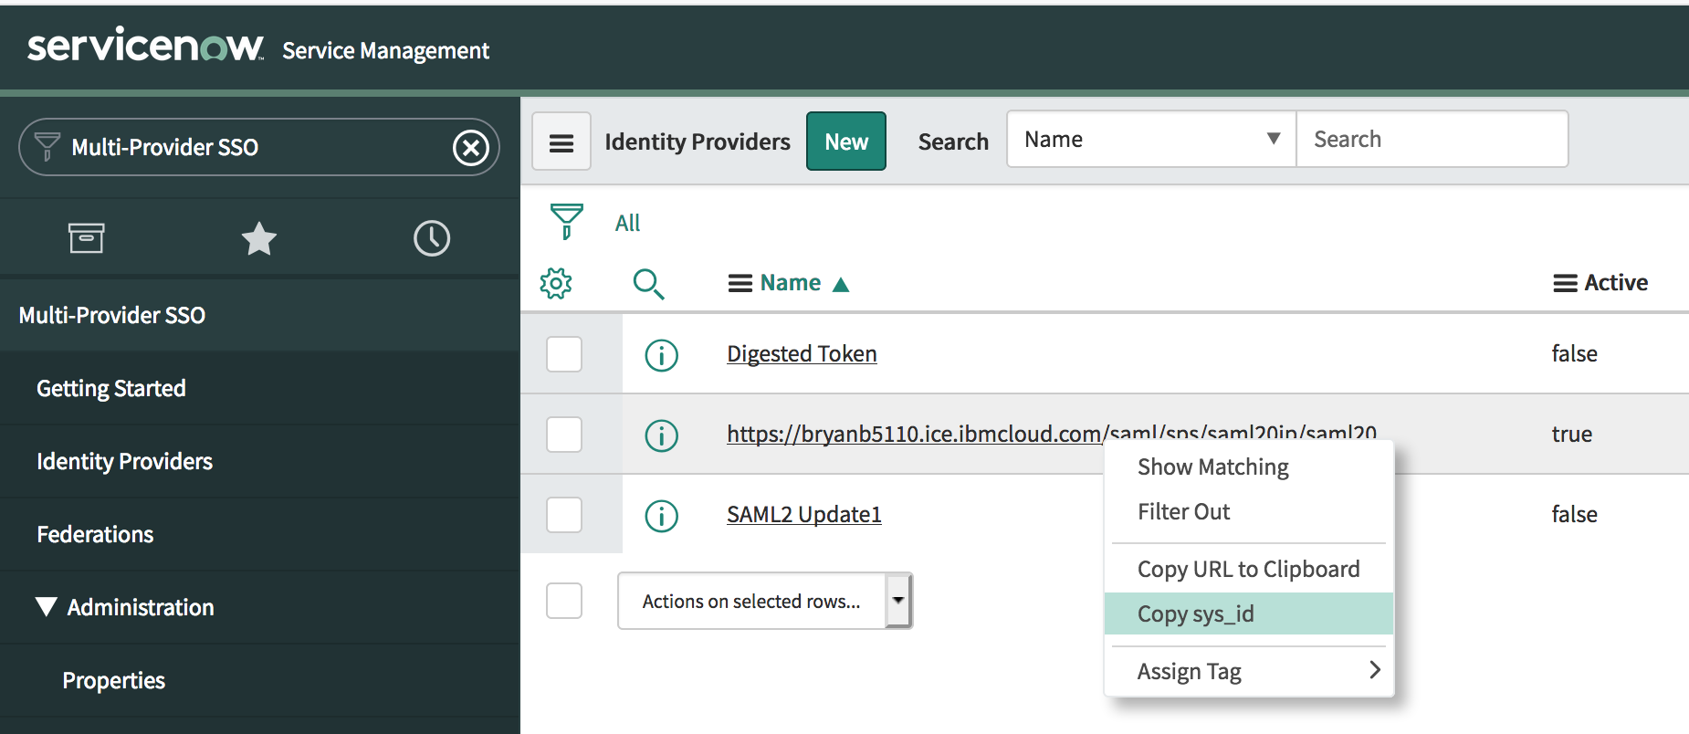
  - Select Copy sys_id.

Enable SAML for Users
To set your Identity Provider as the default value of the SSO Source field, perform the following tasks:
  - Navigate to System Security > Users and Groups > Users.
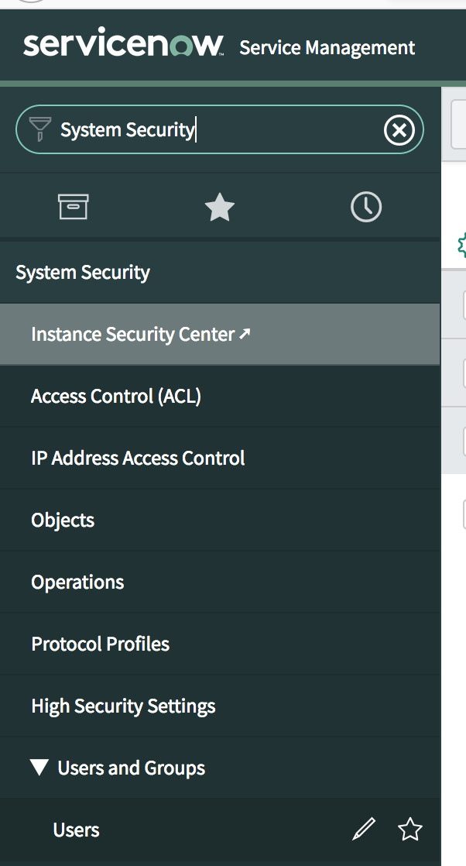
  - Select any user.
  - Navigate to Configure and click Form Design. A new window opens.
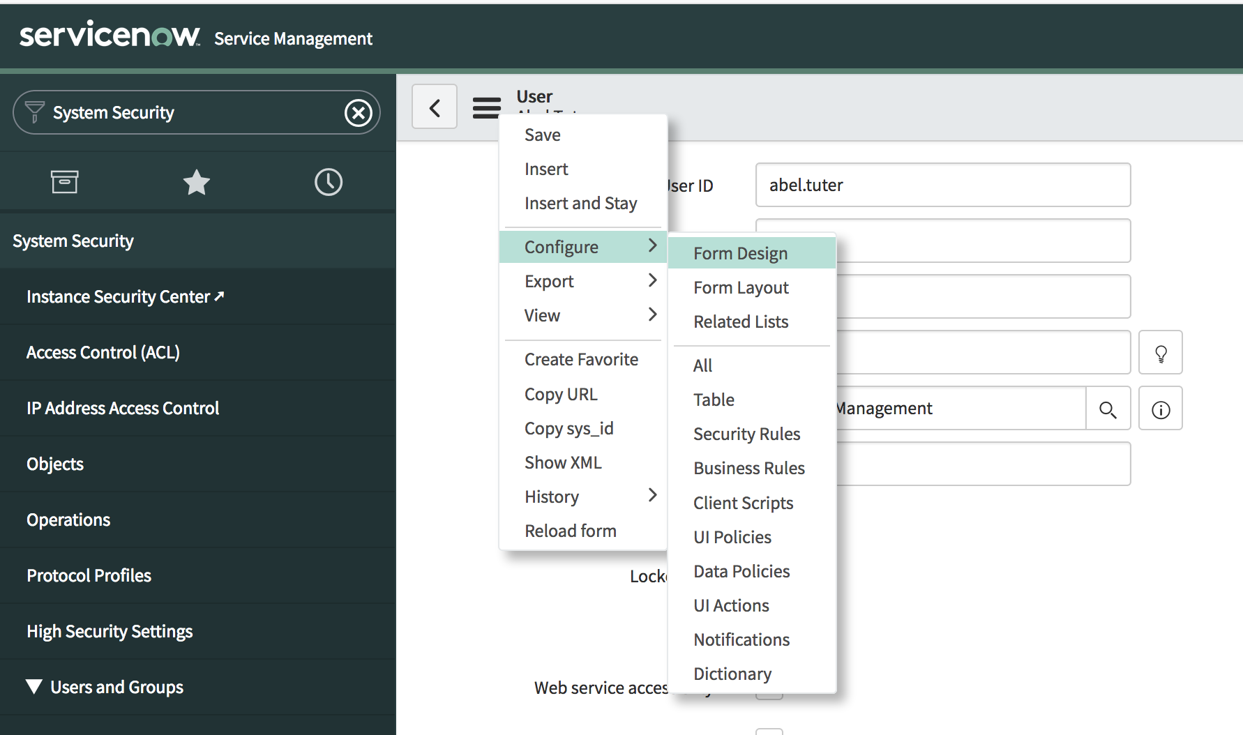
  - Drag and drop the SSO Source field from the Fields section to the User section.
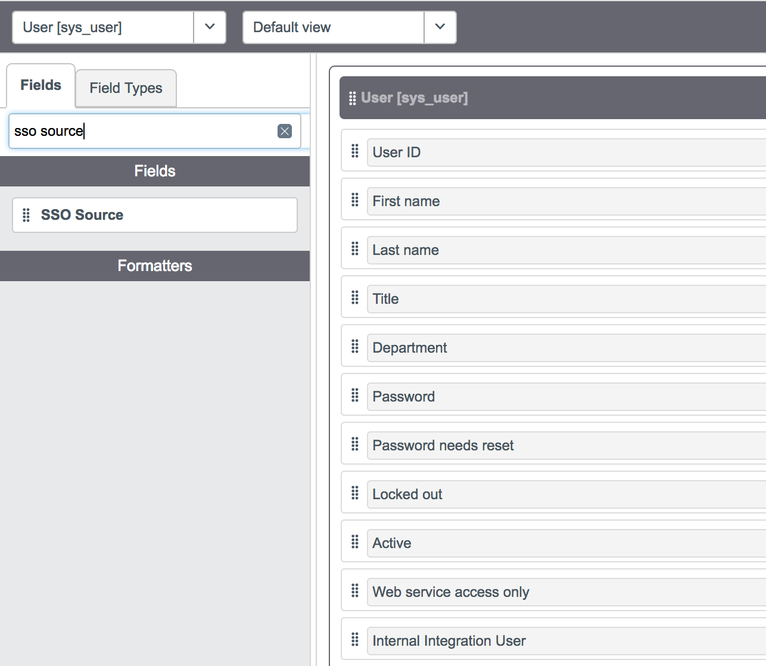
  - Click the settings icon (the cog wheel) for the SSO Source field.
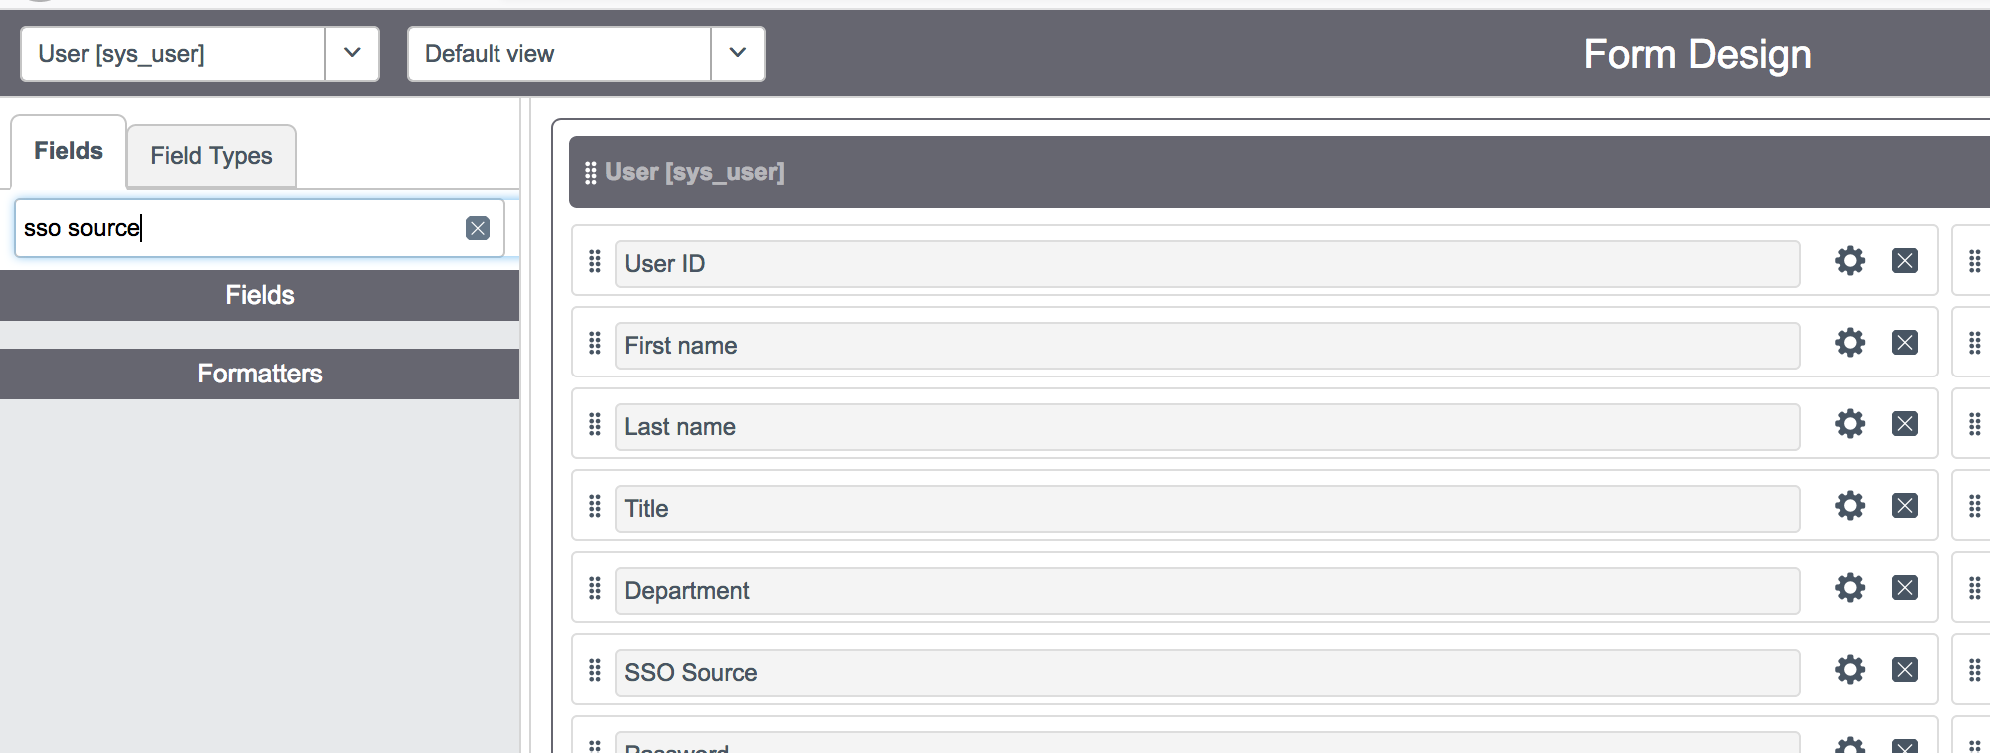
  - In the Default field, specify the sys_id that you copied in the step above
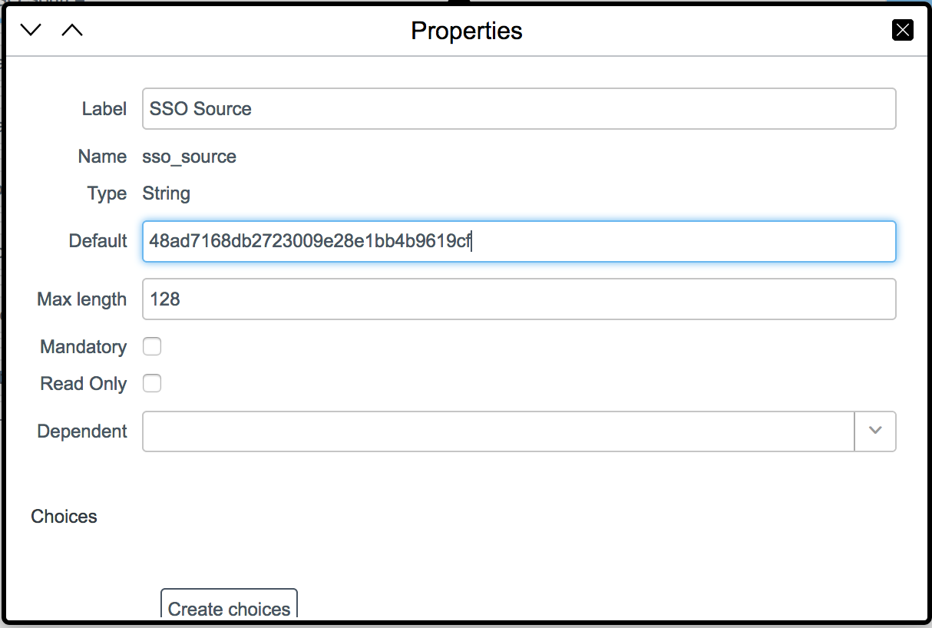
  - Click the X to close and click Save to save your changes.

Other configurations not included in this document
There are other configurations you can apply that are not included in this document. Please see your CI tenant, ServiceNow application sign on tab for details.
Single sign-on for users belonging to a company

Single sign-on for specific users
Configure auto-provisioning for ServiceNow

Verify Single Sign-on
Return to your CI tenant and access the ServiceNow application. Click the Sign-on tab and scroll down to the end. Insure you execute the test as the authorized user. Also, we did NOT use the unique ID setup. Therefore, the Use unique ID URL will not work. Execute your URL links listed under:

Use the following URLs to verify that the single sign-on configuration works
- SSO URL initiated by the Identity Provider:
https://bryanb5110.ice.ibmcloud.com/saml/sps/saml20ip/saml20/logininitial?RequestBinding=HTTPPost&PartnerId=https://dev70438.service-now.com&NameIdFormat=Email
If you want to redirect to a specific Service Provider landing page, append the following query string parameter to the Identity Provider initiated SSO URL:
&Target=<Service Provider Landing Page>
If the Use unique ID check box is selected, the identity provider initiated SSO URL is: https://bryanb5110.ice.ibmcloud.com/saml/sps/saml20ip/saml20/logininitial?RequestBinding=HTTPPost&PartnerId=<PARTNER_PROVIDER_ID>&NameIdFormat=Email&VirtualId=4cb51dc65abd40d6

- URL for service provider initiated SSO:
https://dev70438.service-now.com/navpage.do
To log in with single sign-on, click Use external login, specify User ID, and click Submit.

SSO from CI

Login to your CI tenant as the user that is entitled to ServiceNow. Click ServiceNow

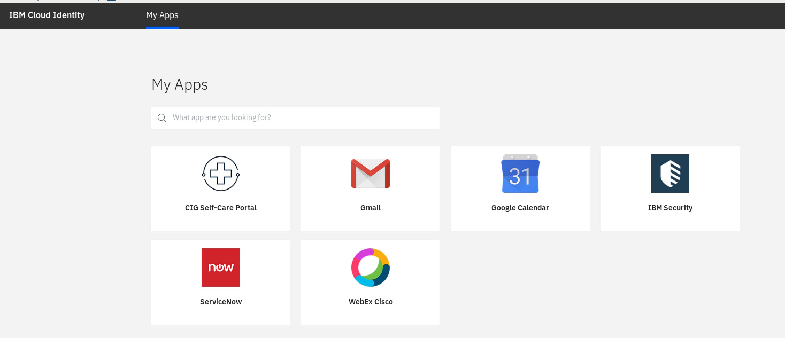

Verify SSO into ServiceNow

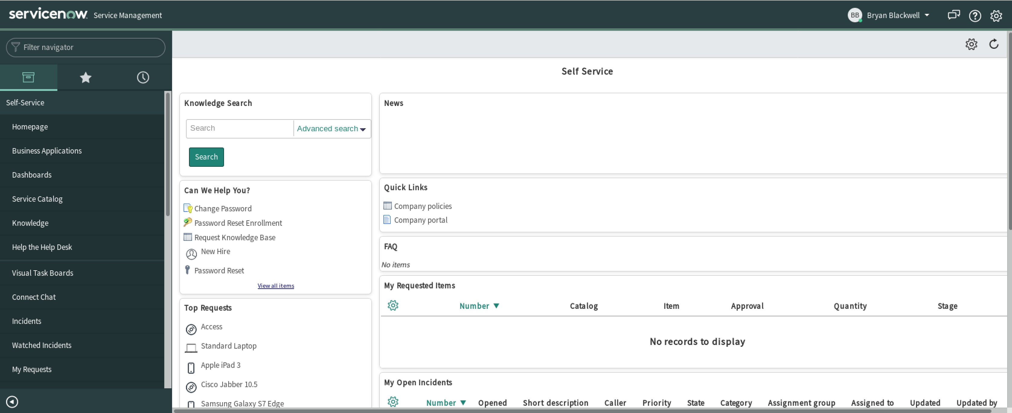

Notices
This information was developed for products and services offered in the U.S.A. IBM may not offer the products, services, or features discussed in this document in other countries. Consult your local IBM representative for information on the products and services currently available in your area. Any reference to an IBM product, program, or service is not intended to state or imply that only that IBM product, program, or service may be used. Any functionally equivalent product, program, or service that does not infringe any IBM intellectual property right may be used instead. However, it is the user's responsibility to evaluate and verify the operation of any non-IBM product, program, or service.
IBM may have patents or pending patent applications covering subject matter described in this document. The furnishing of this document does not give you any license to these patents. You can send license inquiries, in writing, to:
IBM Director of Licensing
IBM Corporation
North Castle Drive
Armonk, NY 10504-1785 U.S.A.
For license inquiries regarding double-byte character set (DBCS) information, contact the IBM Intellectual Property Department in your country or send inquiries, in writing, to:
Intellectual Property Licensing
Legal and Intellectual Property Law
IBM Japan, Ltd.
19-21, Nihonbashi-Hakozakicho, Chuo-ku
Tokyo 103-8510, Japan
The following paragraph does not apply to the United Kingdom or any other country where such provisions are inconsistent with local law :
INTERNATIONAL BUSINESS MACHINES CORPORATION PROVIDES THIS PUBLICATION "AS IS" WITHOUT WARRANTY OF ANY KIND, EITHER EXPRESS OR IMPLIED, INCLUDING, BUT NOT LIMITED TO, THE IMPLIED WARRANTIES OF NON-INFRINGEMENT, MERCHANTABILITY OR FITNESS FOR A PARTICULAR PURPOSE.
Some states do not allow disclaimer of express or implied warranties in certain transactions, therefore, this statement might not apply to you.
This information could include technical inaccuracies or typographical errors. Changes are periodically made to the information herein; these changes will be incorporated in new editions of the publication. IBM may make improvements and/or changes in the product(s) and/or the program(s) described in this publication at any time without notice.
Any references in this information to non-IBM Web sites are provided for convenience only and do not in any manner serve as an endorsement of those Web sites. The materials at those Web sites are not part of the materials for this IBM product and use of those Web sites is at your own risk.
IBM may use or distribute any of the information you supply in any way it believes appropriate without incurring any obligation to you.
Licensees of this program who wish to have information about it for the purpose of enabling: (i) the exchange of information between independently created programs and other programs (including this one) and (ii) the mutual use of the information which has been exchanged, should contact:
IBM Corporation
2Z4A/101
11400 Burnet Road
Austin, TX 78758 U.S.A.
Such information may be available, subject to appropriate terms and conditions, including in some cases payment of a fee.
The licensed program described in this document and all licensed material available for it are provided by IBM under terms of the IBM Customer Agreement, IBM International Program License Agreement or any equivalent agreement between us.
Any performance data contained herein was determined in a controlled environment. Therefore, the results obtained in other operating environments may vary significantly. Some measurements may have been made on development-level systems and there is no guarantee that these measurements will be the same on generally available systems. Furthermore, some measurement may have been estimated through extrapolation. Actual results may vary. Users of this document should verify the applicable data for their specific environment.
Information concerning non-IBM products was obtained from the suppliers of those products, their published announcements or other publicly available sources. IBM has not tested those products and cannot confirm the accuracy of performance, compatibility or any other claims related to non-IBM products. Questions on the capabilities of non-IBM products should be addressed to the suppliers of those products.
All statements regarding IBM's future direction or intent are subject to change or withdrawal without notice, and represent goals and objectives only.
All IBM prices shown are IBM's suggested retail prices, are current and are subject to change without notice. Dealer prices may vary.
This information is for planning purposes only. The information herein is subject to change before the products described become available.
This information contains examples of data and reports used in daily business operations. To illustrate them as completely as possible, the examples include the names of individuals, companies, brands, and products. All of these names are fictitious and any similarity to the names and addresses used by an actual business enterprise is entirely coincidental.
COPYRIGHT LICENSE:
This information contains sample application programs in source language, which illustrate programming techniques on various operating platforms. You may copy, modify, and distribute these sample programs in any form without payment to IBM, for the purposes of developing, using, marketing or distributing application programs conforming to the application programming interface for the operating platform for which the sample programs are written. These examples have not been thoroughly tested under all conditions. IBM, therefore, cannot guarantee or imply reliability, serviceability, or function of these programs. You may copy, modify, and distribute these sample programs in any form without payment to IBM for the purposes of developing, using, marketing, or distributing application programs conforming to IBM's application programming interfaces.
Each copy or any portion of these sample programs or any derivative work, must include a copyright notice as follows:
© IBM 2017. Portions of this code are derived from IBM Corp. Sample Programs. © Copyright IBM Corp 2017. All rights reserved.
If you are viewing this information in softcopy form, the photographs and color illustrations might not be displayed.
Trademarks
IBM, the IBM logo, and ibm.com are trademarks or registered trademarks of International Business Machines Corp., registered in many jurisdictions worldwide. Other product and service names might be trademarks of IBM or other companies. A current list of IBM trademarks is available on the Web at Copyright and trademark information at ibm.com/legal/copytrade.shtml.
Statement of Good Security Practices
IT system security involves protecting systems and information through prevention, detection and response to improper access from within and outside your enterprise. Improper access can result in information being altered, destroyed, misappropriated or misused or can result in damage to or misuse of your systems, including for use in attacks on others. No IT system or product should be considered completely secure and no single product, service or security measure can be completely effective in preventing improper use or access. IBM systems, products and services are designed to be part of a comprehensive security approach, which will necessarily involve additional operational procedures, and may require other systems, products or services to be most effective. IBM DOES NOT WARRANT THAT ANY SYSTEMS, PRODUCTS OR SERVICES ARE IMMUNE FROM, OR WILL MAKE YOUR ENTERPRISE IMMUNE FROM, THE MALICIOUS OR ILLEGAL CONDUCT OF ANY PARTY.

© International Business Machines Corporation 2017
International Business Machines Corporation
New Orchard Road Armonk, NY 10504
Produced in the United States of America 01-2016
All Rights Reserved
References in this publication to IBM products and services do not imply that IBM intends to make them available in all countries in which IBM operates.

