IBM ZOS Connect EE

Creating REST APIs from RBD generated COBOL programs.

March 2022

Author:
Suraj Agarwal

©Copyright International Business Machines Corporation 2000, 2017. ©Copyright HCL Technologies Limited 2017, 2019. All rights reserved. See product license for details. US Government Users Restricted Rights. Use, duplication, or disclosure restricted by GSA ADP Schedule Contract with IBM Corp. Java and all Java-based trademarks and logos are trademarks or registered trademarks of Oracle and/or its affiliates. IBM, the IBM logo, and Tivoli are registered trademarks of IBM Corporation in the United States, other countries, or both.

Contents
Abstract 3
Introduction 3
Prerequisites 3
Part – 1(COMMAREA-CICS as Service) 4
1. Purpose 4
2. CICS Region Setup 4
Part – 2(Channel-CICS as Service) 5
Part – 3(COMMAREA-CICS as Service Provider) 5
Part – 4(Channel-CICS as Service Provider) 5

Abstract
RBD is used to simplify the technical aspect of writing the code in Cobol. As the market is evolving, we need to use the functionality of RBD generated code through REST API using Zos Connect EE tool.
This paper details the different approaches possible for various requirement scenarios.

Introduction
IBM Business Developer (RBD) allows the business developers to use the REST API functionality and can use the CICS as service or CICS can be used as service provider too. The EGL generated Cobol will be connected through CICS and a tool Zos Connect EE. The Cobol program can be called using the Rest API and can see the required output details in the screen. The purpose of this document is to share information about the creation of archive files (SAR, AAR) from API Toolkit which will be used to send request and capture the response.

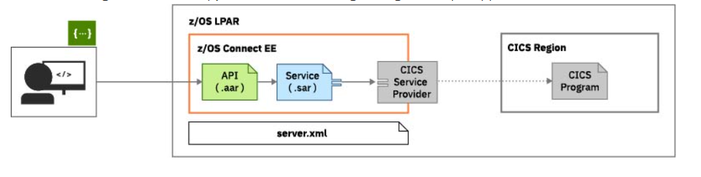

The scenarios described in this paper explain how to make a connection to the EGL generated Cobol program through CICS using Zos Connect EE.

Prerequisites
- IBM Rational Business Developer (RBD).
- Zos Connect Enterprise Edition.
- Knowledge of developing using EGL and RBD.
- Knowledge of generating the COBOL programs from EGL.
- IBM WebSphere Liberty server (V3).

Part – 1(COMMAREA-CICS as Service)

Purpose
The purpose of this section is to describe the setup of ZOS Connect EE tool to connect with the EGL generated programs.

CICS Region Setup
The transaction CSMI (Which is a mirror transaction) is IBM provided, which has TWA size of 0. CSMI is a default transaction which is being called by Zos connect to CICS environment. But our EGL generated code needs a TWA size of 1024 to connect with CICS. For which we need to create a mirror transaction of CSMI with TWA size of 1024. The CSMI transaction would be overwritten by mirror transaction created while creating a SAR file in further steps. For Ex. We have created a mirror transaction ZSMI.
Provide the mirror transaction which is created to overwrite the transaction CSMI while creating the sar file in the configuration tab.

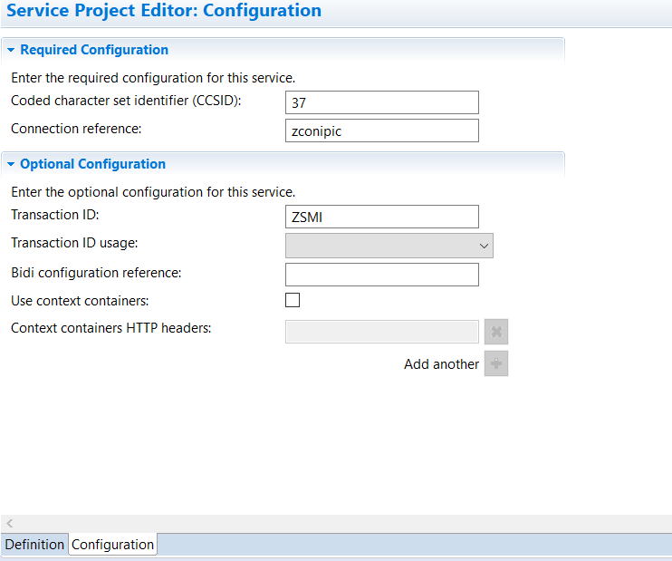

- EGL Program:
To connect to the EGL generated Cobol program, the program needs to be created as sub program in RBD rather than a main program, as the sub program will capture the value passed through Zos connect and can return the response too.

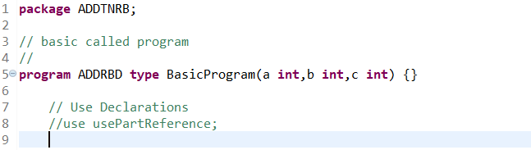

Part – 2(Channel-CICS as Service)
We have tried to achieve this using channel and container but when we are creating a subprogram, the values are not getting captured into the program. When we are creating a main program, we are not getting any get and put statement either which also doesn’t capture the value passed through Zos connect. Need to spend more time and create a POC on the same.

Part – 3(COMMAREA-CICS as Service Provider)
POC needs to be created.

Part – 4(Channel-CICS as Service Provider)
POC needs to be created.

