Return null from attribute formula
Testing

MAM 7.6.1.2

Steps:

- In the WORKORDER table, create two new attributes: CGPERSISTENT and CGNONPERSISTENT:

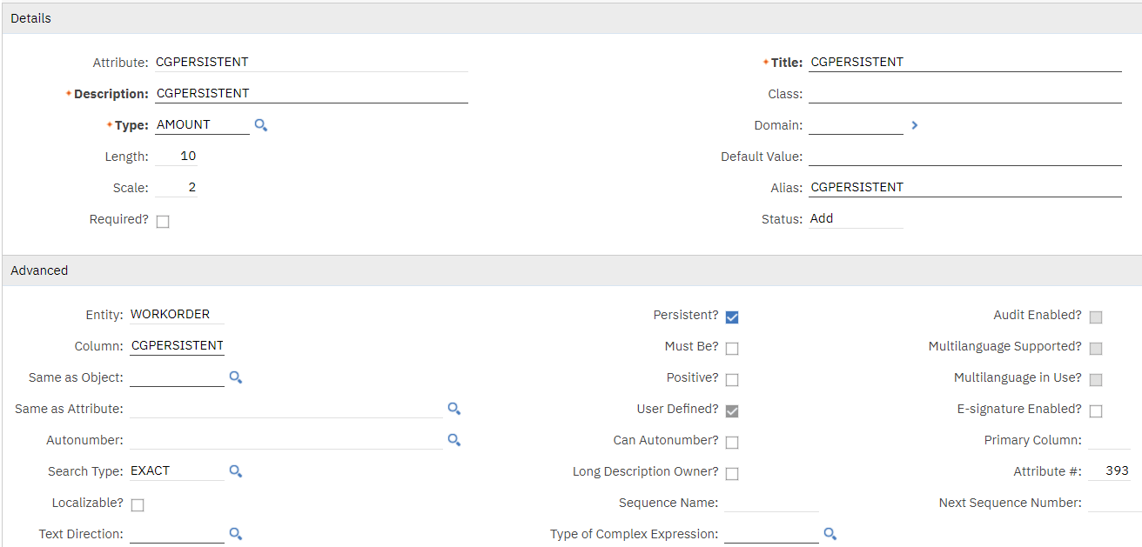
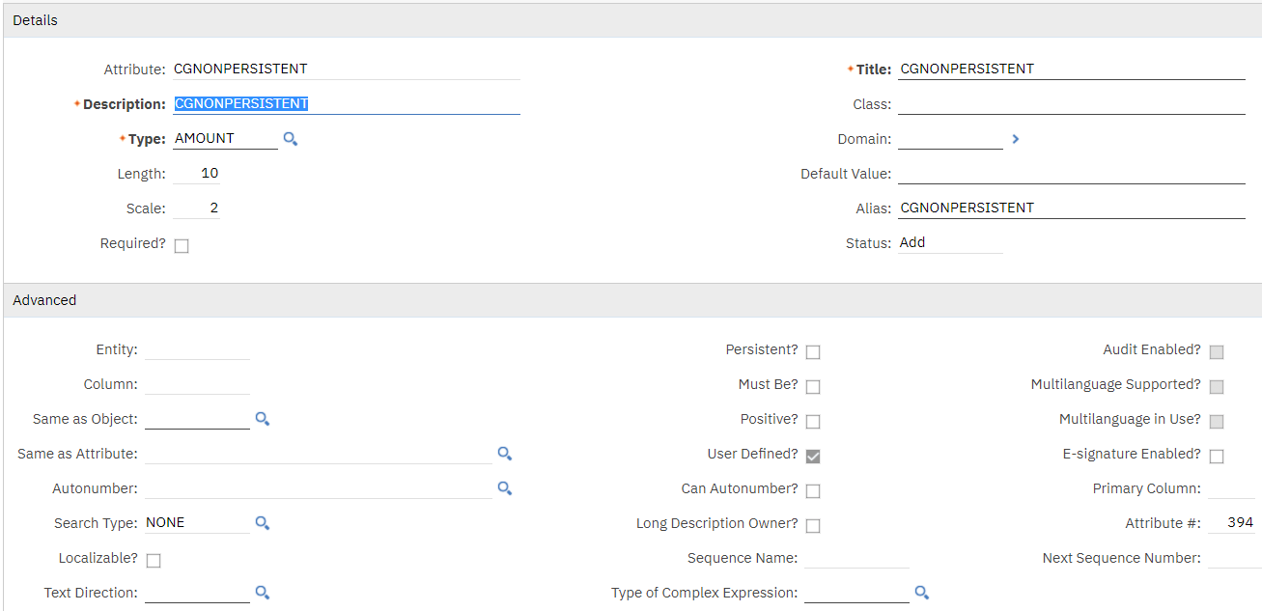

- Apply db config changes.

Non-persistent field testing:

- Create an attribute formula on the CGNONPERSISTENT field:
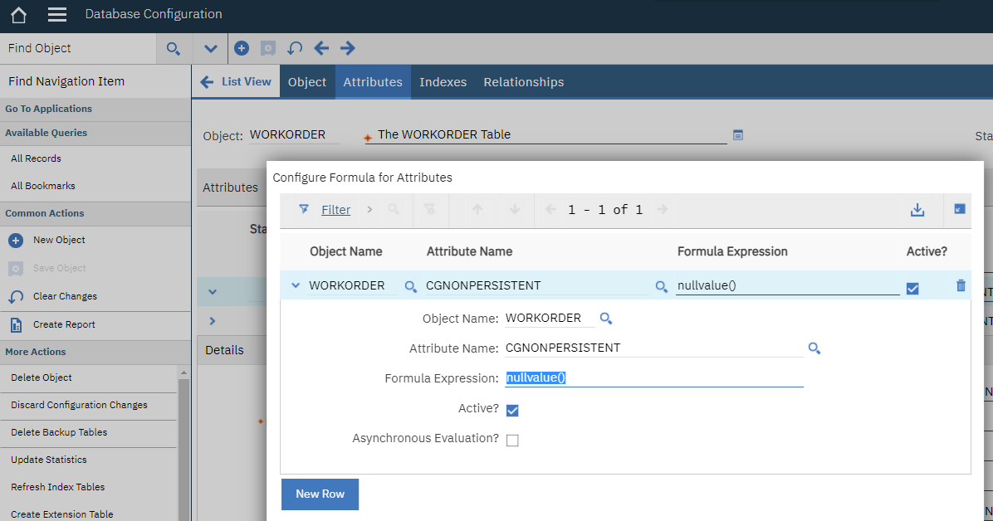
Formula Expression : nullvalue()

- Using Application Designer, add CGNONPERSISTENT as a field in WOTRACK:
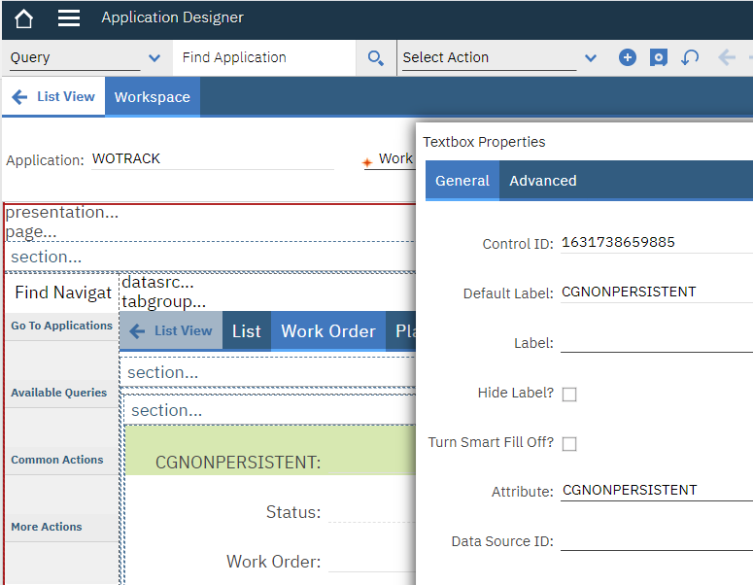

- Open an existing WO in WOTRACK.
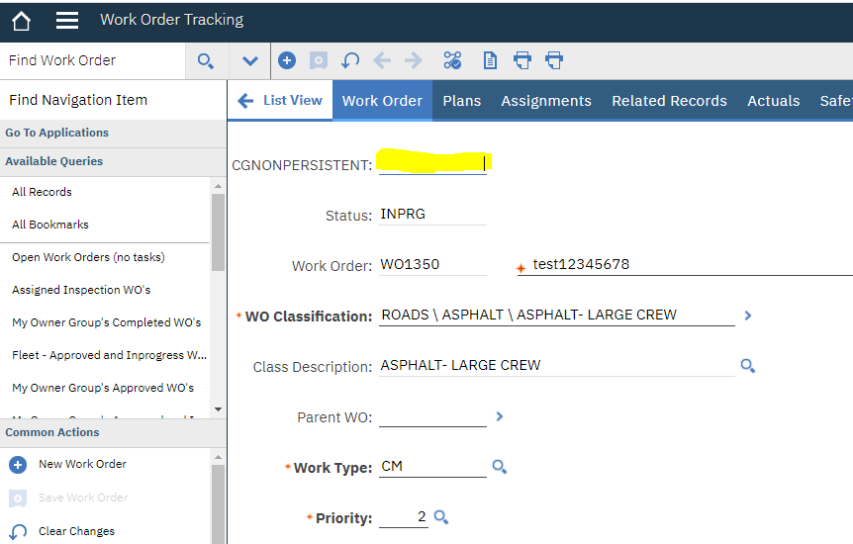
- Results:
Success. We can see that CGNONPERSISTENT has null as its value.
As an additional test, we can change the formula to: 1 + nullvalue()
That works as expected too. It returns null, because we can’t do math on nulls (expected behavior).

And just to be sure, we can change the formula again to 1 + 1
That returns the value 2. So we know that the formula is working.

Persistent field testing:

- Now, perform steps #3-6 above again, but this time, do it for the persistent field: CGPERSISTENT
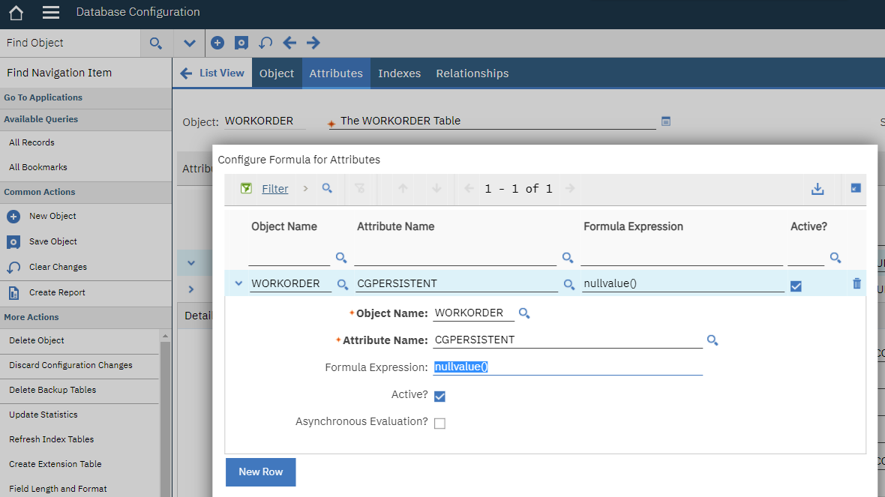
Formula: nullvalue()
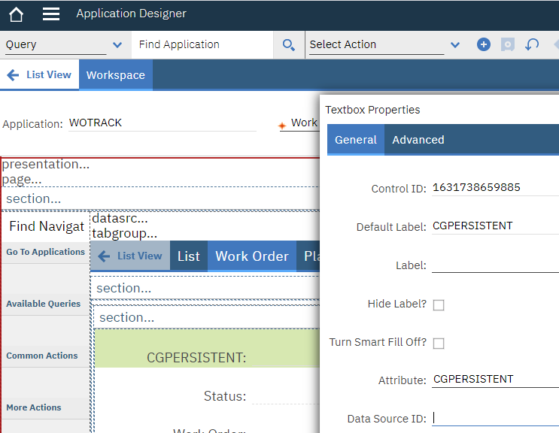

Note:
In order to test the persistent field properly, we need to create or edit a WO. We can’t just view a WO, because that won’t trigger the persistent field to get populated via the formula.

- Results:

Unfortunately, when we create or edit a WO in WOTRACK, the CGPERSISTENT field throws an error:

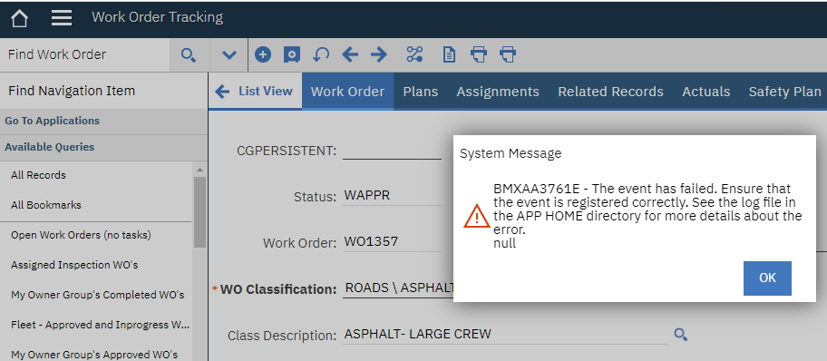

BMXAA3761E - The event has failed. Ensure that the event is registered correctly. See the log file in the APP HOME directory for more details about the error.
null

Conclusion:

Formulas can return null to non-persistent fields.

But, formulas can’t return null to persistent fields.

