Mathematical model SINGLE VEHICLE IRP cost minimization (Bertazzi & Speranza, 2013)
Sets
N | Set of nodes {0,1,…, n}
N’ | Set of customers
T | Set of time periods {1,…, H}
Parameters
c_{ij} | Travel cost between i and j, i∈ N, j∈ N
U_{i} | Max inventory lvl at hand customer can have
r_{0t} | Number of units made available at depot in day t ∈ T
r_{it} | Units consumed at customer i ∈ N’
Q | Available capacity of truck per period
Initial_{i} | Initial inventory level i ∈ N
h_{i} | Inventory holding cost node i ∈ N
Decision Variables
y_{ijt} ∈ {0,1} | Bin var with value 1 if edge (i,j) ∈ E is traversed at day t ∈ T (0 otherwise)
x_{it} ∈ ℤ₊ | Quantity delivered to customer i ∈ N’ at day t ∈ T
z_{it} ∈ {0,1} | Bin var with value 1 if node i ∈ N is visited at day t ∈ T (0 otherwise)
I_{it} ∈ ℤ₊ | Inventory level at node i in N at day t ∈ T

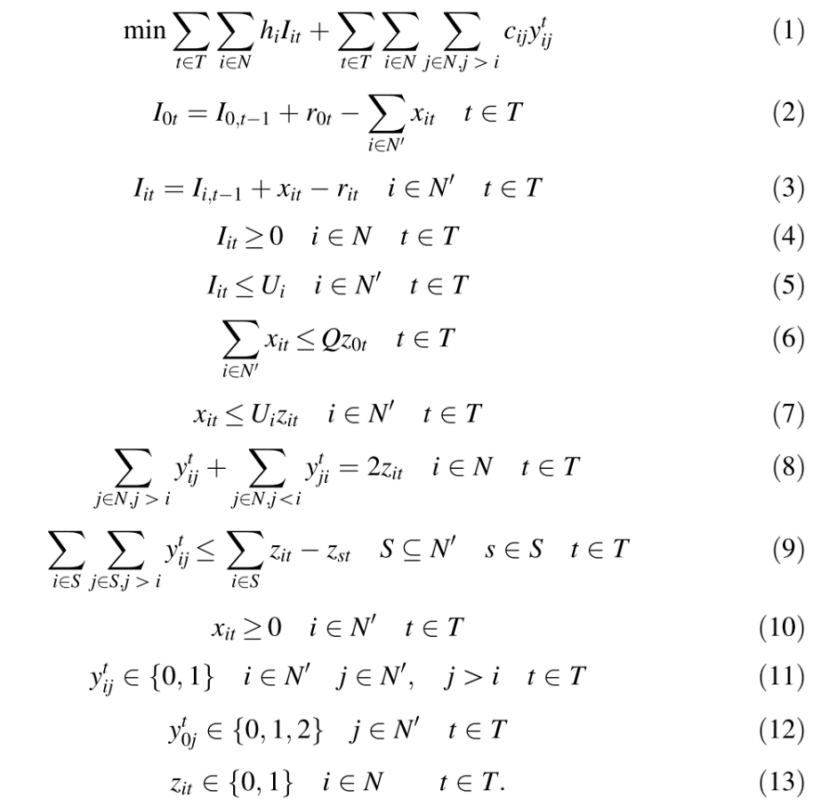
- Objective function (1): minimize transport costs + inventory costs
Determine, for each day t ∈ T, the quantity (possibly null) to deliver to each customer i ∈ N’ and the routes visiting the customers served at day t, at the minimum total cost.
- Constraint (2), (3): define the inventory level at the depot and at the customers.
- Constraint (4): guarantee that no stock–out occurs at the depot and at the customers.
- Constraint (5): impose that the inventory level of any customer never exceeds the maximum level.
- Constraint (6): guarantee that the quantity sent at day t is not greater than the vehicle capacity. Moreover, they impose that if at least one customer is served at day t (that is x_{it} > 0), then the depot is visited at day t (that is z_{0t} = 1).
- Constraint (7): guarantee that if customer i is served at day t (that is x_{it} > 0), then customer i is visited at day t (that is z_{it} = 1).
- Constraint (8), (9): routing constraints that guarantee that a feasible route is determined to visit the customers served at day t.
  - Constraint (8): impose that two edges incident to i are traversed at time t if customer i is visited at time t.
  - Constraint (9): subtour elimination constraints and impose that, for each customer s visited at time t (z_{st} = 1), no route that visits s at time t can be a cycle that does not visit the depot. Here only some of the customers are visited at any time t ∈ T. The right hand side is the number of visited customers in S minus 1 if customer s, with s ∈ S; is visited at time t. If customer s is not visited at time t, then the constraint is ineffective.
- Constraint (10),(11),(12),(13): Integrality constraint
  - Constraint (12): the variables y^{t}_{0j} can take value 2, contrary to all edge variables not incident to the depot. This is due to the fact that there may be routes visiting one customer only and thus traversing an edge twice. The fact that no other edge may be visited more than once in an optimal solution is due to the assumption that the cost matrix satisfies the triangle inequality.

