Dimension Editor
Attributes icon is a Tag icon which makes sense.
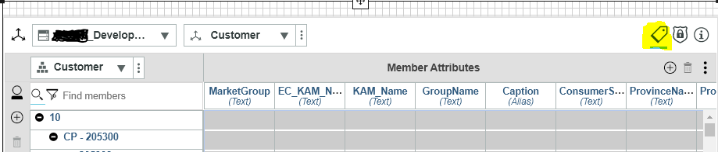

Set Editor
Attributes Icon is three vertical lines which does not follow the dimension editor or the box below showing the attributes.
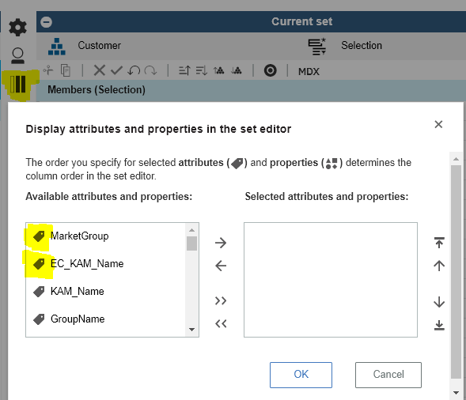

Perspectives Public vs Private
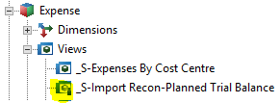
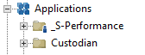

PAW Shared vs Private
A single person in the icon has always represented Private, per Perspectives view above.
PAW folders have the single person as shared and no person as private. Does not make sense. The shared folder should have multiple users like the Users icon but within the folder icon. Similarly, private should then have one person within the folder for clarity.
