Here’s an example of using the TM1 Rest API to create a complete TI process using Postman. In short, the process uses an MDX view on an ElementAttributes cube as its source and writes out Element Name, Attribute, Attribute Value to the server log.
The source view is based on the following MDX view.
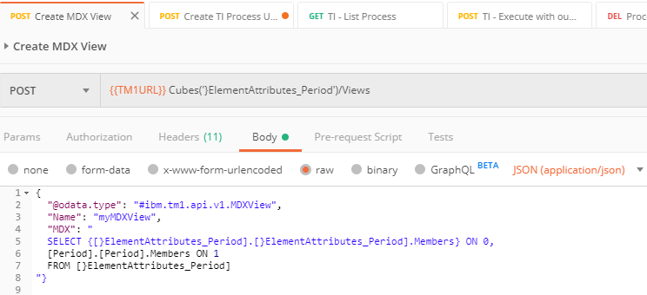
Here’s that the post to create the process.
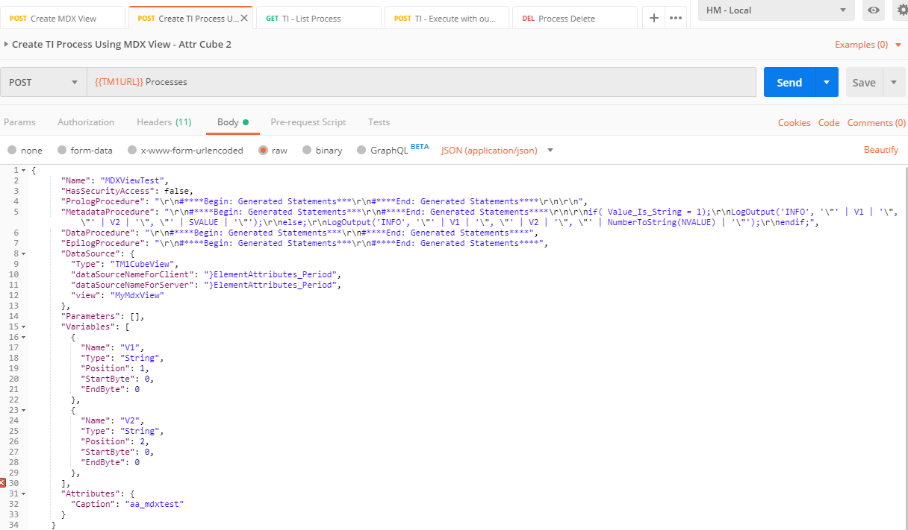

Here’s the text of the body of the post.
{
"@odata.context": "$metadata#Processes/$entity",
"@odata.etag": "W/\"3be4415074c3184326a51e2a85772e35c7609420\"",
"Name": "MDXViewTest",
"HasSecurityAccess": false,
"PrologProcedure": "\r\n#****Begin: Generated Statements***\r\n#****End: Generated Statements****\r\n\r\n",
"MetadataProcedure": "\r\n#****Begin: Generated Statements***\r\n#****End: Generated Statements****\r\n\r\nif( Value_Is_String = 1);\r\nLogOutput('INFO', '\"' | V1 | '\", \"' | V2 | '\", \"' | SVALUE | '\"');\r\nelse;\r\nLogOutput('INFO', '\"' | V1 | '\", \"' | V2 | '\", \"' | NumberToString(NVALUE) | '\"');\r\nendif;",
"DataProcedure": "\r\n#****Begin: Generated Statements***\r\n#****End: Generated Statements****",
"EpilogProcedure": "\r\n#****Begin: Generated Statements***\r\n#****End: Generated Statements****",
"DataSource": {
"Type": "TM1CubeView",
"dataSourceNameForClient": "}ElementAttributes_Period",
"dataSourceNameForServer": "}ElementAttributes_Period",
"view": "MyMdxView"
},
"Parameters": [],
"Variables": [
{
"Name": "V1",
"Type": "String",
"Position": 1,
"StartByte": 0,
"EndByte": 0
},
{
"Name": "V2",
"Type": "String",
"Position": 2,
"StartByte": 0,
"EndByte": 0
}
],
"Attributes": {
"Caption": "MDXViewTest",
"New Name": "MDXViewTest"
}
}

Here’s the output after execution.
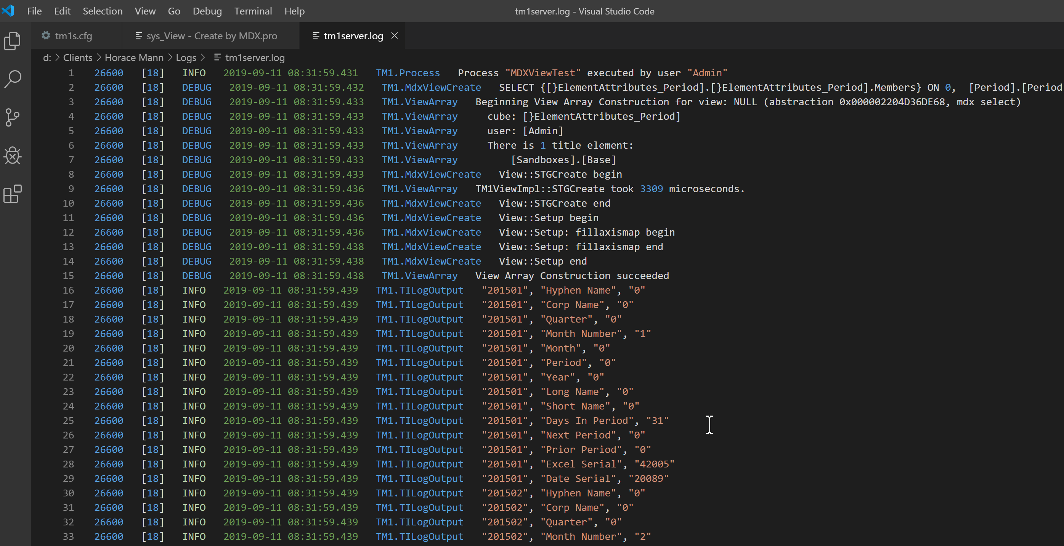

Ping me if you have questions.

Chris

