IBM Cognos Analytics Welcome Page Modifications
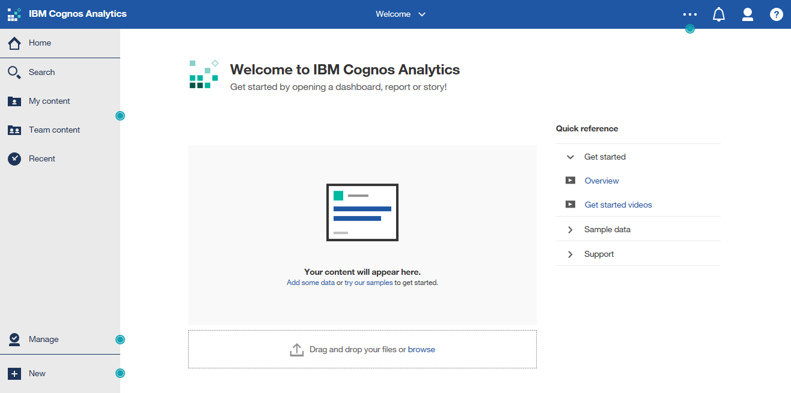
On the ICA Welcome page, the following instructions will get rid of the secondaryWelcomeMsg ( “Get started by opening a dashboard, report or story!” ):
And the homeReferenceContainer ( “Quick reference” ) menu:
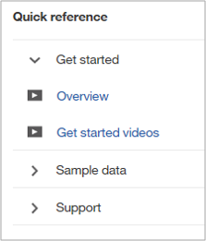
The idea is to locate the Web structures that create these annoying page elements, and modify or remove the structures.
DISCLAIMER: Try this procedure at your own risk. I will NOT be responsible for any system failures that may occur.

Procedure
Task 1: Locate the bundle.js File
- Locate the bundle.js Javascript file buried deep in your Cognos Analytics install location.
<install location>\cognos\analytics\webcontent\bi\js\cahome\bundle.js
You will probably need Cognos System Administrator privileges to get near this file on your Cognos Application Server.
- STOP - IMPORTANT: Create a backup copy of the bundle.js file before you go any further.
This will be your fallback recovery file if you screw things up.
- Open the bundle.js file, in a text editor – I just used NotePad to do my editing.

Task 2: Remove the “secondaryWelcomeMsg” Page Structure
- Do a search to find 2 instances of secondaryWelcomeMsg embedded in <div> tags as shown below:
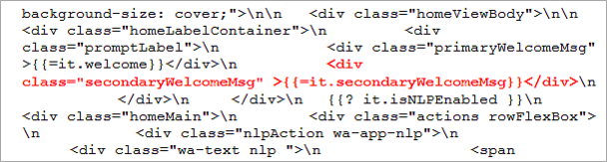
This should be the first instance of secondary WelcomeMsg that you encounter in your search. There are several other instances scattered throughout the bundle.js file so be sure you locate the 2 instances in the <div> tags as shown above.
When you find the code shown above, DO NOT be tempted to hit the ENTER key several times to create more space around the desired code, as this may introduce hidden CRLF characters when the file is saved. And the result will be that the Welcome page will not open because of script errors.
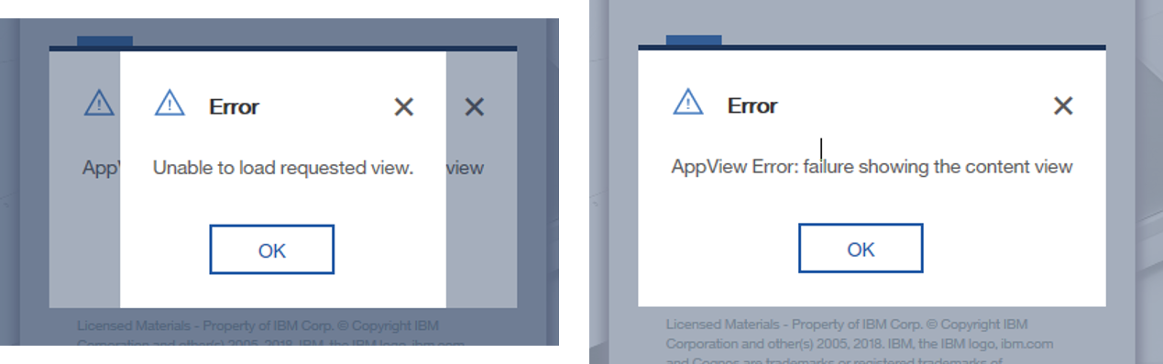
Your task is to just delete only the DIV structure shown above in red.
- Place your curser immediately in front of <div and delete everything to the end of </div>.
<div
class=”secondaryWelcomeMsg”>{{=it.secondaryWelcomeMsg}}</div>
This DIV structure is used to generate the “Get started by opening a dashboard, report or story!” text at the top of the Welcome page.
- DO NOT hit the enter key or place any additional spaces in the remaining syntax.
- Save the file, cross your fingers, and run Cognos to see the result.
If you did it correctly, the secondary welcome message should be gone!

Task 3: Remove the “Quick Reference” Menu from the Right Side
- Do a search to find the first instance of homeReferenceContainer embedded in <div> tags as shown below:
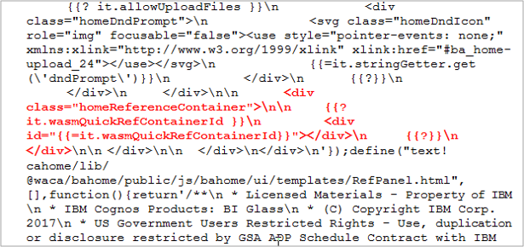
Once again, DO NOT hit ENTER or add any additional spaces in the syntax.
- For the code in red above, place your curser immediately in front of <div and delete everything to the end of the final </div> tag:
<div
class=”homeReferenceContainer”>\n\n {{?
it.wasmQuickRefContainerId }}\n <div
id=”{{=it.wasmQuickRefContainerId}}”></div>\n {{?}}\n
</div>

This DIV structure is used to generate the entire “Quick reference” menu structure at the right-side of the Welcome page.
- DO NOT hit the enter key or place any additional spaces in the remaining syntax.
- Save the file, cross your fingers, and run Cognos to see the result.
If you did it correctly, the secondary welcome message should be gone!
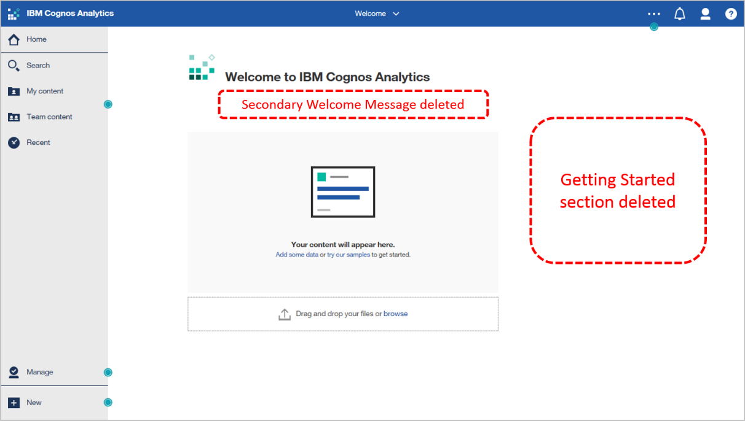
- Keep your backup bundle.js file in a save, dry place for future use if necessary.

These instructions were prepared and tested using IBM Cognos Analytics Release 12 (11.0.12)
For those of you old enough to remember typewriters, CRLF stands for “Carriage Return Line Feed” (ASCII codes 10 and 13).

