Recreate a View Without Impacting Reports
IBM Cognos Analytics Data Module

Purpose
This document will outline the steps needed to recreate a view in a Data Module without impacting the reports sourced from the Data Module.

Data Item Reference
Before we get started, let’s look at and understand how a data item in a report is referenced when the source is a data module. Looking at the example and screenshot below, you can see the data item reference is as follows:
[C].[C_Coffee_sales_and_marketing].[customer].[customer_first_name]
^^ ^^ ^^
Data Module Identifier Table Identifier Column Identifier

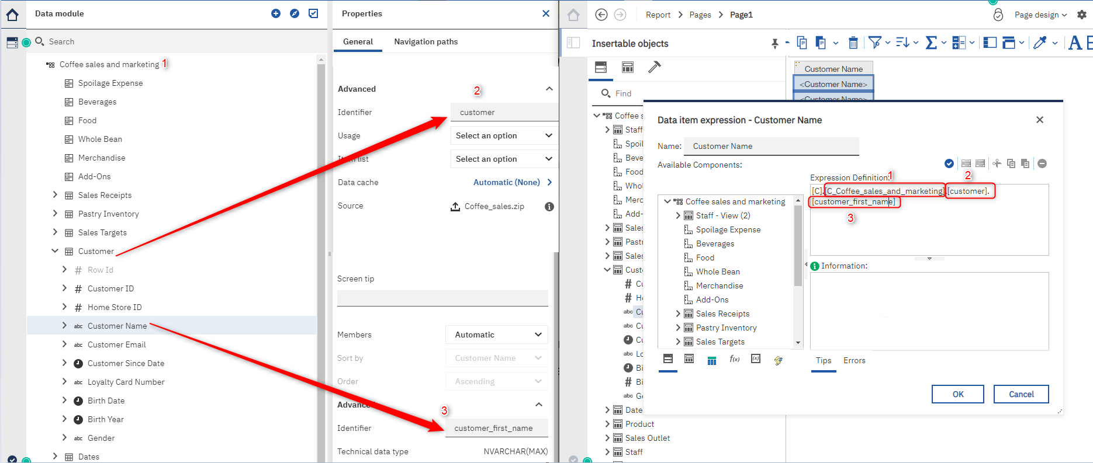

You will notice that both the Table and Column Identifier fields in the data module are editable fields. This makes it easy to recreate a view and change the Table and Column identifiers without impacting the report.
Recreate View
*Before proceeding, take a backup of your Data Module*
From the screenshot below you can see I created a view called "Staff & Sales Receipts"
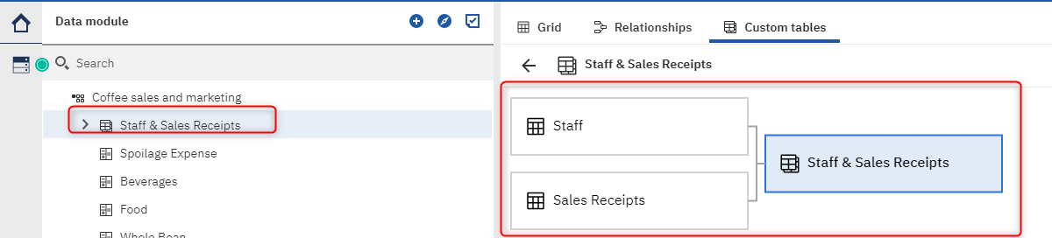

Next, we would like to add the "Customer" table to the view. To do this, we will create a new View called "Staff & Customer & Sales Receipt" with the required tables:
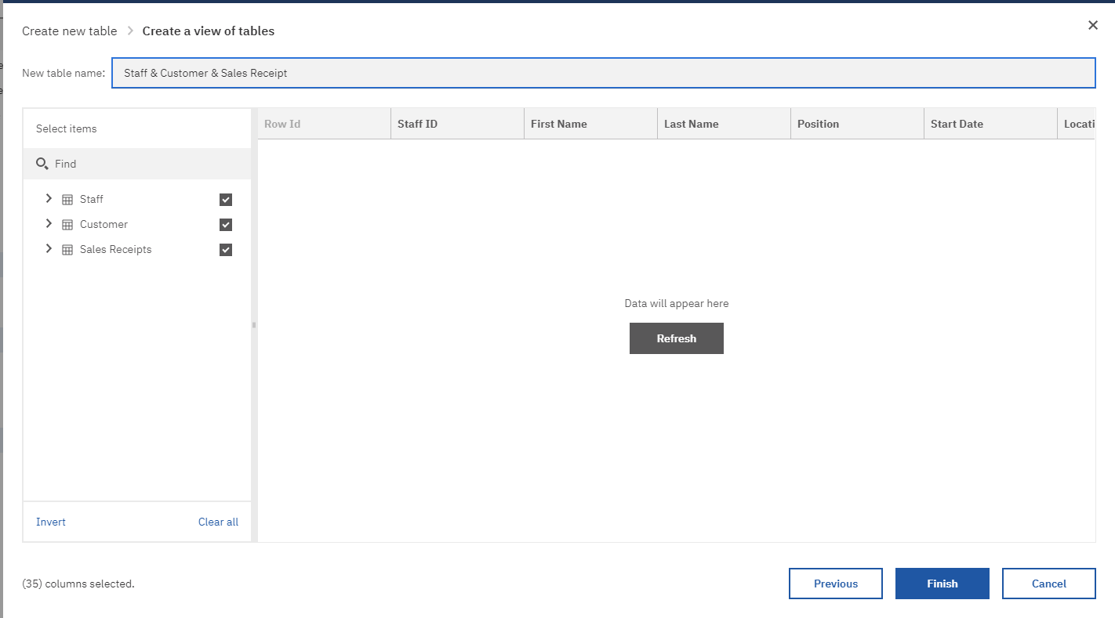

Once that is completed, you should have the new view and original view we want to replace:
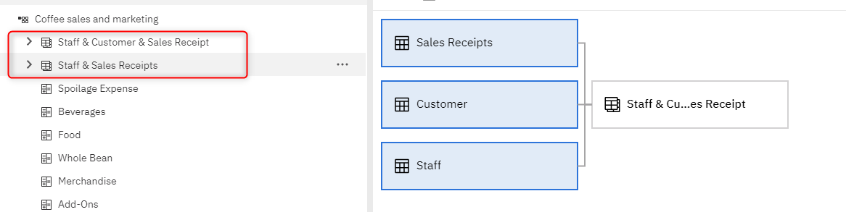
Before we delete the "Staff & Sales Receipts" we need to capture the Table Identifier. To do this go to the properties of your view and from the properties window click "Advanced"
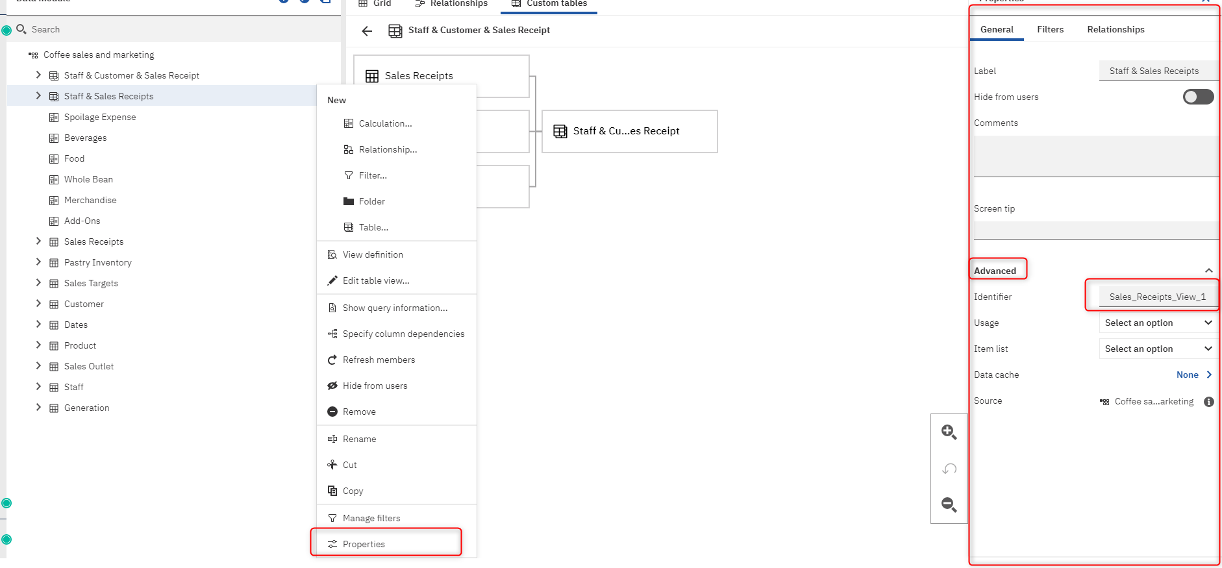
Copy the Identifier field, then delete the view, in this case, we will delete the Staff & Sales Receipts view.
*You need to delete the view first before you can update the new view's identifier field as the identifier filed must be unique*
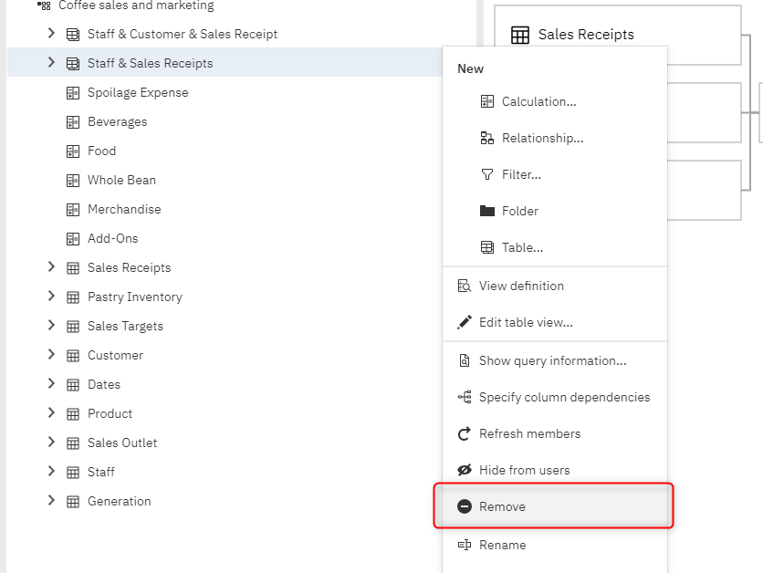

Once the view has been deleted, go to the properties of the "Staff & Customer & Sales Receipt" and update the Identifier field we copied from the original view.
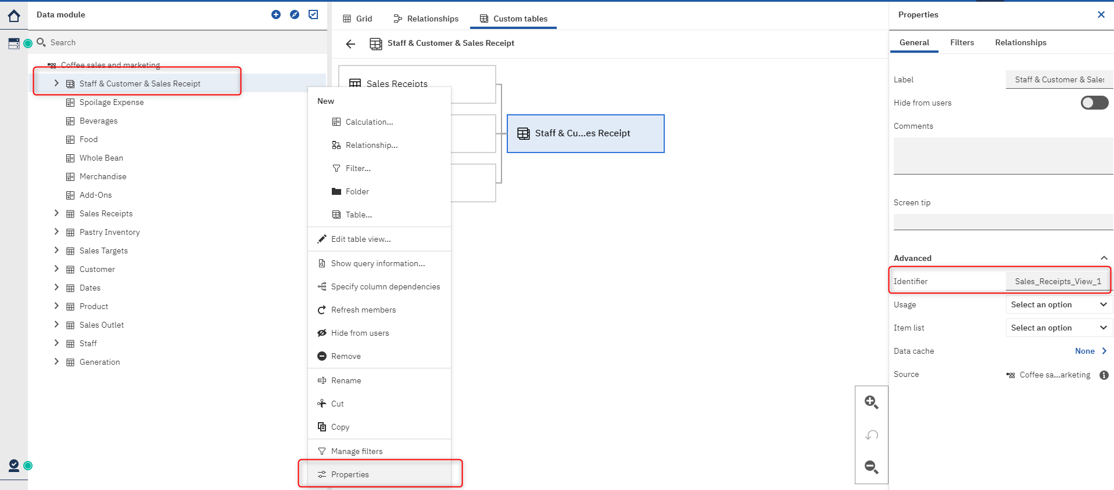

Lastly, Save the model and validate your reports.
To prove out the solution, I initially created a report using the "Staff & Sales Receipt" and after updating the data module to create the new "Staff & Customer & Sales Receipt" view, you can screen from the below screenshot, that the data item references are the same:
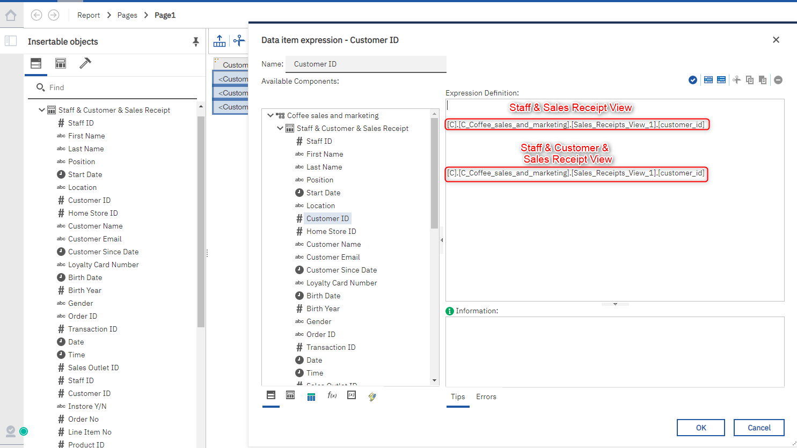

Note Any additional modeling did after the fact, such as joins or calculations, will need to be remodeled.

